TEXAS STATE SOIL AND WATER CONSERVATION BOARD
REQUEST FOR PROPOSALS
FOR THE
FISCAL YEAR 2019 CLEAN WATER ACT §319(h)
NONPOINT SOURCE GRANT PROGRAM

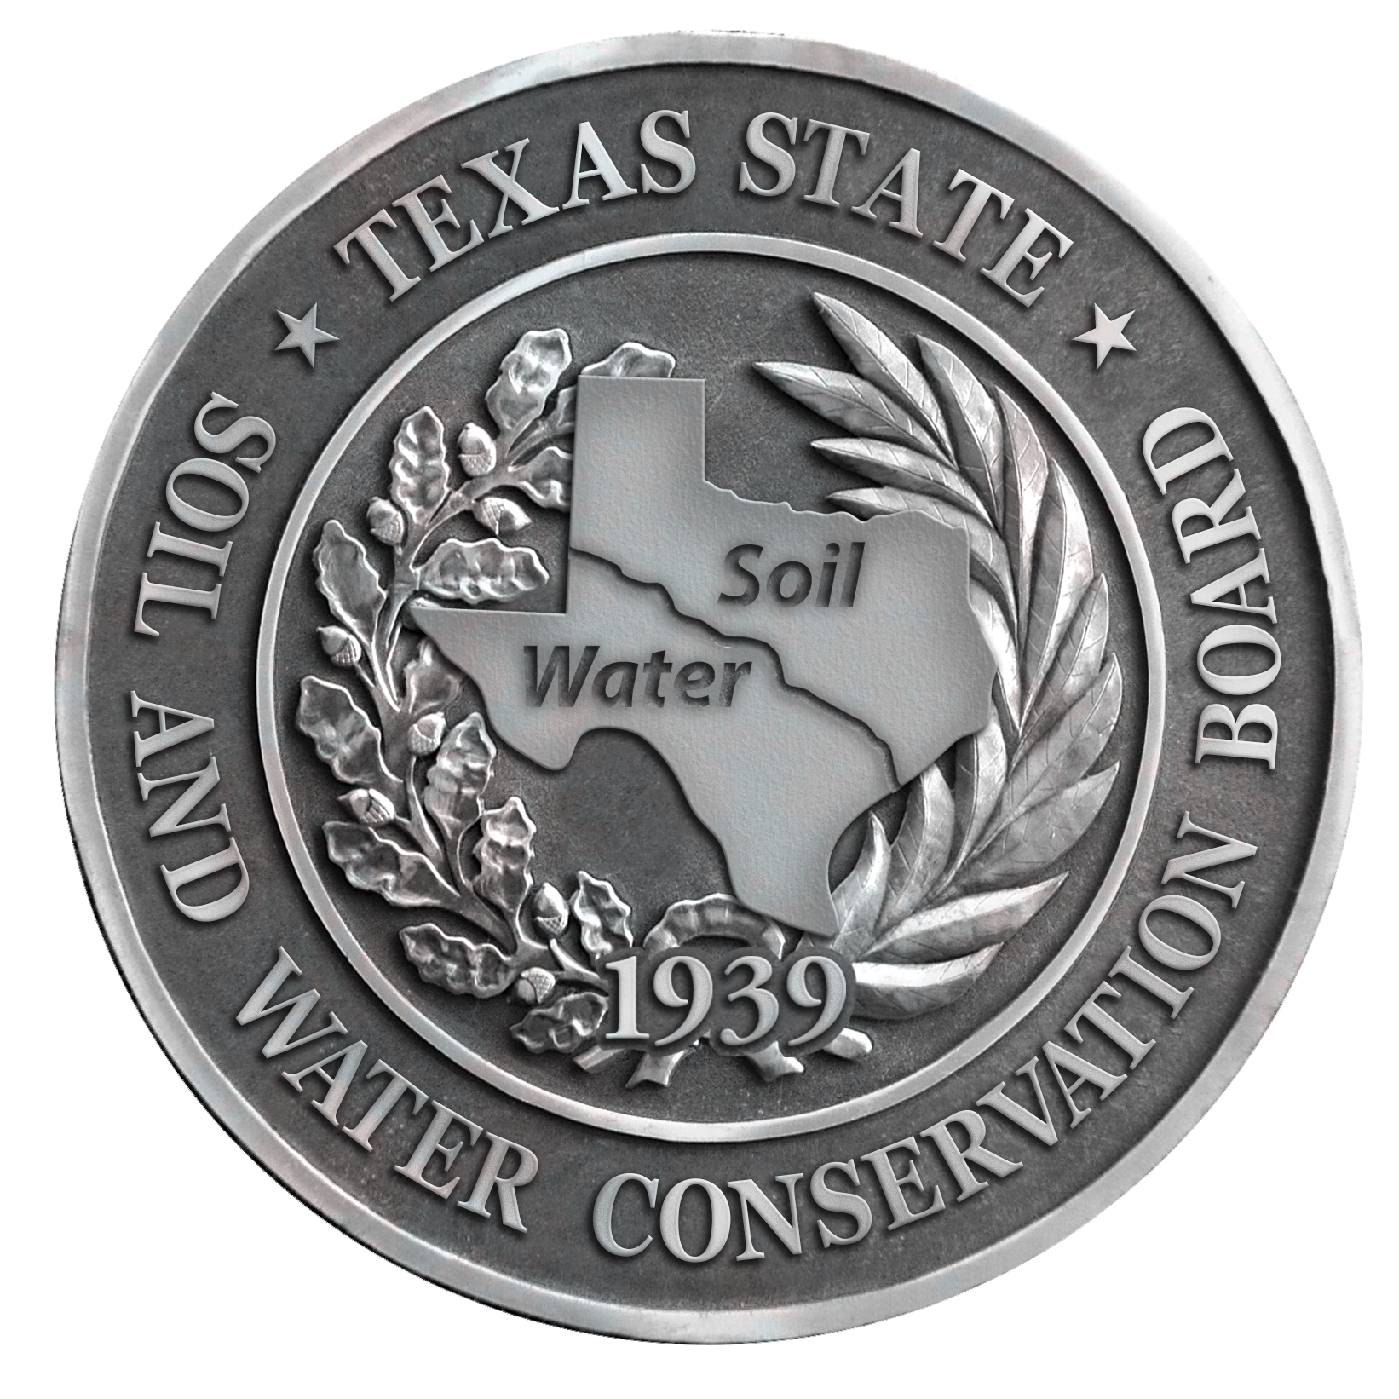

PROPOSALS DUE: September 28, 2018

INTRODUCTION

This request for proposals (RFP) provides instructions and guidance for applicants seeking funding from the Texas State Soil and Water Conservation Board (TSSWCB) under the Clean Water Act (CWA) §319(h) Nonpoint Source (NPS) Grant Program. The U.S. Environmental Protection Agency (EPA) distributes funds appropriated by Congress annually to the TSSWCB under the authorization of CWA §319(h). TSSWCB then administers/awards these federal funds as grants to cooperating entities for activities that address the goals, objectives, and priorities stated in the Texas NPS Management Program. The Texas NPS Management Program is the State’s comprehensive strategy to protect and restore water quality in waterbodies impacted by NPS water pollution. This document can be accessed online at https://www.tsswcb.texas.gov/index.php/programs/texas-nonpoint-source-management-program.

The types of agricultural and silvicultural NPS pollution prevention and abatement activities that can be funded with §319(h) grants include the following: implementation of nine-element watershed protection plans (WPPs) and the agricultural and silvicultural NPS portion of Total Maximum Daily Load (TMDL) Implementation Plans (I-Plans), surface water quality monitoring, data analysis and modeling, demonstration of innovative best management practices (BMPs), technical assistance to landowners for conservation planning, public outreach/education, development of nine-element WPPs including the formation and facilitation of stakeholder groups, and monitoring activities to determine the effectiveness of specific pollution prevention methods. Strictly research activities are not eligible for §319(h) grant funding.

The TSSWCB is requesting proposals for watershed assessment, planning, implementation, demonstration and education projects within the boundaries of impaired or threatened watersheds. The 2014 Texas Integrated Report describes the water quality conditions for waterbodies in the state. All proposals must focus on the restoration and protection of water quality consistent with the goals, objectives, and priority watersheds and aquifers identified in Appendix C and D of the Texas NPS Management Program. Up to $1 million of the TSSWCB’s FY2019 CWA §319(h) grant will be eligible for this RFP. No more than 10% of these funds may be utilized for groundwater projects. A competitive proposal process will be used so that the most appropriate and effective projects are selected for funding.

Project proposals should, where applicable, stress interagency coordination, demonstrate new or innovative technologies, use comprehensive strategies that have statewide applicability, and stress public participation. Examples of project proposals previously funded by TSSWCB are available at http://www.tsswcb.texas.gov/managementprogram/browseactive. Additionally, applicants are encouraged to review EPA’s Grant Guidelines for the NPS Program available at http://water.epa.gov/polwaste/nps/cwact.cfm .

This RFP does not set a maximum or minimum amount for individual projects; however, project funding generally ranges between $100,000 and $400,000 for a two to three year project. The TSSWCB CWA §319(h) NPS Grant Program has a 60/40% match requirement, however proposals that do not meet the minimum matching requirement will still be considered. The cooperating entity will be reimbursed up to 60% from federal funds and must contribute a minimum of 40% of the total costs to conduct the project. The match must be from non-federal sources (may be cash or in-kind services) and must be described in the budget justification. Reimbursable indirect costs are limited to no more than 15% of total federal direct costs.

Quarterly progress and final reports are the minimum project reporting requirements. All projects that include an environmental data collection, generation or compilation component (e.g., water quality monitoring, modeling, bacterial source tracking) must have a Quality Assurance Project Plan (QAPP), to be reviewed and approved by TSSWCB and the EPA. Project budgets and timelines should account for the development and review of QAPPs. More information on QAPPs and the TSSWCB Environmental Data Quality Management Plan is available at http://www.tsswcb.texas.gov/quality.

TSSWCB PRIORITIES

For this FY2019 RFP, the following priorities have been identified. Proposals that do not focus on these priorities are still welcomed but may rank lower than those that focus on the priorities.

Priority Project Activities
- Implement WPPs and TMDL I-Plans (See priority areas listed below).
- WPP development initiatives (See Appendix C in Texas NPS Management Program), which include activities such as the formation of watershed groups or water quality data collection and analysis.
- Implement components of the Texas Coastal NPS Pollution Control Program in the Coastal Management Zone (http://www.tsswcb.texas.gov/coastalnps).
- Support use of federal Farm Bill Programs and Initiatives (National Water Quality Initiative (NWQI).
- Demonstration projects and/or development/delivery of education programs.

Priority Areas for WPP Implementation Projects
- WPPs
  - Leon River
  - Lake Lavon
  - Plum Creek (Segment 1810)
  - Lampasas River
  - Double Bayou
  - Navasota River
  - Attoyac Bayou
  - Mid and Lower Cibolo
  - Tres Palacios

ELIGIBLE ORGANIZATIONS

Grants will be available to public and private entities such as local municipal and county governments and other political subdivisions of the State (e.g., soil and water conservation districts), educational institutions, non-profit organizations, and state and federal agencies. Private organizations, for profit, may participate in projects as partners or contractors but may not apply directly for funding.

SELECTION PROCESS

Submitted proposals will be reviewed, scored, and ranked based on the evaluation and ranking criteria included in this RFP. A minimum scoring requirement (70%) is necessary for proposals to be eligible for consideration.

All applicants, unsuccessful and successful, will be notified. Those applicants whose proposals are recommended for funding will be contacted, and then TSSWCB will work with the applicant to revise and finalize the proposal prior to submittal to EPA. EPA must review and approve all proposals prior to TSSWCB awarding grant funds.

SUBMISSION PROCESS

To obtain a complete copy of TSSWCB’s RFP and proposal submission packet, please visit https://www.tsswcb.texas.gov/index.php/programs/texas-nonpoint-source-management-program or contact Jana Lloyd at (254) 773-2250 ext. 224. All proposals must be submitted electronically (MS® Word) using the workplan template provided in this RFP; otherwise, proposals will be considered administratively incomplete and not considered for funding. All letters of support for the proposal, including letters from Project Partners confirming their role, must be received by the proposal due date to be considered. Submit proposals to jlloyd@tsswcb.texas.gov. Proposals must be received electronically by 5:00 p.m. CDT, September 28, 2018 to be considered.

FY2019 GRANT TIMELINE

Issuance of RFP August 17, 2018
Deadline for Submission of Proposals September 28, 2018
Proposal Evaluation by TSSWCB October-November 2018
Notification of Selected Proposals/Unsuccessful Applicants December 2018
Work with Applicants to Finalize Selected Proposals November- December 2018
Review of Selected Proposals by EPA January 2019
Submit Grant Application to EPA May 2019
Contract Award August 2019
Anticipated Project Start Date September 1, 2019

ATTACHMENTS
- Workplan Template is on pp. 5-15 of this RFP
- Evaluation and Ranking Criteria are on pp. 16-17 of this RFP

Texas State Soil and Water Conservation Board
Clean Water Act §319(h) Nonpoint Source Grant Program
FY 2019 Proposal

SUMMARY PAGE

Title of Project
Project Goals
Project Tasks | (1) Project Administration; (2) Quality Assurance; (3)
Measures of Success
Project Type | Implementation ( ); Education ( ); Planning ( ); Assessment ( ); Groundwater ( )
Status of Waterbody on 2014 Texas Integrated Report | Segment ID |  | Parameter of Impairment or Concern |  |  |  | Category
Project Location (Statewide or Watershed and County)
Key Project Activities | Hire Staff ( ); Surface Water Quality Monitoring ( ); Technical Assistance ( );  Education ( ); Implementation ( ); BMP Effectiveness Monitoring ( );  Demonstration ( ); Planning ( ); Modeling ( ); Bacterial Source Tracking ( ); Other ( )
2017 Texas NPS Management Program Reference
Project Costs | Federal | $ |  | Non-Federal | $ | Total |  | $
Project Management | - Cooperating Entity
Project Period | September 1, 2019 – August 31, 2022

Part I – Applicant Information

Applicant

Project Lead
Title
Organization
E-mail Address
Street Address
City |  |  |  | County |  |  | State |  | Zip Code
Telephone Number |  |  |  |  |  | Fax Number

Project Partners

Names | Roles & Responsibilities
Texas State Soil and Water Conservation Board (TSSWCB) | Provide state oversight and management of all project activities and ensure coordination of activities with related projects and TCEQ.
Cooperating Entity
Partner 1 | Other Project Partners are those that will actively participate in executing the project tasks.
Partner 2
Partner 3

Part II – Project Information

Project Type

Surface Water |  | Groundwater
Does the project implement recommendations made in (a) a completed WPP, (b) an adopted TMDL, (c) an approved I-Plan, (d) a Comprehensive Conservation and Management Plan developed under CWA §320, (e) the Texas Coastal NPS Pollution Control Program, or (f) the Texas Groundwater Protection Strategy? |  |  |  |  |  |  | Yes |  |  | No
If yes, identify the document.
If yes, identify the agency/group that developed and/or approved the document. |  |  |  |  |  | Year Developed

Watershed Information

Watershed or Aquifer Name(s) | Hydrologic Unit Code (12 Digit) | Segment ID | Category on 2014 IR | Size (Acres)

Water Quality Impairment

Describe all known causes (i.e., pollutants of concern) and sources (e.g., agricultural, silvicultural) of water quality impairments or concerns from any of the following sources: 2014 Texas Integrated Report, Clean Rivers Program Basin Summary/Highlights Reports, or other documented sources.

Project Narrative

Problem/Need Statement
Provide a brief statement of the water quality problem or challenge to be addressed. Explain the need for, and importance of, this project. Explain why the proposed project is the appropriate solution for the water quality issue. Include brief descriptions of other projects and coordination efforts that have addressed the water quality issues in the watershed. Describe how this project builds on, and will be coordinated with, those efforts. Reference web pages or published reports as supplemental information.

Project Narrative

General Project Description (Include Project Location Map)
Provide a brief narrative description of the project activities, how the activities will address the water quality problem, and how the activities will accomplish the project’s goals. The project description section should clearly indicate how the proposed tasks will be coordinated with each other and with associated projects when they exist. Indicate how the improvement to water quality, the pollutant load reductions, and other measures of success will be accomplished. If the project includes water quality monitoring, generally describe the sampling strategy including minimum number of sites, minimum number of sampling events, and key analyses to be performed.

Tasks, Objectives and Schedules

Task 1 | Project Administration
Costs | Federal | $ |  | Non-Federal | $ | Total |  | $
Objective | To effectively administer, coordinate and monitor all work performed under this project including technical and financial supervision and preparation of status reports.
Subtask 1.1 | Cooperating Entity will prepare electronic quarterly progress reports (QPRs) for submission to the TSSWCB. QPRs shall document all activities performed within a quarter and shall be submitted by the ^{st} of January, April, July and October. QPRs shall be distributed to all Project Partners.
 | Start Date |  | Month XX |  | Completion Date |  | Month XX
Subtask 1.2 | Cooperating Entity will perform accounting functions for project funds and will submit appropriate Reimbursement Forms to TSSWCB at least quarterly.
 | Start Date |  | Month XX |  | Completion Date |  | Month XX
Subtask 1.3 | Cooperating Entity will host coordination meetings or conference calls, at least quarterly, with Project Partners to discuss project activities, project schedule, communication needs, deliverables, and other requirements. Cooperating Entity will develop lists of action items needed following each project coordination meeting and distribute to project personnel.
 | Start Date |  | Month XX |  | Completion Date |  | Month XX
Subtask 1.4 | Cooperating Entity will develop a Final Report that summarizes activities completed and conclusions reached during the project and discusses the extent to which project goals and measures of success have been achieved.
 | Start Date |  | Month XX |  | Completion Date |  | Month XX
Deliverables | - QPRs in electronic format  - Reimbursement Forms and necessary documentation in hard copy format  - Final Report in electronic and hard copy formats

* If project includes an environmental data collection component, use Quality Assurance Task, if not, delete Task.
Tasks, Objectives and Schedules

Task 2 | Quality Assurance
Costs | Federal | $ |  | Non-Federal | $ | Total |  | $
Objective | To develop data quality objectives (DQOs) and quality assurance/control (QA/QC) activities to ensure data of known and acceptable quality are generated through this project.
Subtask 2.1 | Cooperating Entity will develop a QAPP for activities in Task # consistent with the most recent versions of EPA Requirements for Quality Assurance Project Plans (QA/R-5) and the TSSWCB Environmental Data Quality Management Plan. All monitoring procedures and methods prescribed in the QAPP shall be consistent with the guidelines detailed in the TCEQ Surface Water Quality Monitoring Procedures, Volume 1: Physical and Chemical Monitoring Methods for Water, Sediment, and Tissue (RG-415) and Volume 2: Methods for Collecting and Analyzing Biological Assemblage and Habitat Data (RG-416). [Consistency with Title 30, Chapter 25 of the Texas Administrative Code, Environmental Testing Laboratory Accreditation and Certification, which describes Texas’ approach to implementing the National Environmental Laboratory Accreditation Conference (NELAC) standards, shall be required where applicable.]
 | Start Date |  | Month XX |  | Completion Date |  | Month XX
Subtask 2.2 | Cooperating Entity will implement the approved QAPP. Cooperating Entity will submit revisions and necessary amendments to the QAPP as needed.
 | Start Date |  | Month XX |  | Completion Date |  | Month XX
Deliverables | - QAPP approved by TSSWCB and EPA in both electronic and hard copy formats  - Approved revisions and amendments to QAPP, as needed  - Data of known and acceptable quality as reported through Task #

Tasks, Objectives and Schedules (Replicate or modify table as needed)

Task 3
Costs | Federal | $ |  | Non-Federal | $ | Total |  | $
Objective
Subtask 3.1
 | Start Date |  | Month XX |  | Completion Date |  | Month XX
Subtask 3.2
 | Start Date |  | Month XX |  | Completion Date |  | Month XX
Subtask 3.3
 | Start Date |  | Month XX |  | Completion Date |  | Month XX
Subtask 3.4
 | Start Date |  | Month XX |  | Completion Date |  | Month XX
Subtask 3.5
 | Start Date |  | Month XX |  | Completion Date |  | Month XX
Deliverables | - Tangible work products which will be submitted in fulfillment and/or documentation of the task

Tasks, Objectives and Schedules (Replicate or modify table as needed)

Task 4
Costs | Federal | $ |  | Non-Federal | $ | Total |  | $
Objective
Subtask 4.1
 | Start Date |  | Month XX |  | Completion Date |  | Month XX
Subtask 4.2
 | Start Date |  | Month XX |  | Completion Date |  | Month XX
Subtask 4.3
 | Start Date |  | Month XX |  | Completion Date |  | Month XX
Subtask 4.4
 | Start Date |  | Month XX |  | Completion Date |  | Month XX
Subtask 4.5
 | Start Date |  | Month XX |  | Completion Date |  | Month XX
Deliverables

Project Goals (Expand from Summary Page)

Summarize the outcomes or accomplishments intended to result from this project. Information in this section should closely tie to the Problem/Need Statement, focusing on the restoration and protection of water quality. Include a balance of programmatic, environmental, and social goals, as appropriate to the project. Environmental goals should be as detailed and quantifiable as possible. Goals should be measurable so that success can be measured at the end of the project.

Measures of Success (Expand from Summary Page)

Provide an explanation of the indicators that will be measured and tracked to document and determine the accomplishment of project goals. Include a balance of programmatic, environmental, and social measures of success, as appropriate to the project. Measures of success should be related to project goals and objectives. The indicator should be appropriate in terms of the geographic and temporal scales of the project. The measures should be simple and direct with consistent methodologies and adequate data to evaluate.

2017 Texas NPS Management Program Reference (Expand from Summary Page)

Components, Goals, and Objectives

Estimated Load Reductions Expected (Only applicable to Implementation Project Type)

Give an estimate of NPS pollutant load reductions to be achieved from implementation of BMPs through this project. Cite the method and a summary of the relevant data used in developing the estimate (including types and number of BMPs to be used, acres treated, etc.). At a minimum, estimated load reductions should be provided for nitrogen (lbs/yr), phosphorus (lbs/yr), and sediment (tons/yr), but should also include estimates for other pollutants of concern identified in the project (e.g., indicator bacteria).

EPA State Categorical Program Grants – Workplan Essential Elements
FY 2014-2018 EPA Strategic Plan Reference
Strategic Plan Goal – Goal 2 Protecting America’s Waters
Strategic Plan Objective – Objective 2.2 Protect and Restore Watersheds and Aquatic Ecosystems

Part III – Financial Information

Budget Summary

Federal | $ 0 |  | % of total project |  | ##%
Non-Federal | $ 0 |  | % of total project |  | ##%
Total | $ 0 |  | Total |  | 100%
Category |  | Federal |  | Non-Federal |  | Total
Personnel |  | $ 0 |  | $ 0 |  | $ 0
Fringe Benefits |  | $ 0 |  | $ 0 |  | $ 0
Travel |  | $ 0 |  | $ 0 |  | $ 0
Equipment |  | $ 0 |  | $ 0 |  | $ 0
Supplies |  | $ 0 |  | $ 0 |  | $ 0
Contractual |  | $ 0 |  | $ 0 |  | $ 0
Construction |  | $ 0 |  | $ 0 |  | $ 0
Other |  | $ 0 |  | $ 0 |  | $ 0
Total Direct Costs |  | $ 0 |  | $ 0 |  | $ 0
Indirect Costs (≤ 15%) |  | $ 0 |  | $ 0 |  | $ 0
Total Project Costs |  | $ 0 |  | $ 0 |  | $ 0

Budget Justification (Federal)

Category | Total Amount | Justification
Personnel | $ 0 | Identify all staff by title, annual salary, and the percentage of time each position will be assigned to the project.
Fringe Benefits | $ 0
Travel | $ 0 | Identify the number of trips and the estimated cost per trip. Differentiate mileage, per diem, and hotel costs.
Equipment | $ 0 | Identify individual items with a unit acquisition cost of $5,000 or greater, along with the estimated cost of each item.
Supplies | $ 0 | Examples include: Office Supplies, Computer, Printer, etc.
Contractual* | $ 0
Construction | $ 0
Other | $ 0 | Examples include: Fuel for Vehicle, Conference Registration, Training Fees, etc.
Indirect | $ 0 | Reimbursable indirect costs are limited to no more than 15% of total federal direct costs. State the rate and the base costs associated with the rate. Generally, indirect costs are based on Personnel, Fringe Benefits, Travel, Supplies, Other and up to $25,000 of each subcontract.

Budget Justification (Non-Federal)

Category | Total Amount | Justification
Personnel | $ 0
Fringe Benefits | $ 0
Travel | $ 0
Equipment | $ 0
Supplies | $ 0
Contractual* | $ 0
Construction | $ 0
Other | $ 0
Indirect | $ 0 | The entity may claim additional match through unrecovered indirect costs waived for the federal reimbursement. Generally, this is done by calculating the difference between the standard indirect rate of the entity and the reduced rate of 15% for federal costs. Itemize the indirect costs for the non-federal match and the unrecovered indirect costs for the federal portion separately.

* If the project budget includes funds in the Contractual category, then a Contractual Budget Justification by Category for each sub-contractor is also required.

TSSWCB CWA §319(h) NPS Grant Program
FY2019 RFP Evaluation and Ranking Criteria

Proposals may receive up to 110 points. Minimum requirement to be eligible for funding is 70%.

1. Priority Waterbody: (15 points)
There are four different scoring systems (A, B, C, D) based on whether the proposed project targets Surface Water Assessment, Surface Water Implementation, Surface Water Planning or Groundwater. The categories within each scoring system below correlate to the waterbody’s designation on the 2014 Texas Integrated Report^{1,2}.

¹ For proposals seeking funding for Implementation, if the 2014 Texas Integrated Report does not reflect the current status of a waterbody because a WPP has been completed or a TMDL has been adopted or an I-Plan has been approved since the 2014 IR was published, TSSWCB may appropriately adjust points in scoring system B for a proposal if it implements recommendations from the plan.
² For proposals seeking funding for Planning, if the 2014 Texas Integrated Report does not reflect the current status of a waterbody because a TMDL or UAA is not going to be conducted, TSSWCB may appropriately adjust points in scoring system C for a proposal that will develop a WPP.
2. Measurement of Environmental Benefit: (15 points)
Points awarded based upon the project’s ability to produce quantifiable results that demonstrate prevention and/or reduction in agricultural and/or silvicultural NPS pollution for the waterbody. Provide measurable results such as:
- Pollutant(s) Load Reduction
- Erosion Prevention or Soil Savings (RUSLE)
- Cost Savings for Implementation of Pollution Prevention Methods
- Effectiveness of Pollution Prevention Methods through Data Collection
- Watershed Planning
- Education and Outreach efforts

3. Consistency of the Project with the 2017 Texas NPS Management Program: (10 points)
Points awarded based upon the degree to which the project assists the State in achieving the Components, Goals, and Objectives set forth in the 2012 Texas NPS Management Program for Priority Watersheds and Aquifers.

4. Project Addresses Pollutant(s) of Concern: (15 points)
Points awarded based upon the degree to which the project addresses the most significant sources of agricultural and/or silvicultural NPS pollution within the project area.

5. Project Description, Justification, and Strategy: (15 points)
Proposal presents a clear description and explanation of the proposed project and how the project will help improve water quality.

6. Project Budget is Cost Effective and Accurate: (10 points)
Points awarded based on the budget being categorized and calculated correctly, appropriate costs are budgeted, and detailed 40% match is included.

7. Project Coordination: (10 points)
Points awarded based on the expected involvement/participation of other entities and affected stakeholders. If letters of commitment/support are to be submitted, they must be included with original proposal submission to be considered.

8. Capacity of Performing Entity/Entities: (10 points)
Points awarded based on the ability of the cooperating entity/entities involved to fulfill all commitments specified in the project proposal. Past performance by cooperating entity on projects previously funded by TSSWCB is taken into account.

9. Priority Project Activities and Areas: (5 points)
Is the proposed project within the context of the Priority Project Activities and the geographic scope of the Priority Areas identified in the RFP? If Yes, then points awarded.

10. EPA Accepted 9-Element WPP: (5 points)
Does the project implement components of an EPA accepted 9-Element WPP? If Yes, then points awarded.

