Kickapoo Creek in Henderson County

  - Characterizing the Kickapoo Creek in Henderson County Final Project Report

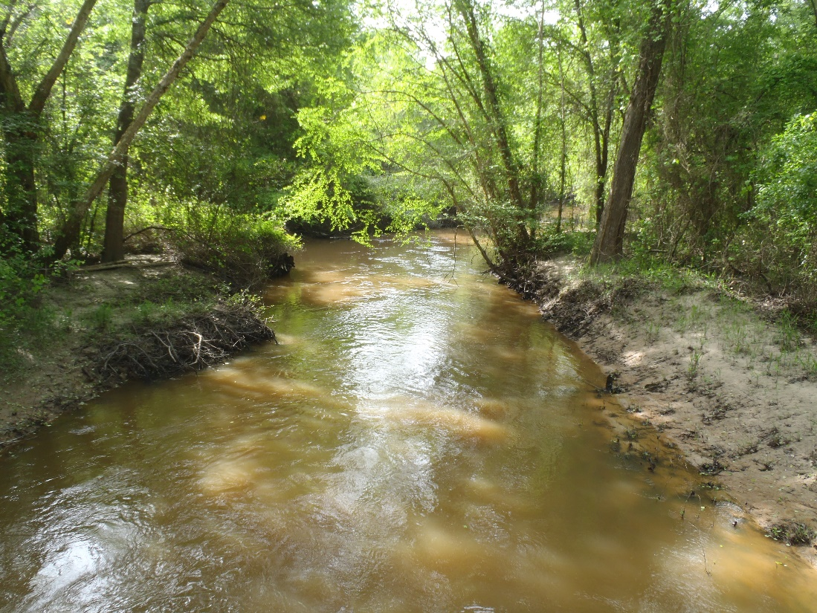

Prepared for:
The Texas State Soil and Water Conservation Board
State Nonpoint Source Grant
Project No. 19-50

Prepared by:
Texas Institute for Applied Environmental Research
TR2102
Spring 2021

This page left intentionally blank

Acknowledgements
Financial support for this report was provided by a State Nonpoint Source Grant through the Texas Sate Soil and Water Conservation Board (TSSWCB) for the project, Characterizing the Kickapoo Creek in Henderson County Watershed (Project No. 19-50). This report was prepared by Leah Taylor, senior project director at TIAER, and Dr. Narayanan Kannan, research scientist. The authors would also like to thank input from stakeholders in the Kickapoo Creek Watershed Partnership.
For more information about this document or any other document TIAER produces, send email to tiaer@tarleton.edu. More information about the Kickapoo Creek project can be accessed from the project website at www.kickapoocreekwpp.com.
Cover photograph is Kickapoo Creek at County Road 3806 in Henderson County (station 22164) taken on April 9, 2020.

Table of Contents

Acknowledgements 3
Table of Contents 4
List of Figures 6
List of Tables 8
Abbrevations 10
Executive Summary 11
Project Description 11
Task 1: Project Administration 12
Subtask 1.1 12
Subtask 1.2 12
Subtask 1.3 12
Subtask 1.4 13
Task 2: Quality Assurance 13
Subtask 2.1 13
Subtask 2.2 13
Task 3: Public Participation and Stakeholder Facilitation 13
Subtask 3.1 13
Subtask 3.2 14
Task 4: Data Inventory and Evaluation for Watershed Characterization and Pollutant Source Identification 14
Subtask 4.1 14
Subtask 4.2 14
Subtask 4.3 15
Task 5: Water Quality Monitoring 15
Subtask 5.1 15
Subtask 5.2 15
Subtask 5.3 15
Conclusion 15
Appendix A: ANRA Clean Rivers Program 2019 Upper Neches Basin Steering Committee Meeting & Basin Highlights Report Presentation 17
Appendix B: ANRA Clean Rivers Program 2019 Upper Neches Basin Steering Committee Meeting & Basin Highlights Report Presentation 18
Appendix C: Public Stakeholder Meeting 19
Appendix D: Kickapoo Creek in Henderson County Watershed Characterization Report 20
Executive Summary 20
Background Information 20
Description of the Watershed 20
Soils and Topography 22
Ecoregions/ Land Use and Land Cover 24
Climate 28
Demographics 29
Water Quality 30
Assessment of Impaired Streams 30
Bacteria 33
Dissolved oxygen 37
Flow 43
Potential Sources of Water Quality Issues 46
Cattle, wildlife and other domestic animals 46
Domestic pets 47
Permitted Discharges 48
Unauthorized Discharges 49
Failing On-Site Sewage Facilities 49
Water Quality Summary 50
Pollutant Source Assessment 50
Introduction 50
Source and Load Determination 51
E-Coli: Load Duration Curves (LDCs) 51
Dissolved Oxygen (DO) Analysis 62
Approach for DO Analysis 62
Analysis of 24-hour DO data 65
Temporal Analysis 71
Correlation Analysis 74
Spatial Analysis 75
Discussions and Conclusions from DO Data Analysis 85
References 87

List of Figures

Figure 1 Watershed and assessment units associated with Segment 0605A, Kickapoo Creek in Henderson County. Insert shows the watershed location within Texas. 21
Figure 2 Kickapoo Creek in Henderson County watershed showing drainage characteristics based on the hydrologic soil group (A: well-drained D: poorly-drained) (https://www.wcc.nrcs.usda.gov/ftpref/wntsc/H&H/training/runoff-curve-numbers1.pdf). 23
Figure 3 Topography of the Kickapoo Creek in Henderson County watershed 24
Figure 4 Ecoregions of the Kickapoo Creek in Henderson County watershed 25
Figure 5 Land cover data for the Kickapoo Creek in Henderson County watershed 26
Figure 6 Average monthly climate of the watershed including total precipitation, normal average, maximum and minimum air temperatures for Tyler, TX (average of 1985 to 2015) 29
Figure 7 TCEQ assessment units and water quality monitoring stations (Portions of the Kickapoo Creek until the water quality monitoring station 22163 comes under A.U. 0605A_02 and the remaining belong to A.U. 0605A_01) 31
Figure 8 E-Coli (MPN/100 mL) concentration in the Kickapoo Creek currently monitored at nine different stations 35
Figure 9 Current data on E-Coli (MPN/100 mL) concentration in the Kickapoo Creek 36
Figure 10 Historic data on E-Coli (MPN/100 mL) concentration in the Kickapoo Creek from Oct. 2000 to Jan. 2017 37
Figure 11 Current data on minimum and average dissolved oxygen concentration (mg/L) (based on the 24 hour data) in the Kickapoo Creek from Aug. 2019 to Dec. 2020 39
Figure 12 Dissolved oxygen saturation (%) in the Kickapoo Creek currently monitored at nine different stations 41
Figure 13 Current data on dissolved oxygen saturation (%) in the Kickapoo Creek 42
Figure 14 Historic data on dissolved oxygen saturation (%) in the Kickapoo Creek 43
Figure 15 Comparison of monthly average streamflow of Kickapoo Creek (estimated using the flow of Neches River at Neches, TX) with limited monitored flow at Brownsboro, TX 44
Figure 16 Comparison of monthly average streamflow of Kickapoo Creek (estimated using the flow of Sabine River at Mineola, TX) with limited monitored flow at Brownsboro, TX 45
Figure 17 Comparison of monthly average streamflow of Kickapoo Creek (estimated using the flow of Neches and Sabine Rivers) with limited monitored flow at Brownsboro, TX 46
Figure 18 Monthly average streamflow trends in the Kickapoo Creek watershed at station 10517 46
Figure 19 Location of wastewater outfalls in the Kickapoo Creek watershed 49
Figure 20 E-coli load duration curve for the Kickapoo Creek watershed at station 22167 (segment 0605A_02). The confidence intervals (CIs) are applicable for the estimated existing loads. 53
Figure 21 E-coli load duration curve for the Kickapoo Creek watershed at station 22166 (segment 0605A_02). The confidence intervals (CIs) are applicable for the estimated existing loads. 53
Figure 22 E-coli load duration curve for the Kickapoo Creek watershed at station 22165 (segment 0605A_02). The confidence intervals (CIs) are applicable for the estimated existing loads. 54
Figure 23 E-coli load duration curve for the Kickapoo Creek watershed at station 16797 (segment 0605A_02). The confidence intervals (CIs) are applicable for the estimated existing loads. 54
Figure 24 E-coli load duration curve for the Kickapoo Creek watershed at station 22164 (segment 0605A_02). The confidence intervals (CIs) are applicable for the estimated existing loads. 55
Figure 25 E-coli load duration curve for the Kickapoo Creek watershed at station 16796 (segment 0605A_02). The confidence intervals (CIs) are applicable for the estimated existing loads. 55
Figure 26 E-coli load duration curve for the Kickapoo Creek watershed at station 22163 (segment 0605A_02). The confidence intervals (CIs) are applicable for the estimated existing loads. 56
Figure 27 E-coli load duration curve for the Kickapoo Creek watershed at station 21618 (segment 0605A_01). The confidence intervals (CIs) are applicable for the estimated existing loads. 56
Figure 28 E-coli load duration curve for the Kickapoo Creek watershed at station 10517 (segment 0605A_01). The confidence intervals (CIs) are applicable for the estimated existing loads. 57
Figure 29 Required E-coli load reduction trends in different water quality monitoring stations 61
Figure 30 Box plot components showing mean, median, 1st and 3rd quartiles, outliers and the upper fence defined as the 3rd quartile plus 1.5 times the Inter Quartile Range (IQR) 64
Figure 31 Scatter plot showing the relationship of 24-hour DO range to Chl-A for data collected in Kickapoo Creek (Data of three stations namely 22166, 22164, and 10517) 67
Figure 32 Scatter plot showing the relationship of 24-hour DO minimum to Chl-A for data collected in Kickapoo Creek (Data of three stations namely 22166, 22164, and 10517) 68
Figure 33 Spatial trends of 24-hr mean DO in the Kickapoo Creek 70
Figure 34 Spatial trends of Chlorophyll-A in the Kickapoo Creek 70
Figure 35 Grab water temperature data plotted by month for stations in Kickapoo Creek (Cool and warm seasons separation at 19.25 ºC) 71
Figure 36 Percent DO saturation plotted by month for stations in Kickapoo Creek (Difference in seasons indicated) 72
Figure 37 Grab DO data plotted by month for stations in Kickapoo Creek (24-hour DO minimum DO criterion indicated by the red line; DO data points shown by different color to indicate seasons) 72
Figure 38 Grab DO data plotted with simultaneously collected water temperature for stations in Kickapoo Creek 73
Figure 39 Percent DO saturation data plotted with water temperature for stations in Kickapoo Creek 74
Figure 40 Box plots of grab dissolved oxygen concentration at stations on Kickapoo Creek 76
Figure 41 Box plots of chlorophyll-A concentration at stations on Kickapoo Creek (screening level is 20 μg/L; one outlier in 16796 (145.9 mg/L warm season data) and one outlier in 22163 (127.6 mg/L warm season data not shown) 77
Figure 42 Box plots of BOD concentration at stations on Kickapoo Creek (one outlier in station 10517 (18 mg/L during warm season) not shown in the box plots) 78
Figure 43 Box plots of total phosphorus concentration at stations on Kickapoo Creek (screening level is 0.66 mg/L; one outlier in station 10517 (3.24 mg/L during warm season not shown) 79
Figure 44 Box plots of orthophosphate concentration at stations on Kickapoo Creek (one outliner in station 10517 (2.55 mg/L during warm season) not shown) 80
Figure 45 Box plots of nitrite and nitrate nitrogen at stations on Kickapoo Creek (screening level 1.1 mg/L) 81
Figure 46 Box plots of ammonia nitrogen concentration at stations on Kickapoo Creek (one outliner in station 10517 (11.36 mg/L during warm season) not shown) 82
Figure 47 Box plots of total Kjeldahl nitrogen at stations on Kickapoo Creek (one outliner in station 10517 (18.68 mg/L during warm season) not shown causative of the depressed DO 83
Figure 48 Spatial patterns in the historic water quality data of Kickapoo Creek 84

List of Tables

Table 1 Watershed identification information 21
Table 2 Land use/land cover classes within the Kickapoo Creek in Henderson County watershed 27
Table 3 Annual Estimates of the Resident Population for Incorporated places 30
Table 4 Projected Estimates of the Resident Population for Incorporated places (Estimated based on the projected population growth for counties) 30
Table 5 Water quality monitoring station IDs in the Kickapoo Creek watershed 32
Table 6 History of water quality impairment in the watershed 32
Table 7 Water Quality data availability for the Kickapoo Creek watershed 33
Table 8 Bacterial impairment status of the Kickapoo Creek 34
Table 9 Dissolved oxygen impairment status of the Kickapoo Creek 38
Table 10 Estimates of cattle, wildlife and other domestic animals in the watershed 47
Table 11 Estimates of domestic pets in the watershed 48
Table 12 Proportion of current (2019-2021) water quality samples exceeding the E-Coli criterion in different sections of the load duration curves (LDCs) 57
Table 13 Proportion of historic water quality samples exceeding the E-Coli criterion in different sections of the load duration curves (LDCs) 58
Table 14 Estimated load reductions needed by flow regime for each water quality monitoring station in the Kickapoo Creek watershed 59
Table 15 Summary of estimated total load reductions needed for each water quality monitoring station in the Kickapoo Creek watershed 62
Table 16 Values of correlation coefficient (r) and corresponding strength of the linear relationship 63
Table 17 Summary of 24-hour deployment DO data for the Kickapoo Creek 66
Table 18 Correlations of 24-hour deployment DO data and different water quality variables for the Kickapoo Creek 69
Table 19 Correlation analysis for percent DO saturation to selected water quality parameters showing r values for stations of Kickapoo Creek in upstream to downstream order 74
Table 20 Correlation analysis of historic data for percent DO saturation to selected water quality parameters showing r values for stations of Kickapoo Creek in upstream to downstream order 75

Abbrevations
Chl-A Chlorophyll-A
DO Dissolved Oxygen
E. coli Escherichia coli
GIS Geographical Information Systems
LDC Load Duration Curve
NED National Evelvation Dataset
QA Quality Assurance
QAPP Quality Assurance Protection Plan
QC Quality Control
QPR Quarterly Progress Report
RUAA Recreational Use Attainability Analysis
SSURGO Soil Survey Geographic Database
SWCD Soil and Water Conservation District
SWQMIS Surface Water Quality Information Systems
TCEQ Texas Commission on Environmental Quality
TSSWCB Texas State Soil and Water Conservation Board

Executive Summary
The bacterial impairment of Kickapoo Creek in Henderson County is classified as 5b indicating that a review of the standards associated with bacteria is needed prior to selecting a management strategy. As part of this standards review, a Recreational Use Attainability Analysis (RUAA) was completed on Kickapoo Creek by TIAER in 2014. Findings of the RUAA (https://www.tceq.texas.gov/waterquality/standards/ruaas/ruaasneches) were submitted by TSSWCB to TCEQ for a potential recommendation of a change in standard from primary recreation to secondary recreation. Upon reviewing RUAA findings, TCEQ did not recommend a change in the recreational standard for Kickapoo Creek, so it remains classified for primary contact recreation.

The DO impairment for Kickapoo Creek in Henderson County is classified as 5c indicating that additional data or information is needed before a management strategy is selected. The DO impairment is based on two 24-hr DO monitoring events, and at least 10 samples are required as adequate data for assessment.

To better assess Kickapoo Creek in Henderson County and identify potential causes and sources of pollution, additional water quality monitoring and a data inventory is needed to characterize the watershed. Stakeholder involvement and understanding of water quality is needed to then determine the best route for dealing with impairments in the watershed.

Project Description
The primary objective of this project was to evaluate existing data within the project area in an effort to characterize causes and sources of pollution in the Kickapoo Creek in Henderson County watershed. Identifying causes and sources of impairments, a comprehensive data inventory of existing information can be invaluable. This includes historical weather, water quality and flow data as well as information estimating wildlife and livestock densities, population characteristics, discharges from wastewater treatment facilities (WWTFs), number of on-site sewage facilities (OSSFs), and other relevant information, such as soils, topography, and land use. Much of this information is available as spatial data that can be displayed as maps via geographic information system (GIS) tools.

GIS analysis will be carried out to identify the sources of pollutants. The data required for doing the GIS analysis include the most recent version of National Land Cover Database (NLCD 2016), the soil map and the associated data from Soil Survey Geographic Database (SSURGO) data, and National Elevation Dataset (NED) (https://catalog.data.gov/dataset/usgs-national-elevation-dataset-ned). For details on livestock operations, cropping system, and irrigation we will use 2017 Agricultural Census data. Types and population of wild animals and domestic pets in the watershed were estimated and included in the analysis, because they are important sources of bacterial impairment of the Kickapoo Creek. Quantity and quality of municipal and industrial wastewater discharged to Kickapoo Creek was obtained from the EPA Enforcement and Compliance Data website or from TECQ permit information.

The watershed does not have a USGS gauging station that records daily flow. Therefore, the average daily flow values were estimated from nearby monitored streams (with similar land cover conditions) based on a drainage area ratio method.

To aid in assessing conditions under which exceedances to bacteria water quality standards occur, load duration curves (LDCs) were developed. The load duration curve (LDC) approach (USEPA 2007), although not based on pollutant fate and transport mechanisms, provides simple ways of understanding the water quality data and interpret information. It uses time series of flow data along with water quality data (observations monitored at infrequent intervals/water quality criterion) to obtain pollutant loads. The approach allows for characterizing the water quality data by relating flow and pollutant loads. It accounts for how stream flow patterns affect changes in water quality during different seasons or flow regimes (high flow, low flow, moist conditions etc.) within a year. The duration curve approach also provided a way to link water quality impairments with watershed processes that are important to identify the pollutant sources and estimate the load reductions (USEPA, 2007). The LDCs of bacteria were developed for Kickapoo Creek watershed as a part of this project. Additionally, analyses were performed using current and historical DO, water quality, and hydrologic data to investigate potential sources of the depressed DO in the Kickapoo Creek.

Task 1: Project Administration
The Texas Institute for Applied Environmental Research (TIAER) has effectively administered, coordinated, and monitored all work performed under this project including technical and financial supervision and preparation of status reports.

Subtask 1.1
To track project progress, TIAER submitted quarterly progress reports (QPRs) to the Texas State Soil and Water Conservation Board (TSSWCB). QPRs documented all activities performed within a quarter and were submitted by the 15th of December, March, June, and September.

Subtask 1.2
TIAER performed accounting functions for project funds and submitted appropriate Reimbursement Forms to TSSWCB quarterly.

Subtask 1.3
TIAER hosted coordination meetings/conference calls, at least quarterly, with Project Partners to discuss project activities, project schedule, communication needs, deliverables, and other requirements. TIAER summarized each meeting in meeting minutes following each project coordination meeting and included them in the QPRs.

Subtask 1.4
TIAER developed a Final Report that summarizes activities completed during the duration of the project as well as the conclusions reached.

Task 2: Quality Assurance
TIAER data quality objectives (DQOs) and quality assurance/control (QA/QC) activities to ensure data of known and acceptable quality are generated throughout this project.

Subtask 2.1
TIAER developed a QAPP for activities in Task 4 and 5 consistent with the most recent versions of EPA Requirements for Quality Assurance Project Plans (QA/R-5) and the TSSWCB Environmental Data Quality Management Plan. All monitoring procedures and methods prescribed in the QAPP were consistent with the guidelines detailed in the TCEQ Surface Water Quality Monitoring Procedures, Volume 1: Physical and Chemical Monitoring Methods for Water, Sediment, and Tissue (RG-415) and Volume 2: Methods for Collecting and Analyzing Biological Assemblage and Habitat Data (RG-416). [Consistency with Title 30, Chapter 25 of the Texas Administrative Code, Environmental Testing Laboratory Accreditation and Certification, which describes Texas’ approach to implementing the National Environmental Laboratory Accreditation Conference (NELAC) standards, shall be required where applicable.] After developing the QAPP, TIAER sent draft and final versions to TSSWCB and a final QAPP document was approved

Subtask 2.2
TIAER implemented the approved QAPP for the development of the Characterizing the Kickapoo Creek in Henderson County Watershed Report and the water quality monitoring. TIAER submitted revisions and amendments of the QAPP to TSSWCB when necessary.

Task 3: Public Participation and Stakeholder Facilitation
One of the primary goals of this project was to increase stakeholder awareness of water quality impairments in the project watershed. TIAER developed and engaged stakeholder groups during the project as best possible. However, due to the global pandemic of COVID-19, restrictions were set in place for organizing educational events and activities. In lieu of public meetings, newsletters via USPS mail and email were sent to stakeholders. Newsletters provided an update on the project tasks and goals.

Subtask 3.1
TIAER identified and met with key stakeholders in the watershed to inform and educate them regarding watershed water quality issues, project findings, and solicit their input on project activities. Unfortunately, due to the global pandemic of COVID-19, project and watershed-wide stakeholder activities were not able to take place due to public health mandates.

Stakeholders included but were not limited to, Trinity – Neches SWCD, Kaufman – Van Zandt SWCD, the local river authority (ANRA), watershed landowners, and watershed municipalities.

Subtask 3.2
TIAER conducted outreach strategies to inform the public about upcoming meetings, status of the project, current and historical water quality, and how the public/stakeholders can address the water quality issues in the watershed. Activities TIAER was able to achieve included:

- Hosting a project webpage (www.kickapoocreekwpp.com)
  - TIAER updated the website monthly with routine monthly monitoring preliminary data and as needed with presentations. The Characterization Report and Final Report are also included on the webpage.
- Meeting and presenting the project to watershed SWCDs, Trinity – Neches SWCD #422 on April 1, 2019 and Kaufman – Van Zandt SWCD #505 on April 3, 2019
- Emails announcing updates and project progress to identified stakeholders; and
- Public meetings
  - Due to the global pandemic of COVID-19, only one public meeting was held on March 3, 2020 in Brownsboro, Texas. Newsletters of project updates were sent to stakeholders in lieu of public meetings during the duration of the project. A newsletter was sent to stakeholders updating them on the progress of the project on August 10, 2020.

TIAER sent TSSWCB all project-related content and materials for review and approval before distribution.

Task 4: Data Inventory and Evaluation for Watershed Characterization and Pollutant Source Identification
TIAER developed a comprehensive inventory of data and information to identify causes and sources of water quality impairments and concerns in the watershed and estimate loading reductions needed to meet water quality standards for bacteria.

Subtask 4.1
TIAER developed a comprehensive inventory for the watershed by assembling existing data and information available. This data inventory includes current and historical weather, water quality and flow data as well as information estimating wildlife and livestock densities, population characteristics, discharges from wastewater treatment facilities (WWTFs), number of on-site sewage facilities (OSSFs), and other relevant information, such as soils, topography, and land use.

Subtask 4.2
TIAER used GIS mapping of information collected with the data inventory (Subtask 4.1) to spatially display potential sources of water quality impairments and concerns in conjunction with water quality information. Water quality for bacteria and flow data (estimated) was used to develop LDCs for bacteria to aid in assessing flow conditions under which exceedances to bacteria water quality standards occur.

Subtask 4.3
Using loading data from causes and sources collected in subtask 4.1 and LDC analyses in subtask 4.2, TIAER estimated pollutant loading reductions needed to meet water quality standards.

Task 5: Water Quality Monitoring
Due to the limited availability of historical water quality data in the Kickapoo Creek watershed, it was determined that monthly water quality monitoring was necessary. TIAER collected additional water quality and flow data to aid with assessment of impairments, identification of sources, and supplement LDC analysis to better characterize impairing parameters within the watershed.

Subtask 5.1
Sites were selected by TIAER and approved by TSSWCB. TIAER conducted site reconnaissance at prospective sample sites identified to determine the suitability of sample collection that will best help characterize the watershed. Once site selection has been finalized, those that needed TCEQ station numbers were submitted for a Station Location requests (SLOC requests).

Subtask 5.2
Water quality monitoring began in August 2019 for the Kickapoo Creek watershed. This included routine, monthly, ambient water quality monitoring at 9 sites. Routine field parameters included water temperature, pH, DO, conductivity, and flow. Water samples will be collected for analysis of E. coli, NH₃-N, TSS, VSS, NO₂-N+NO₃-N, TKN, PO₄-P, TP, BOD, and CHLA. The Angelina - Neches River Authority Laboratory (ANRA) conducted the E. coli analyses. All other laboratory analyses were conducted by TIAER’s laboratory. To provide additional data to aid with assessment of the indicated DO impairment, TIAER conducted 24-hr DO monitoring in conjunction with routine monthly at three locations. Monthly water quality monitoring ended in March 2021.

Subtask 5.3
Every month in which water quality monitoring occurred, ANRA Laboratory transferred completed lab data to TIAER. TIAER maintained a master database of collected data. Data was submitted to TSSWCB by TIAER for submission to the Texas Commission on Environmental Quality (TCEQ) Surface Water Quality Information Systems (SWQMIS) database on a quarterly basis.

Conclusion
Overall, this project was successful in the watershed being accurately characterized through data collection efforts and loadings and loading reductions have been calculated. TIAER worked diligently to complete all project tasks and turn in project deliverables in an appropriate time. TIAER also worked diligently to continue communication to stakeholders during the unforeseen global pandemic of COVID-19.

By completing the “Characterization of Kickapoo Creek in Henderson County Watershed” final report, stakeholders will be knowledgeable in making decisions moving forward in addressing the water quality impairment issues in Kickapoo Creek.

Collaborating with the local river authority, ANRA, helped the project maintain connenctions with stakeholders throughout the project. Additionally, it provided TIAER and watershed stakeholders better resources to understand water quality concerns and issues within the watershed.

Appendix A: Kickapoo Creek in Henderson County Watershed Characterization Report

Executive Summary
Kickapoo Creek in Henderson County has been identified to be impaired for elevated concentrations of Escherichia coli (E. coli) in the 2016 Texas Integrated Report of Surface Water Quality for the Clean Water Act Sections 305(b) and 303(d) (Texas Integrated Report) (TCEQ, 2016). This characterization addresses the E. coli and dissolved oxygen impairments in the Kickapoo Creek watershed through acquisition of historical and direct monitoring data as well as a thorough compilation of land use characteristics that have allowed an assessment of potential sources both spatially and under varying flow conditions.

The project was successful in characterizing the watershed and producing the information needed by stakeholders to determine how best to address the bacteria impairment within the Kickapoo Creek watershed. Stakeholders expressed interest and involvement in moving forward toward the development of a WPP. A project entitled a Kickapoo Creek Watershed Protection Plan will begin in the Spring of 2021. Funding for the WPP will be through the Texas State Soil and Water Conservation Board by a State General Revenue fund.

Background Information

Description of the Watershed
The Kickapoo Creek in Henderson County watershed comprises 176,759 acres and is located almost completely within Henderson County, Texas with a small, northwest portion extending into Van Zandt County (Figure 1, Table 1). Headwaters for Kickapoo Creek in Henderson County are at the confluence of Lake Palestine outside of the City of Chandler in Henderson County and continues into Van Zandt County. Municipalities within the watershed include Edom, Murchison, and Brownsboro. However, the City of Brownsboro is the only municipality along the waterbody.
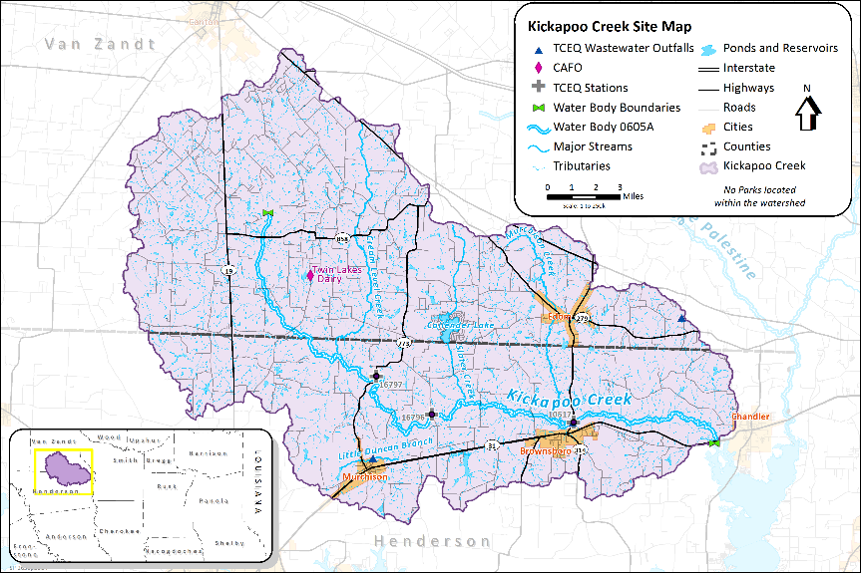
Figure 1 Watershed and assessment units associated with Segment 0605A, Kickapoo Creek in Henderson County. Insert shows the watershed location within Texas

Table 1 Watershed identification information
Watershed | Segment | Hydrologic Unit Code | Size
Kickapoo Creek in Henderson County | 0605A | 120200010201- 0201, 0202, 0203, 0204, 0205, 0206 | 176,759 acres

Segment and assessment units (A.U.s) identified by the Texas Commission on Environmental Quality (TCEQ) in Figure 1 include the following:

- 0605A: Kickapoo Creek in Henderson County from the confluence of Lake Palestine east of Brownsboro in Henderson County to the upstream perennial portion of the stream northeast of Murchison in Henderson County.

- 0605A_01: From the confluence with Lake Palestine (0605) east of Brownsboro in Henderson County to the confluence with Slater Creek (0605E).

- 0605A_02: From the confluence with Slater Creek (0605E) upstream to confluence with unnamed tributary about 1.62 km north of FM 858 in Van Zandt County at NHD RC 120200010000161.

Soils and Topography
The soils and topography of a watershed are important components of watershed hydrology. The slope and elevation define where water will flow, while elevation and soil properties influence how much and how fast water will infiltrate to, flow over, or move through the soil into a water body. Soil properties may also limit the types of development and activities that can occur in certain areas.

Most of the soils (about 62%) in the watershed are well-drained with hydrologic soil groups of A and B (Figure 2). They include the Pickton, Wolfpen, Nahatche, Freestone, Monco, and Bernaldo soil types. A small proportion (about 17%) of soils are moderately drained with the hydrologic soil group of C. Majority of the moderately drained soil come under Cuthbert soil type. Poorly drained soil includes about 21% of the watershed. Majority of them are Woodtell and Derlys soil types. The hydrologic soil group map is shown in Figure 2, with A representing well-drained soils and D identifying poorly-drained soils.

Figure 2 Kickapoo Creek in Henderson County watershed showing drainage characteristics based on the hydrologic soil group (A: well-drained D: poorly-drained) (https://www.wcc.nrcs.usda.gov/ftpref/wntsc/H&H/training/runoff-curve-numbers1.pdf).
Figure 3 Topography of the Kickapoo Creek in Henderson County watershed
Source: National Elevation Dataset (USGS 2021)

The Kickapoo Creek watershed is a predominantly mild-sloping watershed. About 30% of the watershed has less than 2% slope. 43% of the watershed has mild slopes ranging from 2% to 5%. Moderate slopes of 5% to 10% occur in 21% of the area with the remaining 6% area with high slopes. The highest point in the watershed has an elevation of 694 ft (211.5 m) and the lowest point 343 ft (104.5 m) (Figure 3).

Ecoregions/ Land Use and Land Cover
Ecoregions are land areas with ecosystems that contain similar quality and quantity of natural resources (Griffith et al., 2007). The headwaters of Kickapoo Creek in Henderson County lie within the Northern Post Oak Savanna ecoregion (33a) with the lower portion of the watershed within the Tertiary Uplands ecoregion (35a) (Griffith, et al., 2007) (Figure 4). The watershed is primarily rural with only 5% of the watershed comprised of developed land (Figure 4). The dominant land use is hay/pasture comprising 56% of the watershed area largely within the uplands. Riparian areas within the Kickapoo Creek watershed are predominately deciduous forest or woody wetlands transiting to evergreen forest only in the most eastern portion of the watershed. The native deciduous forest is composed mostly of post oak (Quercus stellata), blackjack oak (Quercus marilandica), and black hickory (Carya texana). Some coniferous trees occur, especially among the transitional boundary of Ecoregion 33a and Ecoregion 35a (Griffith et al., 2007). The soils of the watershed are generally well-drained loamy sands or sandy loams in the uplands and frequently flooded loams along the creeks and riparian areas (Stringer, 1998; Hatherly and Mays, 1979). While the riparian areas are largely wooded, frequent flooding and soil wetness severely limits commercial timber production in these areas.

Figure 4 Ecoregions of the Kickapoo Creek in Henderson County watershed
Source: USEPA Eco Regions Level III data

Figure 5 Land cover data for the Kickapoo Creek in Henderson County watershed
Source: 2016 National Land Cover Database (Homer et al. 2020; Yang et al. 2018; Jin et al. 2019).

The land cover for the watershed area was obtained from the National Land Cover Database (NLCD 2016) at 98 ft (30m) resolution (Homer et al. 2020; Yang et al. 2018; Jin et al. 2019). The database is maintained by the U.S. Geological Survey. The proportions of different land cover categories occurring in the watershed are shown in Table 2 along with the corresponding area in acres. The major portion of the Kickapoo Creek watershed is rural with predominant land covers of hay/pasture (56%), forest (22%) and wetlands (12%) (Figure 5). (The land use/land cover categories within the watershed are described as follows from the NLCD legend:

Table 2 Land use/land cover classes within the Kickapoo Creek in Henderson County watershed
Source: 2016 National Land Cover Database (2016 NLCD) (Homer et al. 2020; Yang et al. 2018; Jin et al. 2019).

Land cover category | Area (acres) | Proportion of watershed (%)
Open Water | 2,760 | 1.6%
Developed, Open Space | 3,966 | 2.2%
Developed, Low Intensity | 4,133 | 2.3%
Developed, Medium Intensity | 304 | 0.2%
Developed, High Intensity | 61 | 0.0%
Barren Land | 236 | 0.1%
Deciduous Forest | 977 | 0.6%
Evergreen Forest | 5,802 | 3.3%
Mixed Forest | 32,674 | 18.5%
Shrub/Scrub | 1,290 | 0.7%
Herbaceous | 2,729 | 1.5%
Hay/Pasture | 99,832 | 56.5%
Cultivated Crops | 22 | 0.0%
Woody Wetlands | 20,367 | 11.5%
Emergent Herbaceous Wetlands | 1,607 | 0.9%
TOTAL | 176,759 | 100%

Pasture/Hay – Areas of grasses, legumes, or grass-legume mixtures planted for livestock grazing or the production of seed or hay crops, typically on a perennial cycle. Pasture/hay vegetation accounts for greater than 20% of total vegetation.
Deciduous Forest – Areas dominated by trees generally greater than 5 meters tall, and greater than 20% of total vegetation cover. More than 75% of the tree species shed foliage simultaneously in response to seasonal change.
Woody Wetlands – Areas where forest or shrubland vegetation accounts for greater than 20% of vegetative cover and the soil or substrate is periodically saturated with or covered with water.
Shrub/Scrub – Areas dominated by shrubs; less than 5 meters tall with shrub canopy typically greater than 20% of total vegetation. This class includes true shrubs, young trees in an early successional stage, or trees stunted from environmental conditions.
Cultivated Crops – Areas used for the production of annual crops, such as corn, soybeans, vegetables, tobacco, and cotton, and also perennial woody crops such as orchards and vineyards. Crop vegetation accounts for greater than 20% of total vegetation. This class also includes all land being actively tilled.
Evergreen Forest – Areas dominated by trees generally greater than 5 meters tall, and greater than 20% of total vegetation cover. More than 75% of the tree species maintain their leaves all year. Canopy is never without green foliage.
Developed, Low Intensity – Areas with a mixture of constructed materials and vegetation. Impervious surfaces account for 20% to 49% percent of total cover. These areas most commonly include single-family housing units.
Mixed Forest – Areas dominated by trees generally greater than 5 meters tall, and greater than 20% of total vegetation cover. Neither deciduous nor evergreen species are greater than 75% of total tree cover.
Developed, Open Space – Areas with a mixture of some constructed materials, but mostly vegetation in the form of lawn grasses. Impervious surfaces account for less than 20% of total cover. These areas most commonly include large-lot, single-family housing units, parks, golf courses, and vegetation planted in developed settings for recreation, erosion control, or aesthetic purposes.
Open Water – Areas of open water, generally with less than 25% cover of vegetation or soil.
Grassland/Herbaceous – Areas dominated by graminoid or herbaceous vegetation, generally greater than 80% of total vegetation. These areas are not subject to intensive management such as tilling, but can be utilized for grazing.
Emergent Herbaceous Wetlands – Areas where perennial herbaceous vegetation accounts for greater than 80% of vegetative cover and the soil or substrate is periodically saturated with or covered with water.
Barren Land (Rock/Sand/Clay) – areas of bedrock, desert pavement, scarps, talus, slides, volcanic material, glacial debris, sand dunes, strip mines, gravel pits and other accumulations of earthen material. Generally, vegetation accounts for less than 15% of total cover.
Developed, Medium Intensity – Areas with a mixture of constructed materials and vegetation. Impervious surfaces account for 50% to 79% of the total cover. These areas most commonly include single-family housing units.
Developed High Intensity – Highly developed areas where people reside or work in high numbers. Examples include apartment complexes, row houses, and commercial/industrial. Impervious surfaces account for 80% to 100% of the total cover.

Climate
There is no active weather station recording precipitation and temperature data within the Kickapoo Creek watershed. The closest weather stations in proximity to the watershed are located in Tyler, Texas (Tyler Pounds Field GHCND: USW00013972) and Athens, Texas (Athens Municipal Airport: KF44). Both Tyler and Athens stations show more or less similar weather patterns. To show the average climate for the watershed, data from Tyler (population 104,789 based on the United States Census Bureau, 2019) was used in this report. The average annual precipitation is about 48 inches (1,200 mm). The watershed receives some type of precipitation every month, however, March and December are the rainiest months and May and November are the least rainy months (Figure 6). Summers are usually hot with maximum temperature in the 90s ºF and minimum temperature in the 70s ºF. Spring and fall temperatures range from 40s ºF and 50s ºF for the minimum and 60s ºF and 70s ºF for the maximum. Snowfall in the winter is rare to none with maximum temperature in the 50s ºF and minimum temperature in the 30s ºF (Figure 6).

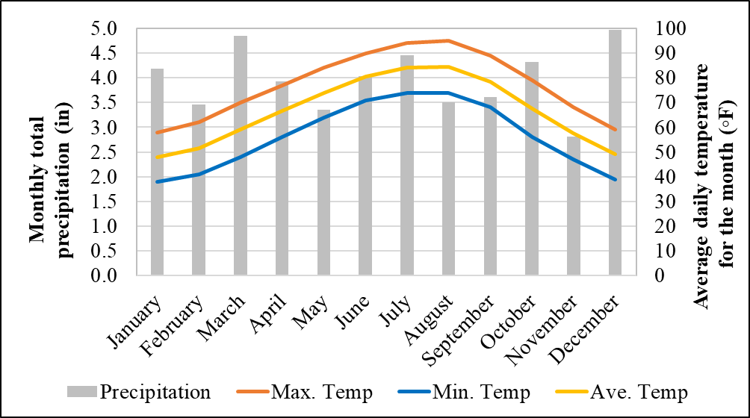
Figure 6 Average monthly climate of the watershed including total precipitation, normal average, maximum and minimum air temperatures for Tyler, TX (average of 1985 to 2015)
Source: NOAA 2021 and timeanddate.com

Demographics
Population estimations for the Kickapoo Creek in Henderson County watershed were developed using the annual estimates of the resident population for incorporated places (U.S. Census Bureau, (USCB 2019) and the 911 address database (911.gov; tnris.org) that has the information on number of households. The estimates shown in Table 3 are of the most recent last 10 years. Edom, Murchison, and Brownsboro are the cities in the watershed for which population estimates are available. Majority of the watershed is rural and the rural population is estimated by clipping the 911 address database of both Van Zandt and Henderson counties (together) with the Kickapoo Creek watershed boundary. The number of rural households within the watershed obtained in the previous step (6,476) is multipied by the average population per household (2.84/household for Texas (https://www.statista.com/statistics/242265/average-size-of-us-households-by-state/) to estimate the total population within the watershed. The total estimated watershed population is about 20,662. The most recent estimate (of year 2019) shows the population of 392,599 and 1279 respectively for Edom, Murchison, and Brownsboro. From table 3, what we can notice immediately is that there is a 14% increase in the estimated population of Brownsboro from 2016 to 2017. Edom and Murchison show more or less a steady population over a period of 10 years from 2010. Table 4 shows projected population growth in the watershed from 2020 to 2050. The trend shows a slight increase in population until 2030 and a small decrease thereafter until 2050. Barring a 14% reduction of Brownsboro population in the future there is nothing important to notice from the projected population estimates. The total current population in the watershed is not expected to change dramatically in the next three decades.
Table 3 Annual Estimates of the Resident Population for Incorporated places
Source: USCB, 2019
Year | 2010 | 2011 | 2012 | 2013 | 2014 | 2015 | 2016 | 2017 | 2018 | 2019
Edom | 373 | 372 | 369 | 369 | 371 | 373 | 382 | 386 | 389 | 392
Murchison | 592 | 590 | 592 | 585 | 589 | 587 | 591 | 594 | 599 | 599
Brownsboro | 1,044 | 1,044 | 1,044 | 1,045 | 1,063 | 1,069 | 1,076 | 1,227 | 1,250 | 1,279
Rural |  |  |  |  |  |  |  |  |  | 18,392
Watershed total |  |  |  |  |  |  |  |  |  | 20,662
Table 4 Projected Estimates of the Resident Population for Incorporated places (Estimated based on the projected population growth for counties)
Source of data for the estimates: Texas Demographic Center (TDC 2021)
Year | 2020 | 2025 | 2030 | 2035 | 2040 | 2045 | 2050
Edom | 381 | 388 | 393 | 396 | 396 | 398 | 400
Murchison | 594 | 597 | 598 | 595 | 589 | 584 | 578
Brownsboro | 1,081 | 1,088 | 1,089 | 1,084 | 1,073 | 1,063 | 1,053

Water Quality

Assessment of Impaired Streams
Under the Federal Clean Water Act (CWA) section 303(d) and 305(b), the State of Texas is required to identify water bodies that are unable to meet water quality standards for their designated uses. The Texas Commission on Environmental Quality (TCEQ) assigns unique "segment" identifiers to each water body. Locations within a segment are broken up into hydrologically distinct assessment units (A.U.s). The A.U.s are evaluated every two years to determine if they meet designated water quality standards, and those that are not meeting requirements are listed on the 303(d) List in the Texas Integrated Report (TCEQ, 2020):
https://www.tceq.texas.gov/assets/public/waterquality/swqm/assess/20txir/2020_303d.pdf
TCEQ defines the designated uses for all water bodies, which in turn establishes the water quality criteria to which a water body must adhere. Currently, Kickapoo Creek in Henderson County watershed must meet "primary contact recreation" uses and support aquatic life use. The water quality for recreation use is evaluated by measuring concentrations of fecal indicator bacteria in 100 milliliters (mL) of water. Aquatic life use is a measure of a water body's ability to support a healthy aquatic ecosystem. Aquatic life use is evaluated based on the dissolved oxygen (D.O.) concentration, toxic substance concentrations, ambient water and sediment toxicity, and indices of habitat, benthic macroinvertebrates, and fish communities. General use water quality requirements also include measures of temperature, pH, chloride, sulfate, and total dissolved solids. Currently, water bodies are also screened for levels of concern for nutrients and chlorophyll-a.

According to the 2020 Texas Integrated Report and 303(d) List (TCEQ, 2020), both A.U.s on Kickapoo Creek are impaired due to elevated levels of bacteria (Table 5, Table 6 Figure 7). Kickapoo Creek also has one A.U. impaired with depressed dissolved oxygen (0605A_01) (Table 6). The historic water quality impairment status of the stream is also shown in Table 6. Water quality is monitored at designated sites throughout the watershed. The TCEQ Surface Water Quality Monitoring Program (SWQM) coordinates the collection of water quality samples at specified water quality monitoring sites in the watershed and state.

Figure 7 TCEQ assessment units and water quality monitoring stations (Portions of the Kickapoo Creek until the water quality monitoring station 22163 comes under A.U. 0605A_02 and the remaining belong to A.U. 0605A_01)
Table 5 Water quality monitoring station IDs in the Kickapoo Creek watershed
Upstream---------------------------------------------------------------------------------Downstream
Segment 0605A_02 |  |  |  |  |  |  | Segment 0605A_01
22167 | 22166 | 22165 | 16797 | 22164 | 16796 | 22163 | 21618 | 10517
Table 6 History of water quality impairment in the watershed
Year | Bacteria impairment category |  | Dissolved Oxygen impairment category
 | Seg0605A_02 | 0605A_01 | 0605A_02 | 0605A_01
2020 | 5c | 5c |  | 5c
2018 | 5c | 5c |  | 5c
2016 | 5b | 5b |  | 5c
2014 | 5b | 5b |  | 5c
2012 |  | 5b |  | 5c
2010 |  | 5c |  | 5c
2008 |  | 5c |  | 5c
2006 |  | 5c |  | 5c
2004 |  | 5c
2002 |  | 5c
2000 | Not supported for contact recreation | Not supported for contact recreation

TIAER conducted routine, monthly, ambient water quality monitoring at nine sites in the Kickapoo Creek in Henderson County watershed from 2019 – 2021 (Figure 7, Table 5). Routine field parameters included water temperature, pH, D.O., conductivity, and flow. Water samples were collected for analysis of E. coli, NH₃-N, TSS, VSS, NO₂-N+NO₃-N, TKN, PO₄-P, T.P., BOD, and CHLA. To provide additional data to aid with assessment of the indicated D.O. impairment, TIAER conducted 24-hr D.O. monitoring in conjunction with routine monthly at three locations (sites 10517, 22164, and 22166). Also, some historic water quality samples available in sites 16796, 16797, and 10517 were also used to support the analysis (Table 7).

Table 7 Water Quality data availability for the Kickapoo Creek watershed
(*Instantaneous discharge)
Monitoring Station Description | Station ID | Period of data availability
 |  | Flow* | TSS | Nitro-gen | Phos-phorus | DO | BOD | Bacteria
Kickapoo Creek at FM 858 | 22167 | 2019-2020 | 2019-2020 | 2019-2020 | 2019-2020 | 2019-2020 | 2019-2020 | 2019-2020
Kickapoo Creek at Van Zandt CR 4206 | 22166 | 2019-2020 | 2019-2020 | 2019-2020 | 2019-2020 | 2019-2020 | 2019-2020 | 2019-2020
Kickapoo Creek at FM 1861 | 22165 | 2019-2020 | 2019-2020 | 2019-2020 | 2019-2020 | 2019-2020 | 2019-2020 | 2019-2020
Kickapoo Creek at FM 733 near Murchison | 16797 | 2008-2018  2019-2020 | 2008-2016  2019-2020 | 2008-2016  2019-2020 | 2008-2016  2019-2020 | 2000-2016  2019-2020 | 1999-2000  2019-2020 | 2008-2017  2019-2020
Kickapoo Creek at Henderson CR 3806 | 22164 | 2019-2020 | 2019-2020 | 2019-2020 | 2019-2020 | 2019-2020 | 2019-2020 | 2019-2020
Kickapoo Creek at FM 1803 | 16796 | --  2019-2020 | 2005-2008  2019-2020 | 2005-2008  2019-2020 | 2000-2008  2019-2020 | 2000-2008  2019-2020 | 1999-2000  2019-2020 | 2005-2008  2019-2020
Kickapoo Creek upstream of Henderson CR 3520 | 22163 | 2019-2020 | 2019-2020 | 2019-2020 | 2019-2020 | 2019-2020 | 2019-2020 | 2019-2020
Kickapoo Creek at Henderson 3514 | 21618 | ---  2019-2020 | ---  2019-2020 | 2015-2017  2019-2020 | 2015-2017  2019-2020 | ---  2019-2020 | ---  2019-2020 | ---  2019-2020
Kickapoo Creek at FM 314 near Brownsboro | 10517 | 1978-1986  2019-2020 | 1997-2010  2019-2020 | 1997-2010  2019-2020 | 1999-2010  2019-2020 | 1997-2010  2019-2020 | 1998-2000  2019-2020 | 2000-2010  2019-2020

Bacteria
As previously mentioned, concentrations of fecal indicator bacteria are evaluated to assess illness risk during contact recreation. In freshwater environments, concentrations of E. coli bacteria are measured to determine fecal contamination in water bodies from warm-blooded animals and other sources. The presence of fecal indicator bacteria may indicate that associated pathogens from the intestinal tracts of warm-blooded animals could reach water bodies and cause illness in people that recreate in them. Indicator bacteria can originate from numerous sources, including wildlife, livestock, domestic pets, malfunctioning OSSFs, non-point source urban and agricultural runoff, sanitary sewer overflows, and direct discharges from wastewater treatment facilities (WWTFs). Under the primary contact recreation standards, the geometric mean criterion for bacteria is 126 most probable number (MPN) of E. coli per 100mL.
The Kickapoo Creek was evaluated using seven years of monitored data from December 2011 with a geometric mean criterion of 126 MPN/100 mL as the standard. Both the upstream and downstream segments (AUs 0605A_01 and 0605A_02) have exceeded the geometric mean criteria, and therefore they are declared impaired in the 2020 Texas Integrated Report (Table 8).
Table 8 Bacterial impairment status of the Kickapoo Creek
Source: 2020 Texas Integrated Report, Observations used from 12/01/2011 to 11/30/2018 to obtain E-Coli geometric mean.
Assessment Unit | Description | E-Coli Geometric mean (MPN/100 mL) | Support Status
0605A_01 | From the confluence with Lake Palestine (0605) east of Brownsboro in Henderson County to the  confluence with Slater Creek (0605E). | 307.47 | Not supporting
0605A_02 | From the confluence with Slater Creek (0605E) upstream to confluence with unnamed tributary about 1.62 km north of FM 858 in Van Zandt County at NHD RC 12020001000161. | 287.89 | Not supporting

E. coli concentrations are currently measured at nine stations throughout the watershed (Table 7 and figures 7 to 9) by the TIAER monitoring team; two stations in the A.U. 0605A_01 and seven stations in the A.U. 0605A_02. With respect to the WQ criterion of 126 MPN/100 mL, all the stations show E-Coli concentrations exceeding the criterion with the maximum exceedances (for the total number of samples) in station 22167 the most upstream station and minimum exceedances in 22163 one of the downstream stations. Looking at the entire Kickapoo Creek including data from all the nine stations (Figure 9), 74% of the water samples (114 samples/153 total) monitored show E. coli exceedances in the Kickapoo Creek. Some historic E. coli concentrations monitored in the previous years are also available for three stations namely 16796, 16796, and 10517 (Table 7, Figure 10). Similar to the current data, the historic data also shows significant number of E-coli exceedances in the Kickapoo Creek. The entire historic Kickapoo Creek E-Coli data shows about 71% (67 samples/94 total) of the data samples showing deteriorating water quality when compared to the stipulated water quality criterion. The individual proportions of samples exceeding the E. coli criterion in the historic data are 74%, 58% and 73% for the stations 16797, 16796, 10517 respectively.
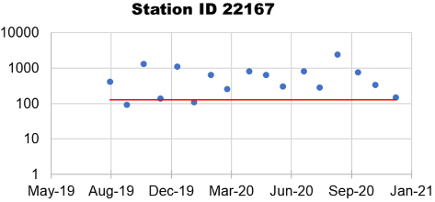 | 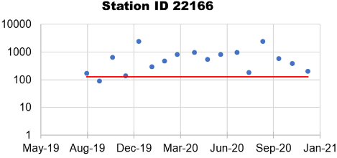 | 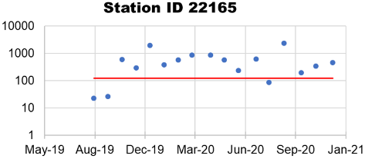
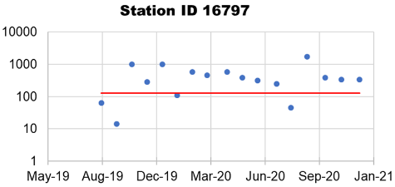 | 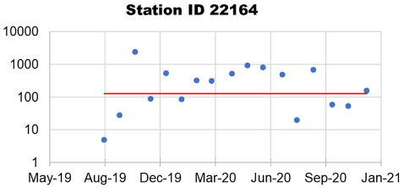 | 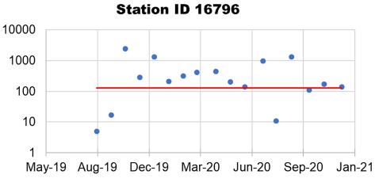
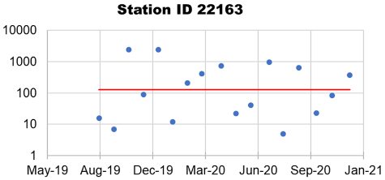 | 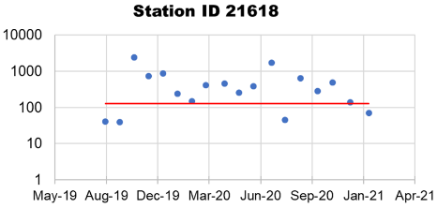 | 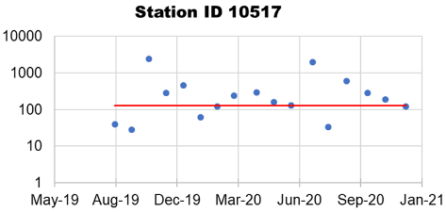

Figure 8 E-Coli (MPN/100 mL) concentration in the Kickapoo Creek currently monitored at nine different stations
Note: Data shown for stations from upstream to downstream in the order for the period Aug. 2019 to Dec. 2020, Red line indicates the E-Coli water quality criterion of 126 MPN/100 mL, data points above the red line indicate non-compliance, y-axis is plotted in log scale.

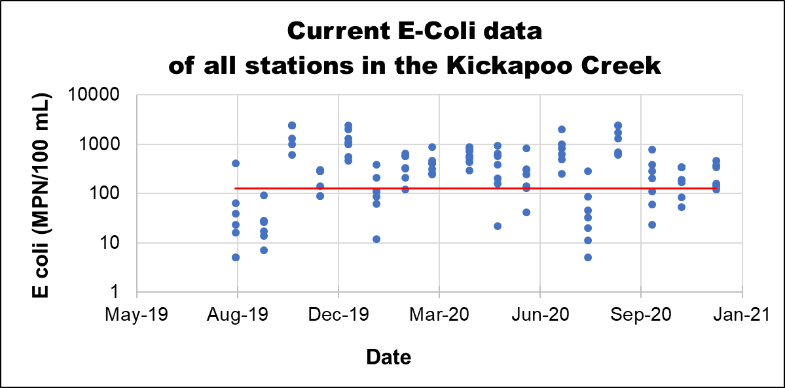
Figure 9 Current data on E-Coli (MPN/100 mL) concentration in the Kickapoo Creek
Note: Data shown for all the stations in the creek from Aug. 2019 to Dec. 2020, Red line indicates the E-Coli water quality criterion of 126 MPN/100 mL, data points above the red line indicate non-compliance, y-axis is plotted in log scale.
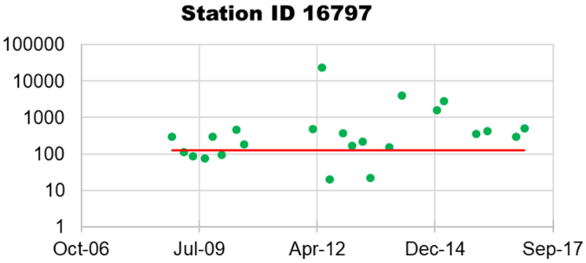 | 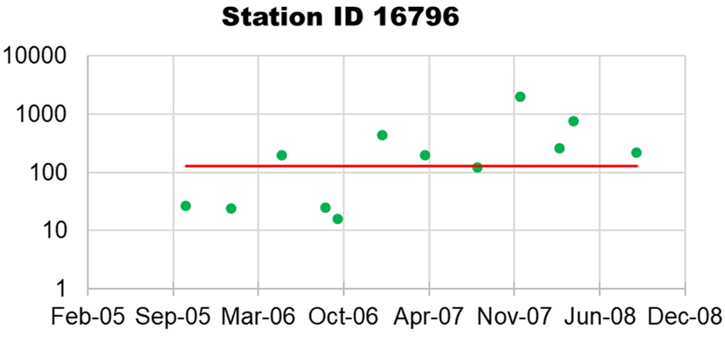
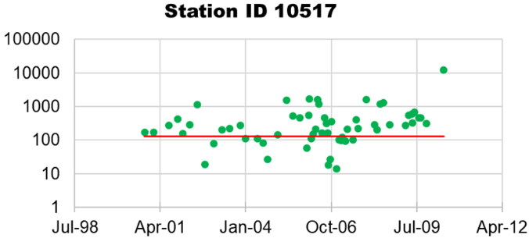 | 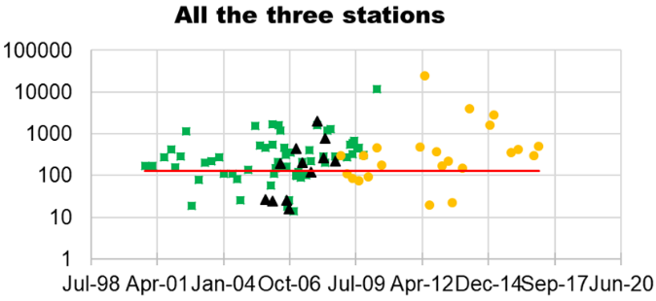

Figure 10 Historic data on E-Coli (MPN/100 mL) concentration in the Kickapoo Creek from Oct. 2000 to Jan. 2017
Note: The first three graphs show data for the three individual stations in the creek. The fourth graphs shows data of all the three stations. Red line indicates the E-Coli water quality criterion of 126 MPN/100 mL, data points above the red line indicate non-compliance, y-axis is plotted in log scale.

Dissolved oxygen
Dissolved Oxygen (DO) is essential for aquatic organisms to survive and refers to the concentration of oxygen gas incorporated into the water. DO concentrations fluctuate in the environment, but anthropogenic activities can contribute to excessive organic matter and nutrients, consequently depressing DO concentrations. Every water body assessed by the Texas State Water Quality Standards is assigned an aquatic life-use (ALU) category of either minimal, limited, intermediate, high, or exceptional. To ensure that water bodies protect these ALU categories, DO criteria are implemented. Classified water bodies must meet an average DO criterion measured over 24 hours and a minimum DO criterion (TCEQ, 2020). Unclassified streams are assigned an ALU based upon the specific segment's flow-type, categorized as perennial, intermittent with perennial pools, and intermittent without perennial pools. Specific DO criteria are associated with each unclassified stream type unless a site-specific ALU has been assigned to the unclassified water body. The 24-hour average D.O. criteria are measured over 24 hours, and sampling events occur at various times throughout the year to represent unbiased and seasonally representative data. When 24-hour average D.O. is not available, grab D.O. measurements are utilized and include a minimum criterion and screening level criterion (TCEQ, 2020).

The DO status of the Kickapoo Creek in Henderson County watersheds was evaluated using the seven years of historical data from December 2011 (Table 9) against the DO standards and reported in the 2020 Texas Integrated Report. The downstream segment (AU 0605A_01) had low DO, and therefore it was declared as not supporting. However, the upstream segment (0605A_02) is fully supporting the DO criterion (Table 9).

Grab DO concentrations are currently measured at nine stations throughout the watershed (Table 7 and Figure 7) by the TIAER monitoring team; two stations in the A.U. 0605A_01 and seven stations in the A.U. 0605A_02. In addition, 24 hour DO is continuously monitored in three out of those nine stations (22166, 22164, and 10517). Some historical DO concentrations monitored in the previous years are also available for three stations: 16796, 16796, and 10517 (Table 7). The grab DO concentrations were converted to dissolved oxygen saturation (DOsat) based on the method outlined in https://projects.ncsu.edu/cals/course/zo419/oxygen.html using water temperature, DO concentrations, and the elevation of the station.
Table 9 Dissolved oxygen impairment status of the Kickapoo Creek
Source: 2020 Texas Integrated Report, Observations used from 12/01/2011 to 11/30/2018 to obtain E-Coli geometric mean.
Assessment Unit | Description | DO grab minimum (mg/L) | Support Status
0605A_01 | From the confluence with Lake Palestine (0605) east of Brownsboro in Henderson County to the  confluence with Slater Creek (0605E). | 1.33 (1/3 exceedances) | Not supporting
0605A_02 | From the confluence with Slater Creek (0605E) upstream to confluence with unnamed tributary about 1.62 km north of FM 858 in Van Zandt County at NHD RC 12020001000161. | NA (0/18 exceedances) | Fully supporting

When studying 24hour DO data, with respect to the average DO criterion of 3 mg/L, 0% (0/17 samples), 18% (3/17 samples) and 24% (4/17 samples) of water samples are below the criterion for the stations 22166, 22164, and 10517 respectively (Figure 11). With reference to the minimum DO criterion of 2 mg/L, 0% (0/17), 18% (3/17), and 24% (4/17) of water samples are below the criterion for the stations 22166, 22164, and 10517 respectively (Figure 11). The two downstream stations show some DO concentrations below the criterion with the upstream station 22166 showing no water samples below the DO minimum or average (Figure 11). Looking at the entire Kickapoo Creek including data from all the three stations (Figure 11), 14% of the water samples (7 samples/51 total) monitored show DO concentrations below the minimum criterion and 14% of the water samples (7/51) show DO concentrations below the average criterion in the Kickapoo Creek. Historic data on 24 hour DO was not available and therefore they will not be discussed in this report.

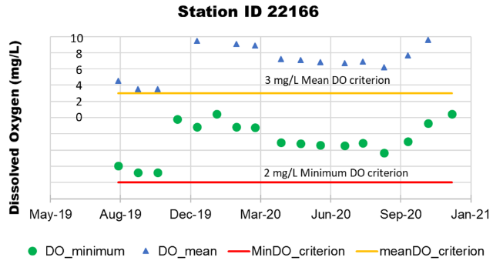 | 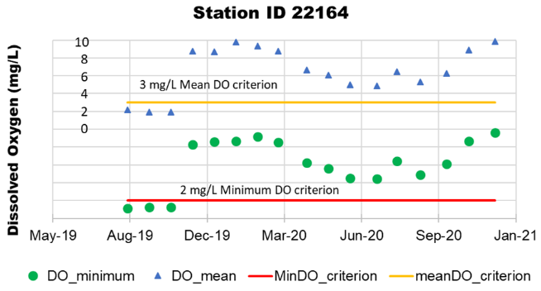
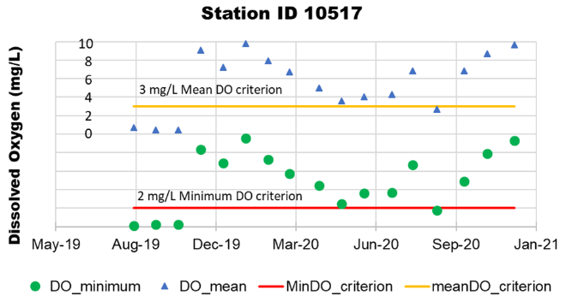 | 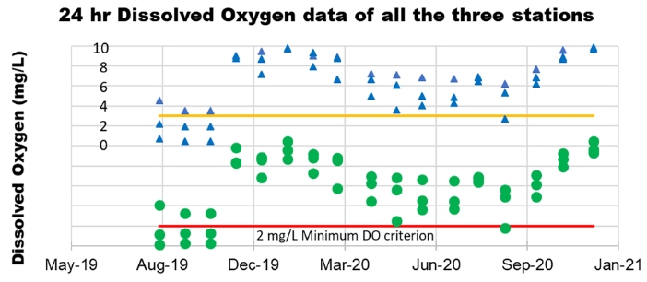

Figure 11 Current data on minimum and average dissolved oxygen concentration (mg/L) (based on the 24 hour data) in the Kickapoo Creek from Aug. 2019 to Dec. 2020
Note: The first three graphs show data for the three individual stations in the creek. The fourth graph shows data of all the three stations. Red line indicates the minimum water quality criterion of 2 mg/L and the orange line indicates the mean water quality criterion of 3 mg/L, data points below the red line or orange line indicate non-compliance.

Current data on grab DO monitored at the nine stations are converted to DOsat and classified into four categories as >90% DOsat: excellent; >75 and <90: good; >60 and <75: fair; and <60: poor (Figure 12). This categorization was created for easy interpretation of results and not based on any stipulated standards. The categorization of DOsat results of water samples for each station is shown in figure 12. All the stations show samples under all the categories. However, only a small portion of them fall under poor DOsat quality (Figure 12). There appears to be a trend in DOsat data. As we move downstream, the number of poor DOsat quality water sample increases and vice versa. Considering the DOsat data from all the stations (Figure 13), majority of the water samples collected in the nine stations fall under the category of good (46.4%), followed by fair (31.4%), poor (18.3%), and excellent (3.9%).
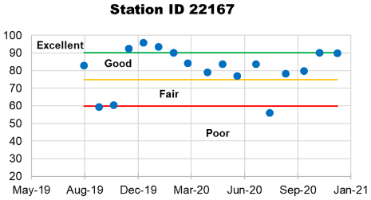 | 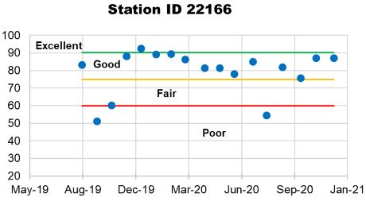 | 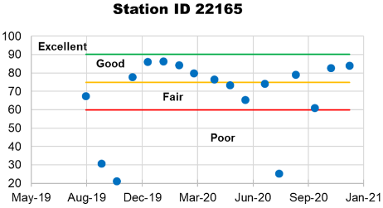
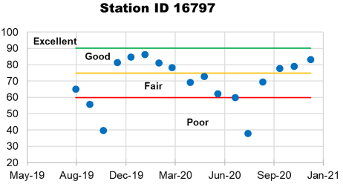 | 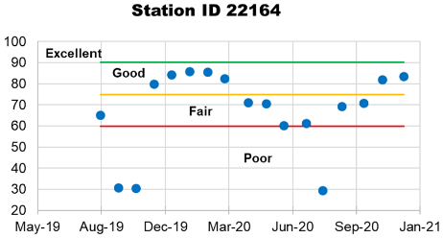 | 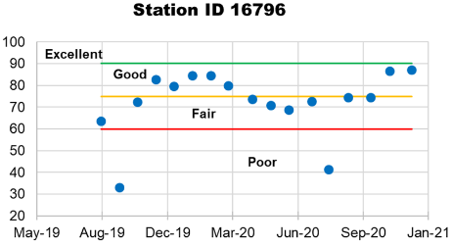
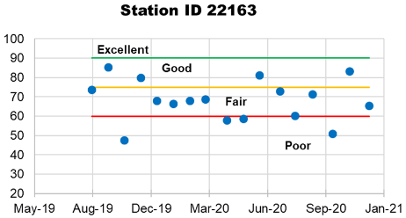 | 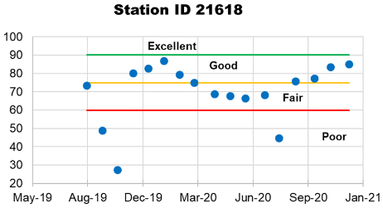 | 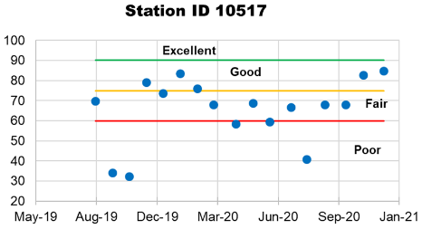
Figure 12 Dissolved oxygen saturation (%) in the Kickapoo Creek currently monitored at nine different stations
Note: Data shown for stations from upstream to downstream in the order for the period Aug. 2019 to Dec. 2020. The data shown are based on the grab water quality samples collected at each monitoring station. Numbers closer to 100 are desirable and closer to 0 are not desirable.
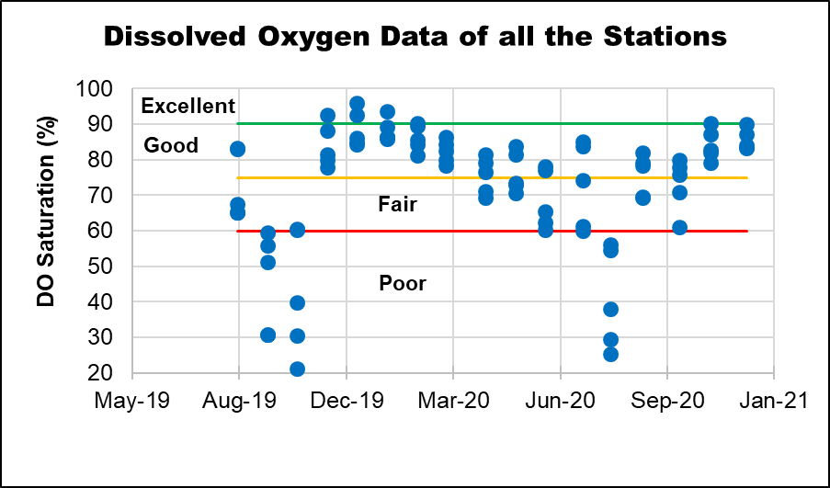
Figure 13 Current data on dissolved oxygen saturation (%) in the Kickapoo Creek
Note: Data shown for all the water quality stations for the period Aug. 2019 to Dec. 2020. The data shown are based on the grab water quality samples collected at all the monitoring stations. Numbers closer to 100 are desirable and closer to 0 are not desirable.
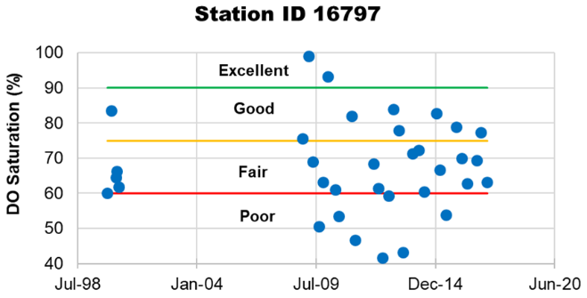 | 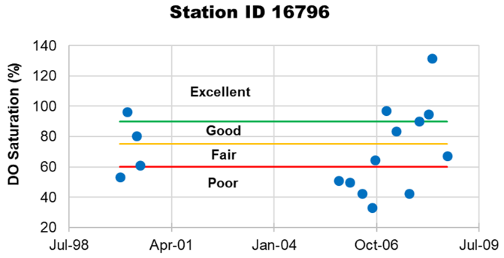
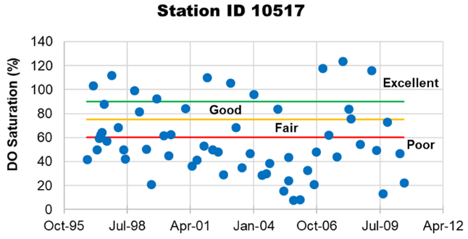 | 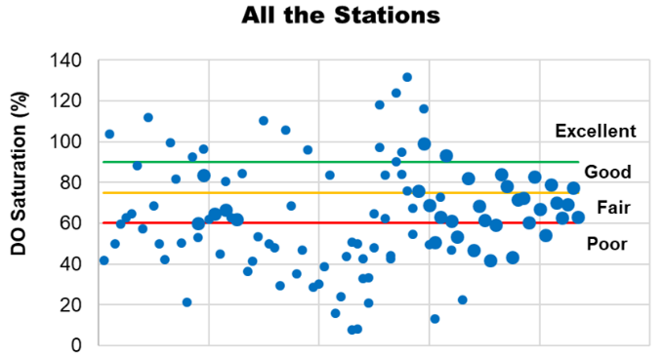

Figure 14 Historic data on dissolved oxygen saturation (%) in the Kickapoo Creek
Note: The first three graphs show data for the three individual stations in the creek. The fourth graph shows data of all the three stations. Data points below red line indicates poor dissolved oxygen saturation (DOsat) (<60%), data points in between red and yellow lines (60 to 75 % DO saturation) show fair quality, points within yellow and green lines (>75 and <90) mean good DOsat, and those above green (>90% DOsat) indicate excellent DO conditions in the stream. The quality categorization is suggestive for easy interpretation of dissolved oxygen results and not based on any stipulated standards.

Some historic grab DO concentrations monitored in the previous years are also available for three stations namely 16796, 16796, and 10517 (Table 7, Figure 14). Unlike the current data, the historic data shows significant number of water samples showing poor DO saturation in the Kickapoo Creek. The entire historic Kickapoo Creek DO saturation data shows about 43% of the data samples showing poor DO saturation and 26% of the samples show fair DO saturation. About 15% and 16% of the historic water samples show good and excellent categories (Figure 14). The maximum number of poor DOsat water samples occur in the most downstream station (10517) of the Kickapoo Creek.

Flow
Generally, the amount of water flowing in a stream at a given time is dynamic and always changing in response to natural (e.g., precipitation events) and anthropogenic (e.g., changes in land cover) factors. From a water quality perspective, streamflow is essential because it influences a water body's ability to assimilate pollutants.

A United States Geological Survey (USGS) streamflow gauge (Gauge ID: 08031200) continuously monitored streamflow data from 05/01/1962 until 09/29/1989. The gauge was located near Brownsboro, TX. However, the continuous monitoring was discontinued in 1989, and more recent data on daily streamflow was not available for this watershed. However, instantaneous streamflow information is available for all the nine stations, along with the water quality data. Therefore, continuous streamflow data was estimated for all the nine stations (where the water quality is currently monitored) based on the Drainage-Area Ratio method (DAR).

In the Drainage-Area Ratio Method (DAR), streamflow data from the source station (where continuous flow data is available) will be converted to flow per unit area (ft³/sec of discharge/mi²) by dividing each value of the time series with the drainage area corresponding to the source station. The flow per unit area time series from the source station will be used to estimate the flow data for the target location by simply multiplying the drainage area of the target location. When multiple source stations are involved to estimate flow for a single target station, appropriate weights need to be used.
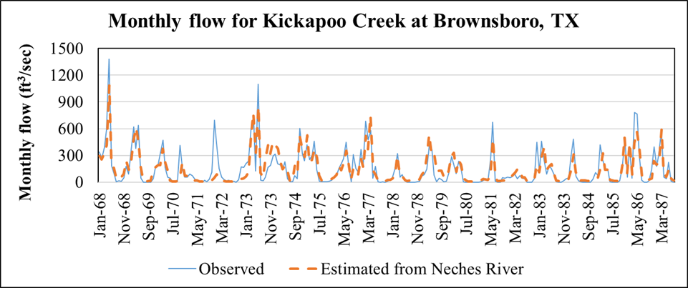
Figure 15 Comparison of monthly average streamflow of Kickapoo Creek (estimated using the flow of Neches River at Neches, TX) with limited monitored flow at Brownsboro, TX

To estimate the streamflow of Kickapoo Creek two nearby stations with similar watershed characteristics (to that of Kickapoo Creek) are available. They are Neches river at Neches, TX and Sabine river at Minneola, TX. Although Kickapoo Creek is a part of the Upper Neches river watershed, it could have been adequate to use the gauge available at Neches river at Neches, TX alone. However, using the flow data from this gauge alone resulted in under-estimation of peaks and completely missing one runoff event (Figure 15). This was verified using limited flow observations monitored for the Kickapoo Creek at Brownsboro, TX (Figure 15).

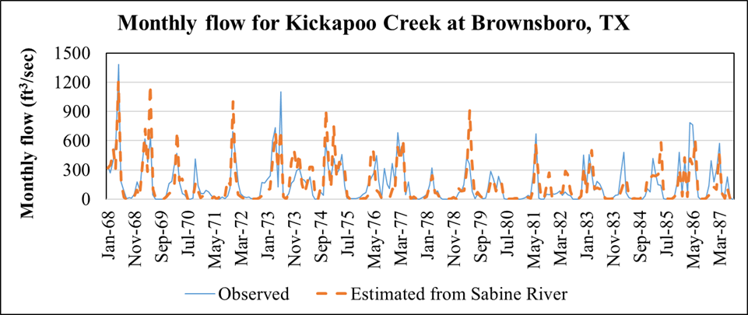
Figure 16 Comparison of monthly average streamflow of Kickapoo Creek (estimated using the flow of Sabine River at Mineola, TX) with limited monitored flow at Brownsboro, TX

Using data from Sabine river alone also had problems in adequately reproducing the flow patterns. Majority of the flow peaks were over-estimated and some under-estimated (Figure 16). However, using a combination of the two stations (with equal weights) produced the flow patterns and magnitudes adequately for the Kickapoo Creek watershed (Figure 17).

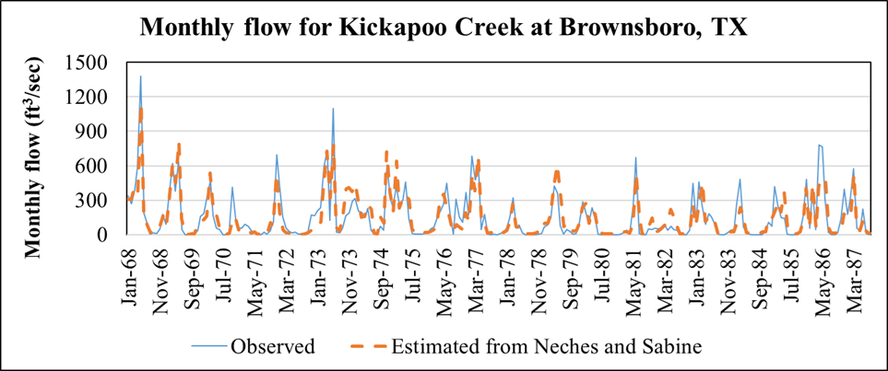
Figure 17 Comparison of monthly average streamflow of Kickapoo Creek (estimated using the flow of Neches and Sabine Rivers) with limited monitored flow at Brownsboro, TX

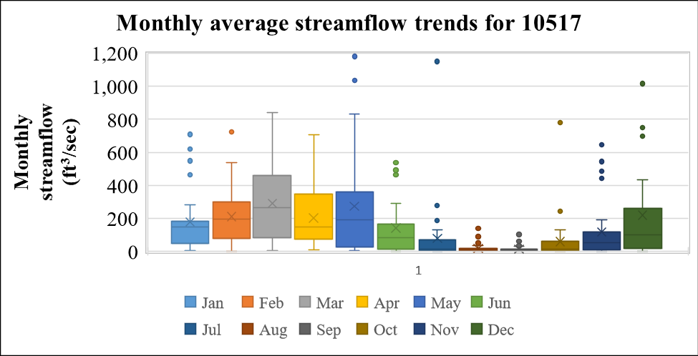
Figure 18 Monthly average streamflow trends in the Kickapoo Creek watershed at station 10517

Although daily streamflow values are required for the project to develop LDCs, they are not shown in this report because of noise in the data. However, the monthly streamflows are shown here (Figures 17 and 18) for better interpretation of the trends, patterns and magnitudes. Although figure 18 shows trends only for the station 10517, similar trends were seen in the other eight stations as well because the source of flow data is the same and the only variable changing flow is the drainage area of each water quality station in the Kickapoo Creek. With respect to the average flow in the creek, August and September are the driest months and March to May the wettest months in the watershed.

Potential Sources of Water Quality Issues

Cattle, wildlife and other domestic animals
Domestic livestock, particularly cattle, are common throughout the watershed. Runoff from precipitation events can transport fecal matter, nutrients and bacteria from pastures and rangeland into nearby creeks and streams. Livestock with direct access to streams can also wade and defecate directly into water bodies resulting in direct contributions of bacteria and nutrients to the water. Streamside riparian buffers, fencing, and grazing practices that reduce the time livestock spend near streams can reduce livestock impacts on water quality.

Watershed-level livestock numbers are not available. Therefore, the populations were estimated using the USDA Agricultural Census dataset (2017 Agricultural Census). Specifically, the cattle and calves, horses and ponies, all goats, mules, burros and donkeys, and feral hog populations for each county was obtained. The county-level data were multiplied by a ratio based on the area of the particular county within the watershed. Van Zandt county has 16.6% of its area in the Kickapoo Creek watershed whereas Henderson County has 12.7% area. Therefore, the animal numbers in Van Zandt was multiplied with 0.166 and Henderson by 0.127 with the assumption that the animals are distributed uniformly throughout the counties.
Table 10 Estimates of cattle, wildlife and other domestic animals in the watershed
County | Area Ratio | Cattle and Calves | All goats | Mule, burros, and donkeys | Horses and ponies | Feral Hogs
Henderson | 0.127 | 59,076 | 2,083 | 1,389 | 3,914 | 652
Van Zandt | 0.166 | 89,422 | 3,917 | 1,123 | 4,253 | 806
Watershed |  | 22,347 | 915 | 363 | 1,203 | 217

Domestic pets
Fecal matter from pets can contribute to bacteria loads in the watersheds when not picked up and disposed of properly. In rural areas, such as the Kickapoo Creek watershed, pets often spend most their time roaming around outdoors, making proper waste disposal impractical. The American Veterinary Medical Association (AVMA) estimates there are approximately 0.614 dogs and 0.457 cats/home across the United States (AVMA, 2018). The number of domestic birds per household is insignificant and therefore they are not considered. To estimate the number of domestic pets in the watershed, the above-mentioned ratios were multiplied with the number of households (7,497) in each watershed. The estimates of domestic pets are provided in Table 11.

Table 11 Estimates of domestic pets in the watershed
Item | Dogs | Cats
Number of animals per household | 0.614 | 0.457
Number of animals in the watershed | 4,603 | 3,426

Permitted Discharges
Permitted discharges are sources regulated by permit under the Texas Pollutant Discharge Elimination System (TPDES) and the National Pollutant Discharge Elimination System (NPDES) programs. Examples of permitted discharges include Waste Water Treatment Facilities (WWTF) discharges, industrial or construction site stormwater discharges, and discharges from municipal separate storm sewer systems (MS4) of regulated cities or agencies. WWTFs treat municipal wastewater before discharging the treated effluent into a water body. WWTFs are required to test and report the levels of indicator bacteria and nutrients as a condition of their discharge permit. Plants that exceed their permitted levels may require infrastructure or process improvements to meet the permitted discharge requirements.

As of year 2021, five wastewater outfalls were present in the Kickapoo Creek watershed. Three of them belong to wastewater treatment facilities, one of them a water supply corporation and another one an RV park. There are two municipal permitted wastewater treatment facilities (WWTFs) within the Kickapoo Creek in Henderson County watershed, the City of Brownsboro WWTF (TX0062707) and the City of Murchison WWTF (TX0072087). The largest permitted discharge is the City of Brownsboro with a permitted average daily flow of 0.156 MGD (or 224.6 gallons per minute (GPM)). The current average discharge (for the year 2020) of Brownsboro is 0.0715 MGD (or 63 GPM) (USEPA ECHO database). The City of Brownsboro WWTF is located in Brownsboro at the intersection of FM 314 and County Road 3300. It has one outfall that discharges into a drainage ditch to Kickapoo Creek. The City of Murchison WWTF (TX0072087) is located in Murchison Texas, northeast of the intersection of FM 773 and County Road 1616 on 10121 County Road 3807. Average daily discharge for the Murchison WWTF is not to exceed 0.08 MGD or an average of 167 GPM. The current average flow for the year 2020 is 0.0181 MGD (or 26.1 GPM) (USEPA ECHO database). A third small WWTF (TX0133086), run by the RPM Water Supply Corporation, does not discharge directly into Kickapoo Creek but to Battle Creek, which merges with Kickapoo Creek in a braided fashion as part of Kickapoo Cove of Lake Palestine. Depending on flow conditions and patterns, Battle Creek may be considered a tributary of Kickapoo Creek or a separate creek into Lake Palestine.

During 2018, one of the facilities reported water quality violations for E-Coli, BOD and DO and another one reported exceedances for Total Suspended Solids (TSS) and BOD during 2005 and 2006. Compliance status is based on the period of record available through the TCEQ database, which shows history of facility compliance with NPDES and TPDES permit requirements.
There is one concentrated animal feeding operation (CAFO) within the Kickapoo Creek watershed with a general permit. The Twin Lake Dairy (TXG920265) is located on the east side of FM 1861, about 1 mile south of its intersection with FM 858 in Van Zandt County. The Twin Lake Dairy is permitted for 3,599 total dairy cattle of which 2,880 are milking cows.

Figure 19 Location of wastewater outfalls in the Kickapoo Creek watershed

Unauthorized Discharges
Storm Sewer Overflows (SSOs) are unauthorized discharges that must be addressed by the responsible party, either the TPDES permittee or the owner of the collection system that is connected to a permitted system. SSOs in dry weather most often result from blockages in the sewer collection pipes, line breaks, defective design, power failures or vandalism. Inflow and infiltration (I&I) are typical causes of SSOs under conditions of high flow in the WWTF system. Blockages in the line may exacerbate the I&I problem. The TCEQ Region 5 Office maintain a database of SSO data reported by municipalities. These SSO data typically contain estimates of the total gallons spilled, responsible entity, and a general location of the spill. The reports of SSO events that occurred within the Kickapoo Creek watershed between January 2015 and December 2019 are shown in. Two separate incidences were reported for two different facilities. The reported data indicate that the SSOs occurred year-round and that both durations were unknown. Overflow volumes for both incidences were one gallon.

Failing On-Site Sewage Facilities
Septic systems or on-site sewage facilities (OSSFs) are often used in rural areas that do not have the ability to connect to a central wastewater collection system. To estimate the number of potential OSSFs in the watershed the number of households are needed. The number of households were estimated based on the 911 emergency address points (911.gov; https://data.tnris.org/collection/117cf9e1-3b1e-48f2-97a3-47020d871035) outside of city boundaries (TxDOT 2021 (http://gis-txdot.opendata.arcgis.com/datasets/txdot-city-boundaries)).. Of the 7,497 households in the Kickapoo Creek watershed, 6,476 (86.4%) were estimated to be outside of municipal areas serviced by WWTFs and, thus, likely on septic systems.

Water Quality Summary
The Kickapoo Creek watershed is predominantly rural. Significant portion (56%) of the watershed has been utilized for pasture or grazing with appreciable proportion (22%) as forest. The current population of the watershed is 20,662. It is not projected to increase significantly over the next 30 years.

The primary water quality concern is elevated bacteria and depressed DO in the watershed. Potential contributors to the bacteria impairments likely include some combination of (1) managed livestock/cattle; (2) unmanaged wildlife/feral hogs; (3) failing OSSFs; (4) stormwater runoff from urban areas and impervious surfaces (including contributions from household pets); and (5) permitted discharges and SSOs. Potential contributions to the depressed dissolved oxygen likely include various forms of nitrogen and phosphorus reaching the creek from the same above-mentioned pollutant sources.

Pollutant Source Assessment

Introduction
Water quality analysis, described in the previous section, established that the primary water quality concerns in the Kickapoo Creek are excessive bacteria and depressed dissolved oxygen. The current water quality standard established by TCEQ for primary contact recreation is 126 MPN/100mL for E. coli. The 2020 Texas Integrated Report (TCEQ, 2020) lists Kickapoo Creek as impaired with a geometric mean of 288 and 307 MPN/100 mL E. coli for the upstream and downstream segments. The downstream segment consistently showed excess bacteria since the year 2000 and the upstream segment from 2014.

In order to calculate the reductions needed to meet primary contact recreation standards, the bacteria load capacity of the Kickapoo Creek was calculated. The current bacterial load of Kickapoo creek was also calculated using water quality samples collected and the Load Duration Curve (LDC) method. By taking the difference between the load capacity and the current load, this characterization estimates the needed bacterial load reductions to meet water quality standards.

Furthermore, this section estimates the relative load contributions from different potential fecal bacteria sources. A Geographic Information Systems (GIS) analysis, which includes the best available data, provided relative load contribution estimates. By estimating the relative potential contribution of different fecal bacteria sources across the watershed, sub-watershed areas can be prioritized as to when and where future potential management measures should occur.

Depressed dissolved oxygen of the stream is also a major concern in the Kickapoo Creek. Based on the aquatic life-use (ALU) category, the current water quality standards established by TCEQ is 2 mg/L for the minimum DO and 3 mg/L for the average DO. The 2020 Texas Integrated Report (TCEQ, 2020) lists Kickapoo Creek as impaired with a minimum DO of 1.33 mg/L for the downstream segment. The downstream segment consistently showed depressed DO since the year 2006.

In order to estimate the improvements needed in the DO of Kickapoo creek, DO concentrations were related to all the water quality variables to find out the probable causes of depressed DO. The DO data was also analyzed based on seasonality, spatial and temporal patterns to develop meaningful interpretations that will be used to improve the DO situation in the Kickapoo.

Source and Load Determination

E-Coli: Load Duration Curves (LDCs)
A Load Duration Curve (LDC) is a widely accepted methodology used to characterize water quality data across different flow conditions in a watershed. An LDC provides a visual display of streamflow, load capacity and water quality exceedance. An LDC is first developed by constructing a flow duration curve (FDC) using historical streamflow data. The historical flow measurements used to develop the FDCs for Kickapoo Creek were not available. Therefore, continuous streamflow data was estimated for all the nine stations (where the water quality is currently monitored) based on the Drainage-Area Ratio method (DAR) the details of which are presented in the previous section.

An FDC is a summary of the hydrology of the stream, indicating the percentage of time that a given flow is equaled or exceeded. An FDC is constructed by ranking flow measurements from highest to lowest and determining the frequency of different flow measurements at the sampling location. X-axis represents the percent of time that flow was at or above a particular flow value. Y-axis represents the flow value corresponding to the frequency (X-axis) in the dataset. Exceedance values near 100 percent occur during low flow or drought conditions while values approaching 0 percent occur during periods of high flow or flood conditions.

The pale thick blue lines on the following LDCs are the allowable load at the water quality criterion for E. coli (geometric mean of 126 MPN/100 mL). These lines were created by multiplying the estimated stream flow for each gage in cfs by the geometric mean of 126 MPN/100 mL for E. coli and by a conversion factor (2.4465525×10⁷), which gives the loading unit of MPN/day. Green circles represent the current E-Coli observations, black triangles represent historic observations and the large blue squares indicate the geometric mean of the current observations. The grey lines indicate the estimated existing load estimated from the regression relationship of instantaneous flow and E-Coli load that are developed using the currently monitored data. Exceedance values along the x-axis represent the percent of time the bacteria load was at or above a particular value on the y-axis. The orange and red dotted lines indicate the 90% lower and upper confidence limits of the estimated existing load. It should be noted that the historic data is available only at a limited number of water quality stations.
For LDCs, historical bacteria data (where available) were shown along with the current load and allowable loads. Each historical E. coli measurement was associated with the streamflow on the day of measurement and converted to a bacteria load. The associated streamflow for each bacteria loading was compared to the FDC data to determine its value for "percent days flow exceeded," which becomes the "percent of days load exceeded" value for purposes of plotting the E. coli loading. Each load was then plotted on the LDCs at their percent exceedance. This process was repeated for each historic E. coli measurement. Points above the LDCs represent exceedances of the bacteria criterion and its associated allowable loadings.

The flow/load exceedance frequency can be subdivided into hydrologic condition classes to facilitate the diagnostic and analytical uses of the LDC. For this characterization, five flow regimes were identified. These five intervals along the x-axis of the LDCs are (1) 0-10 percent (high flows); (2) 10-40 percent (moist conditions); (3) 40-60 percent (mid-range flows); (2) 60-90 percent (dry conditions); and (3) 90-100 percent (low flows).

In total, nine LDCs were produced (figures 20 to 28) for the Kickapoo Creek watershed. The interpretation of E-coli criterion exceedances in the nine LDCs are summarized in Table 12 (based on water quality samples collected as a part of the present project) and Table 13 (based on historic water quality samples). None of the water quality samples collected in the present project show exceedances in the high flow region of LDC (Table 12). However, the historic samples collected in three stations show exceedances (16% of the total) in the high flow regime (Table 13). None of the historic samples show exceedances in the low flow region of LDC. With the exception of stations 22167 and 22166 none of the stations show exceedances to E. coli criterion for the current water quality samples. A majority of the E-coli water quality exceedances fall in the moist conditions, mid-range flows and dry conditions. This interpretation was true with both the current and historic water quality samples collected in Kickapoo Creek. In both the current and historic data, about 30% of exceedances in the watershed occur during dry conditions region of the LDC (Tables 12 and 13). The flow range of dry conditions typically belong to the months of August and September. This corresponds closely to the least rainy months (July, August and September) in the watershed. In summary, point source pollution is likely responsible for about 30% bacterial exceedances in the watershed. This also emphasizes the dominant role of non-point source bacterial pollution in the watershed which could have come from wildlife, people living in rural areas without access to a wastewater treatment system, and livestock.

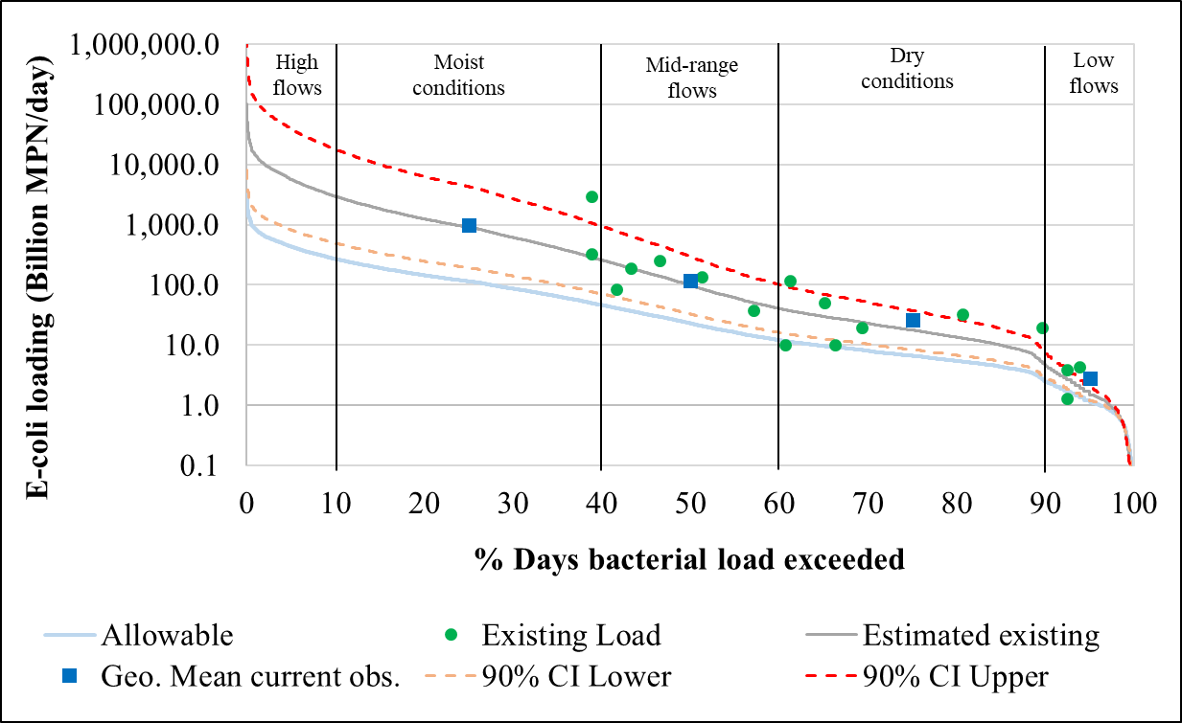
Figure 20 E-coli load duration curve for the Kickapoo Creek watershed at station 22167 (segment 0605A_02). The confidence intervals (CIs) are applicable for the estimated existing loads.

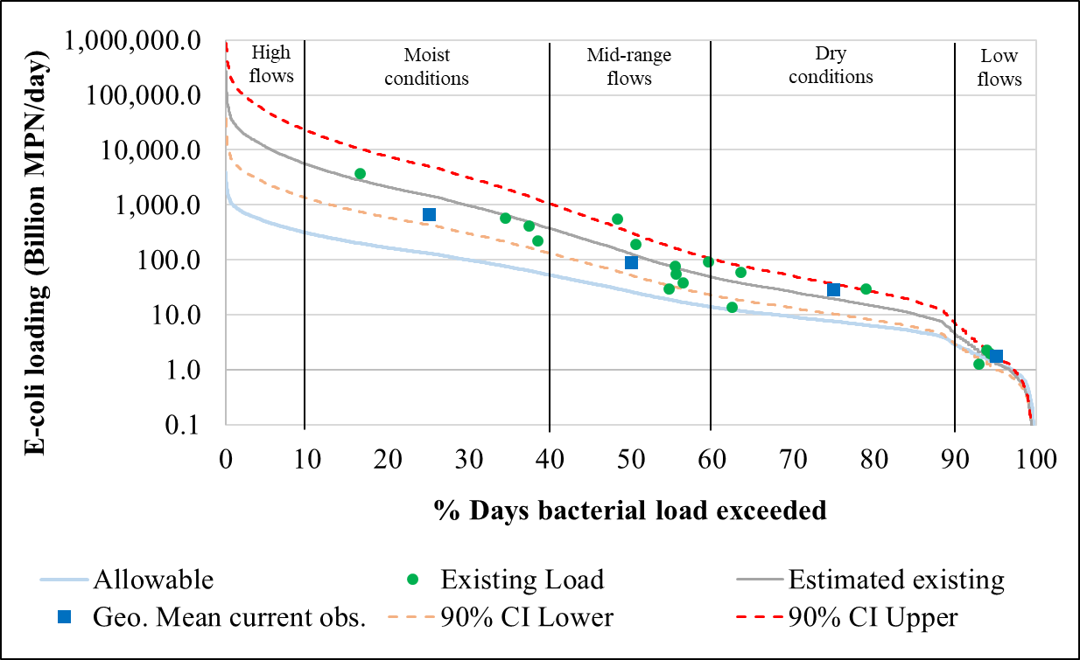
Figure 21 E-coli load duration curve for the Kickapoo Creek watershed at station 22166 (segment 0605A_02). The confidence intervals (CIs) are applicable for the estimated existing loads.

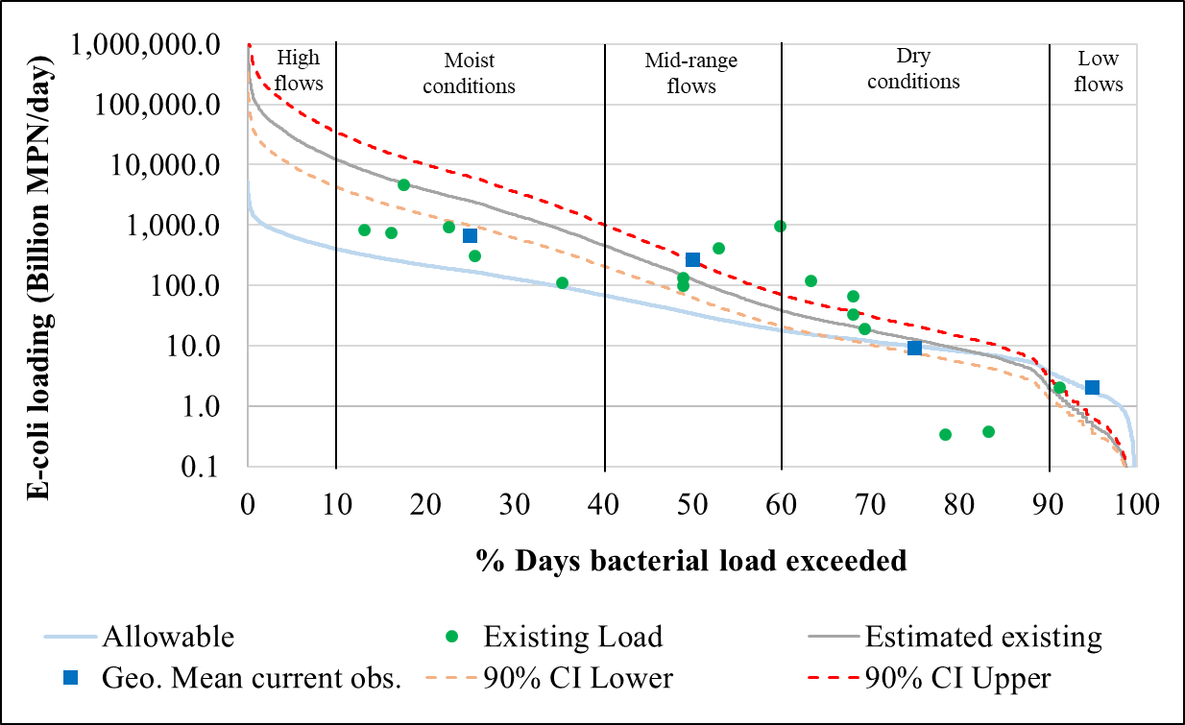
Figure 22 E-coli load duration curve for the Kickapoo Creek watershed at station 22165 (segment 0605A_02). The confidence intervals (CIs) are applicable for the estimated existing loads.
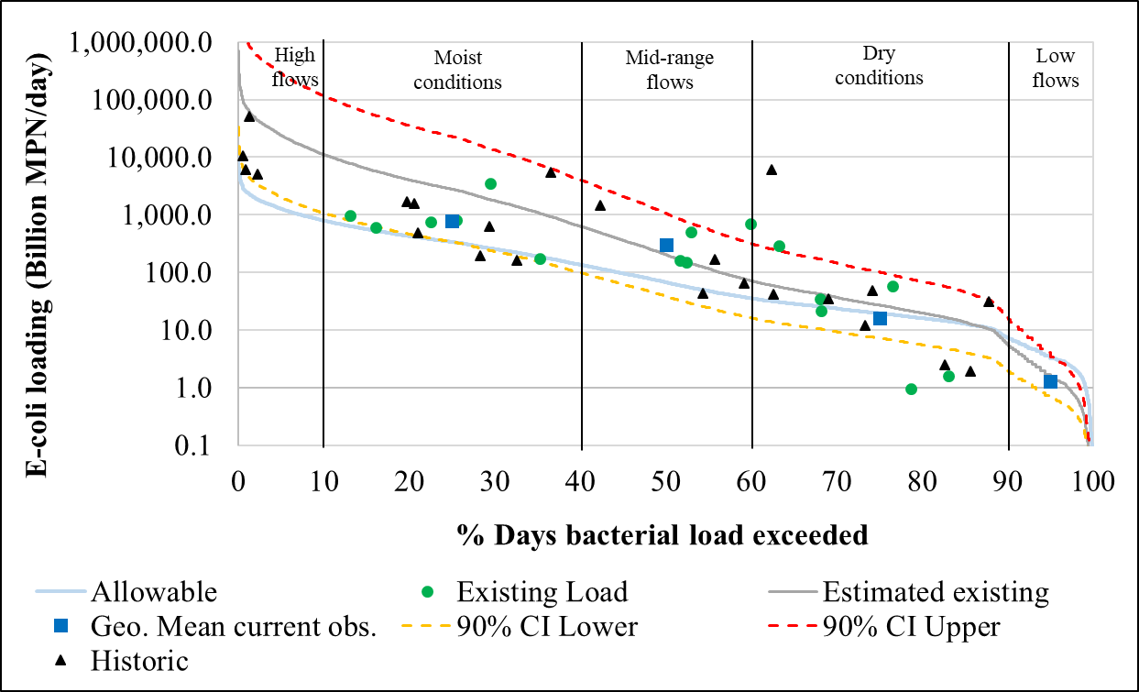
Figure 23 E-coli load duration curve for the Kickapoo Creek watershed at station 16797 (segment 0605A_02). The confidence intervals (CIs) are applicable for the estimated existing loads.

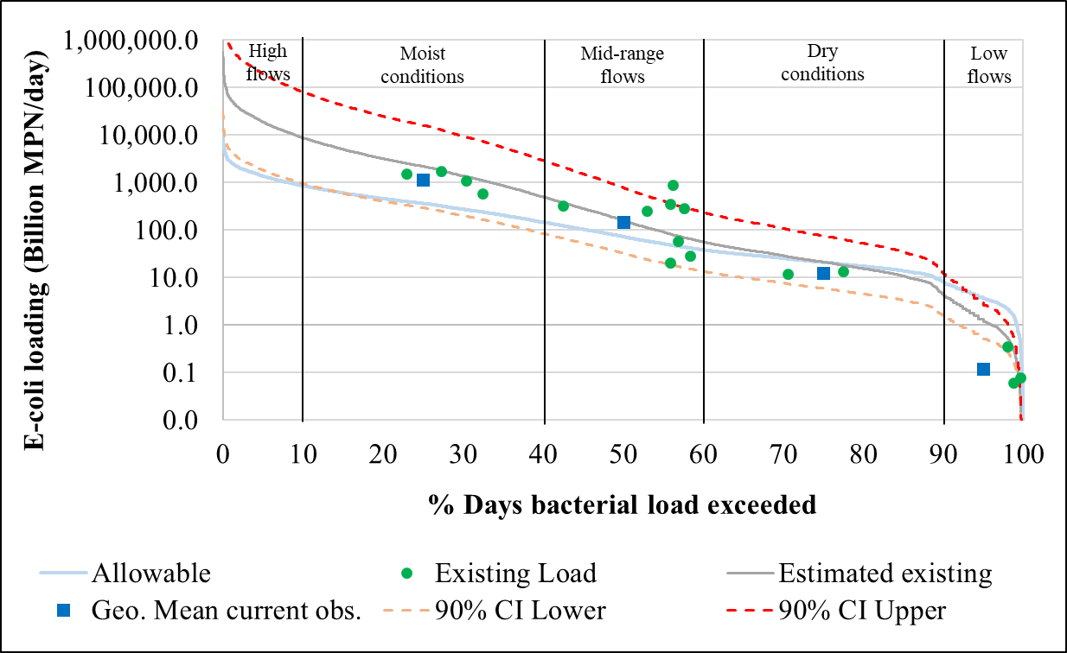
Figure 24 E-coli load duration curve for the Kickapoo Creek watershed at station 22164 (segment 0605A_02). The confidence intervals (CIs) are applicable for the estimated existing loads.

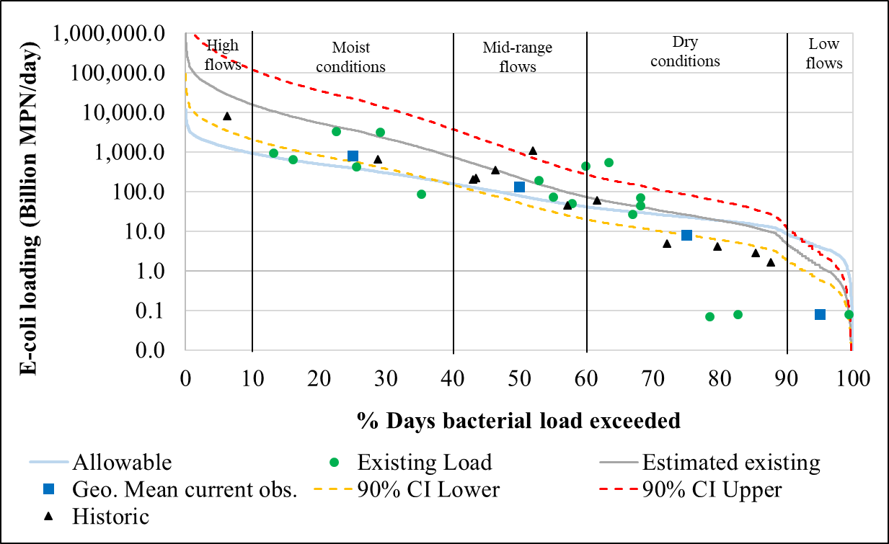
Figure 25 E-coli load duration curve for the Kickapoo Creek watershed at station 16796 (segment 0605A_02). The confidence intervals (CIs) are applicable for the estimated existing loads.

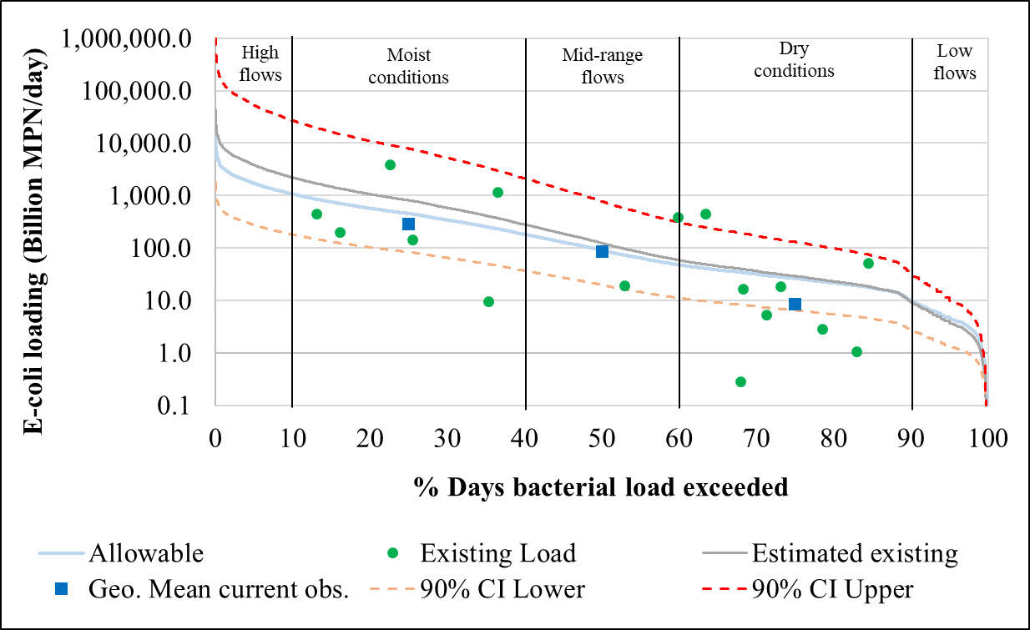
Figure 26 E-coli load duration curve for the Kickapoo Creek watershed at station 22163 (segment 0605A_02). The confidence intervals (CIs) are applicable for the estimated existing loads.

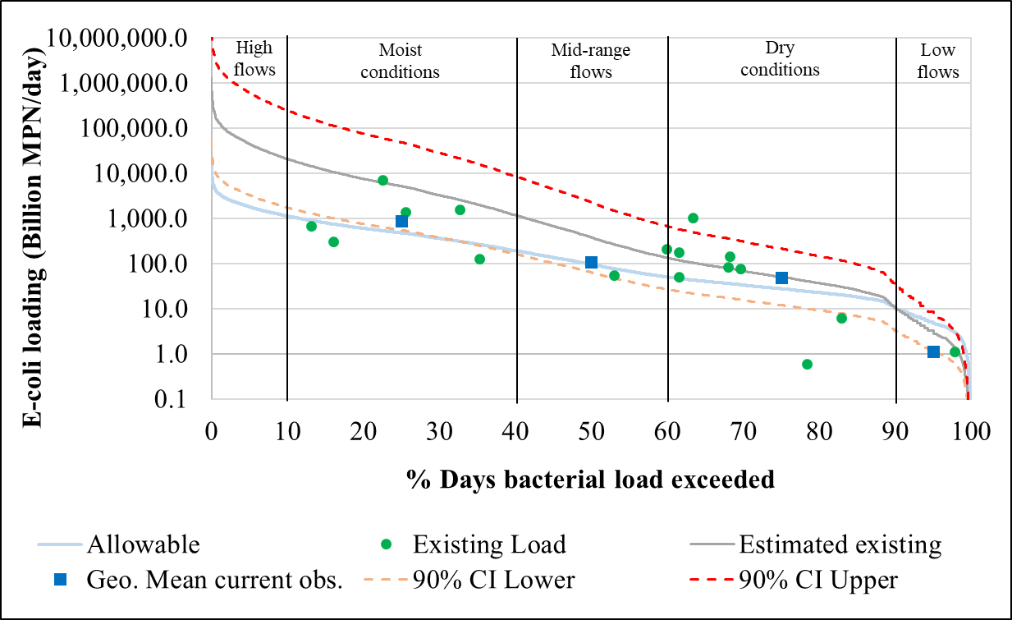
Figure 27 E-coli load duration curve for the Kickapoo Creek watershed at station 21618 (segment 0605A_01). The confidence intervals (CIs) are applicable for the estimated existing loads.

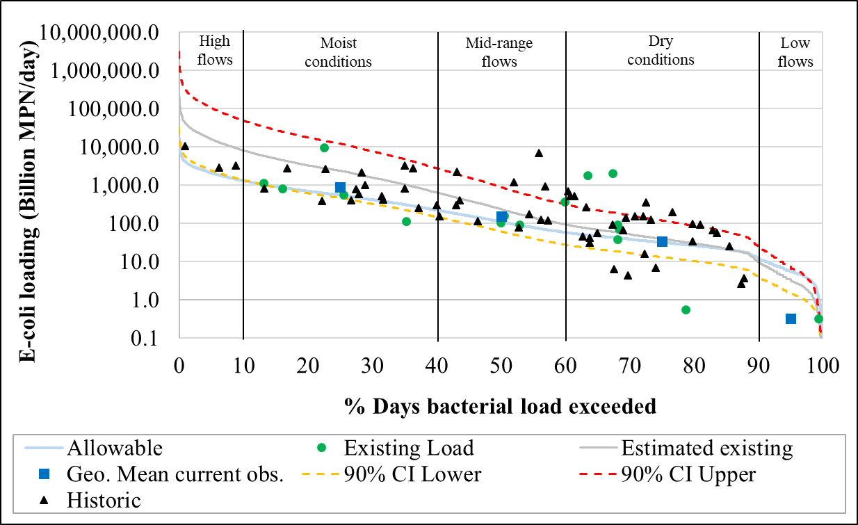
Figure 28 E-coli load duration curve for the Kickapoo Creek watershed at station 10517 (segment 0605A_01). The confidence intervals (CIs) are applicable for the estimated existing loads.
Table 12 Proportion of current (2019-2021) water quality samples exceeding the E-Coli criterion in different sections of the load duration curves (LDCs)
Monitoring  station | Stream segment | High flows | Moist conditions | Mid-range flows | Dry conditions | Low flows
22167  22166  22165  16797  22164  16796  22163  21618  10517  Average | 0605A_02  0605A_02  0605A_02  0605A_02  0605A_02  0605A_02  0605A_02  0605A_01  0605A_01 | 0  0  0  0  0  0  0  0  0  0 | 13  25  43  46  40  42  40  30  33  35 | 33  44  29  31  60  33  20  10  33  32 | 40  19  29  23  0  25  40  60  33  30 | 13  13  0  0  0  0  0  0  0  3

Table 13 Proportion of historic water quality samples exceeding the E-Coli criterion in different sections of the load duration curves (LDCs)
Monitoring  station | Stream segment | High flows | Moist conditions | Mid-range flows | Dry conditions | Low flows
16797  16796  10517  Average | 0605A_02  0605A_02  0605A_01 | 29  13  7  16 | 36  13  28  25 | 21  50  21  31 | 14  25  44  28 | 0  0  0  0

Based on the LDCs developed for the Kickapoo Creek, the load reductions required were estimated by flow regime for each water quality monitoring station in the watershed and shown in Table 14 and the proportions of load reductions were plotted in a graph and shown in Figure 29. Except the upstream two stations, the low flow regime (blue line) does not need any load reductions. The dry conditions (orange line) require some consistent load reductions throughout. However, the maximum load reductions in all the stations were associated with mid-range of flows, moist conditions and high flows. Although the current monitoring effort did not record any water quality samples during high flow conditions, the estimated existing load (based on regression relationships between flow and E-Coli load) and allowable load (based on the E. coli water quality criterion) with numerical integration techniques estimated the loads in the high flow regime of the LDCs. The total E-coli load reductions required to meet the allowable load in the Kickapoo Creek is summarized by station in Table 15. From the table we can see that the station 22163 require the least total load reductions. All the other stations show the load reductions from 82.5 to 96.5 with the maximum load reductions expected from the station at 22165 (Table 15).

Table 14 Estimated load reductions needed by flow regime for each water quality monitoring station in the Kickapoo Creek watershed
Flow regime | Percent days E-coli loads exceeded | Total E-coli loads  (billion MPN/day) |  | Load reductions needed  to meet the allowed load
 |  | Existing | Allowed | Proportion (%) |  | Daily (billion MPN/day) |  | Annual (billion MPN/year)
Station 22167 of Assessment Unit 0605A_02 of the Kickapoo Creek
High flows  Moist conditions  Mid-range  Dry conditions  Low flows  Total | 2 to 10  10 to 40  40 to 60  60 to 90  90 to 100  2 to 100 | 43,303.49  32,604.62  2,307.91  581.61  18.57  78,816.21 | 3,304.86  3,769.77  501.29  207.80  12.34  7,796.06 | 92.4  88.4  78.3  64.3  33.6  90.1 | 39,998.63  28,834.85  1,806.62  373.81  6.23  71,020.15 |  | 14,599,500.1  10,524,721.7  659,417.6  136,441.4  2,274.7  25,922,355.5
Station 22166 of Assessment Unit 0605A_02 of the Kickapoo Creek
High flows  Moist conditions  Mid-range  Dry conditions  Low flows  Total | 2 to 10  10 to 40  40 to 60  60 to 90  90 to 100  2 to 100 | 85,272.23  55,380.55  3,105.61  651.43  16.61  144,426.43 | 3,772.15  4,302.79  572.17  237.18  14.08  8,898.37 | 95.6  92.2  81.6  63.6  15.2  93.8 | 81,500.08  51,077.76  2,533.44  414.25  2.52  135,528.06 |  | 29,747,529.8  18,643,383.9  924,706.3  151,202.7  920.5  49,467,743.3
Station 22165 of Assessment Unit 0605A_02 of the Kickapoo Creek
High flows  Moist conditions  Mid-range  Dry conditions  Low flows  Total | 2 to 10  10 to 40  40 to 60  60 to 90  90 to 100  2 to 100 | 224,829.11  103,701.13  3,336.61  452.00  6.78  332,325.64 | 4,903.12  5,592.85  743.72  308.29  18.31  11,566.28 | 97.8  94.6  77.7  31.8  -170.1  96.5 | 219,926.00  98,108.28  2,592.89  143.71  -11.53  320,759.36 |  | 80,272,989.0  35,809,522.4  946,405.9  52,455.9  -4,208.1  117,077,165.1
Station 16797 of Assessment Unit 0605A_02 of the Kickapoo Creek
High flows  Moist conditions  Mid-range  Dry conditions  Low flows  Total | 2 to 10  10 to 40  40 to 60  60 to 90  90 to 100  2 to 100 | 183,903.29  107,128.76  5,047.55  923.14  19.91  297,022.64 | 9,713.92  11,080.40  1,473.44  610.77  36.27  22,914.80 | 94.7  89.7  70.8  33.8  -82.2  92.3 | 174,189.38  96,048.35  3,574.11  312.36  -16.36  274,107.85 |  | 63,579,122.0  35,057,649.1  1,304,551.7  114,012.9  -5,971.5  100,049,364.2
Station 22164 of Assessment Unit 0605A_02 of the Kickapoo Creek
High flows  Moist conditions  Mid-range  Dry conditions  Low flows  Total | 2 to 10  10 to 40  40 to 60  60 to 90  90 to 100  2 to 100 | 144,649.95  84,211.55  3,963.89  724.39  15.61  233,565.39 | 10,469.91  11,942.75  1,588.11  658.31  39.09  24,698.16 | 92.8  85.8  59.9  9.1  -150.5  89.4 | 134,180.04  72,268.80  2,375.79  66.09  -23.48  208,867.23 |  | 48,975,712.9  26,378,113.5  867,162.3  24,121.2  -8,571.4  76,236,538.5
Station 16796 of Assessment Unit 0605A_02 of the Kickapoo Creek
High flows  Moist conditions  Mid-range  Dry conditions  Low flows  Total | 2 to 10  10 to 40  40 to 60  60 to 90  90 to 100  2 to 100 | 271,379.42  142,102.75  5,632.49  899.08  16.44  420,030.17 | 11,225.26  12,804.35  1,702.68  705.80  41.91  26,480.01 | 95.9  91.0  69.8  21.5  -155.0  93.7 | 260,154.16  129,298.39  3,929.81  193.28  -25.47  393,550.16 |  | 94,956,268.9  47,193,913.4  1,434,378.9  70,546.4  -9,298.0  143,645,809.6
Station 22163 of Assessment Unit 0605A_02 of the Kickapoo Creek
High flows  Moist conditions  Mid-range  Dry conditions  Low flows  Total | 2 to 10  10 to 40  40 to 60  60 to 90  90 to 100  2 to 100 | 29,112.62  27,605.26  2,785.26  928.30  41.92  60,473.36 | 13,043.37  14,878.22  1,978.46  820.11  48.70  30,768.86 | 55.2  46.1  29.0  11.7  -16.2  49.1 | 16,069.24  12,727.04  806.80  108.18  -6.78  29,704.49 |  | 5,865,274.2  4,645,370.7  294,481.7  39,487.0  -2,473.9  10,842,139.8
Station 21618 of Assessment Unit 0605A_01 of the Kickapoo Creek
High flows  Moist conditions  Mid-range  Dry conditions  Low flows  Total | 2 to 10  10 to 40  40 to 60  60 to 90  90 to 100  2 to 100 | 338,438.34  197,588.06  9,343.07  1,713.56  37.08  547,120.10 | 13,659.65  15,581.19  2,071.94  858.86  51.00  32,222.64 | 96.0  92.1  77.8  49.9  -37.5  94.1 | 324,778.70  182,006.87  7,271.13  854.69  -13.92  514,897.47 |  | 118,544,224.7  66,432,506.1  2,653,963.1  311,962.4  -5,080.7  187,937,575.7
Station 10517 of Assessment Unit 0605A_01 of the Kickapoo Creek
High flows  Moist conditions  Mid-range  Dry conditions  Low flows  Total | 2 to 10  10 to 40  40 to 60  60 to 90  90 to 100  2 to 100 | 121,459.61  86,305.56  5,579.39  1,309.05  38.28  214,691.88 | 15,897.88  18,134.28  2,411.44  999.59  59.36  37,502.55 | 86.9  79.0  56.8  23.6  -55.1  82.5 | 105,561.73  68,171.28  3,167.95  309.45  -21.08  177,189.33 |  | 38,530,030.6  24,882,517.5  1,156,301.6  112,950.1  -7,692.8  64,674,107.1

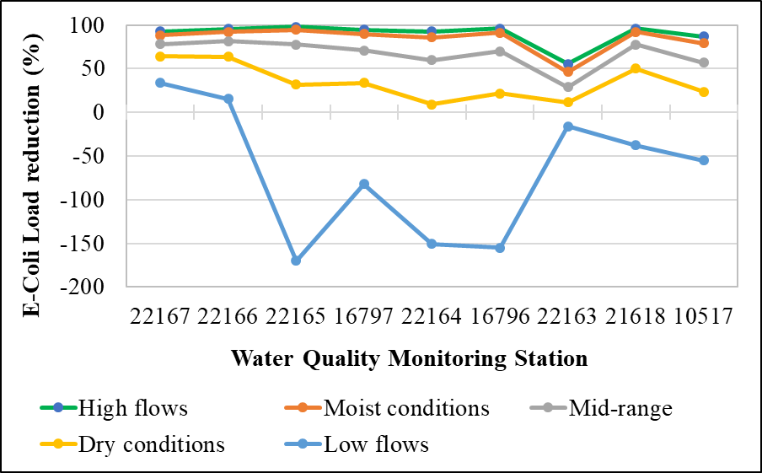
Figure 29 Required E-coli load reduction trends in different water quality monitoring stations

Table 15 Summary of estimated total load reductions needed for each water quality monitoring station in the Kickapoo Creek watershed
Station | Assessment Unit | Total E-coli loads  (billion MPN/day) |  | Load reductions needed  to meet the allowed load
 |  | Existing | Allowed | Proportion (%) |  | Daily (billion MPN/day) |  | Annual (billion MPN/year)
22167 | 0605A_02 | 78,816.21 | 7,796.06 | 90.1 | 71,020.15 |  | 25,922,355.5
22166 | 0605A_02 | 144,426.43 | 8,898.37 | 93.8 | 135,528.06 |  | 49,467,743.3
22165 | 0605A_02 | 332,325.64 | 11,566.28 | 96.5 | 320,759.36 |  | 117,077,165.1
16797 | 0605A_02 | 297,022.64 | 22,914.80 | 92.3 | 274,107.85 |  | 100,049,364.2
22164 | 0605A_02 | 233,565.39 | 24,698.16 | 89.4 | 208,867.23 |  | 76,236,538.5
16796 | 0605A_02 | 420,030.17 | 26,480.01 | 93.7 | 393,550.16 |  | 143,645,809.6
22163 | 0605A_02 | 60,473.36 | 30,768.86 | 49.1 | 29,704.49 |  | 10,842,139.8
21618 | 0605A_01 | 547,120.10 | 32,222.64 | 94.1 | 514,897.47 |  | 187,937,575.7
10517 | 0605A_01 | 214,691.88 | 37,502.55 | 82.5 | 177,189.33 |  | 64,674,107.1

Dissolved Oxygen (DO) Analysis

Approach for DO Analysis
In this section, the various graphical, statistical, and qualitative analyses performed to investigate relationships of DO to various water quality are provided. The DO analyses consider separately the data collected from 24-hour deployments of a multiprobe instrument and from grab (or single measurement) data collected as a one-time reading from a multiprobe instrument.
Other water quality data were frequently collected with the grab DO measurement. These water quality data include such parameters as specific conductance (which can be used to estimate salinity); nutrient forms (e.g., total Kjeldahl nitrogen (TKN), ammonia (NH₃-N), nitrite plus nitrate nitrogen (NO₂₃-N), orthophosphate phosphorus (PO₄-P), and total phosphorus (Total-P)), five-day carbonaceous biochemical oxygen demand (CBOD), total suspended solids (TSS), volatile suspended solids (VSS), pH, chlorophyll-a and water temperature. The concentration of nutrient forms and chlorophyll-a can provide an indication of nutrient enrichment and conditions favorable for eutrophication, whereas, parameters such as NH₃-N (which oxidizes to nitrate (NO₃-N), CBOD, and VSS can provide indications of the amount of oxygen-demanding substances in the water. Various descriptive and inferential statistics will be presented in this section to provide insights into DO conditions in the Kickapoo Creek and any reasonable cause-and-effect relationships that may exist between these parameters and DO.
The water quality stations providing the data to develop the FDC/LDC curves are the same as those with DO and the other water quality data. The depressed DO investigations benefit from including data for all the nine stations to provide a spatial continuum along the Kickapoo Creek. The stations used in this analysis are provided in Figure 7.

The more rigorous statistical analyses used linear regression and the associated correlation analyses. In these analyses, DO and DO deficit (to be defined later) were used as the dependent variables, and the other water quality parameters (potential causative and relational factors) were used as the independent variables. Linear regression methods, employing least-squares criterion, were used to perform the desired analysis. The correlation coefficient (r) from each analyses was used to evaluate the strength and direction (i.e., negative or positive correlation) of relationships between DO as the dependent variable and various independent variables. The magnitude of r is a measure of how well two sample populations vary jointly and can have values over the interval of -1.0 to 1.0. A value of r close to +1 or -1 indicates a highly positive or negative degree of correlation and a good fit to a linear model, whereas a value of r close to 0 indicates a poor fit to a linear model. For these analyses a “weak”, “moderate”, or “good” strength of linear relationship between two variables is defined by r in the ranges shown in Table 16.
Table 16 Values of correlation coefficient (r) and corresponding strength of the linear relationship
Correlation coefficient (r) | Negative | Positive
Weak  Moderate  Good | -0.59 to 0.00  -0.79 to -0.60  -0.80 to -1.00 | 0.00 to 0.59  0.60 to 0.79  0.80 to 1.00

While linear regression analysis does not establish cause and effect responses, the approach does lend itself to gaining insights into relationships of DO to other water quality variables. These relationships can then be interpreted based on established responses from principles and observations of aquatic biology, water chemistry, and environmental engineering that indicate likely cause and effect responses and infer conditions favorable to occurrences of depressed DO.

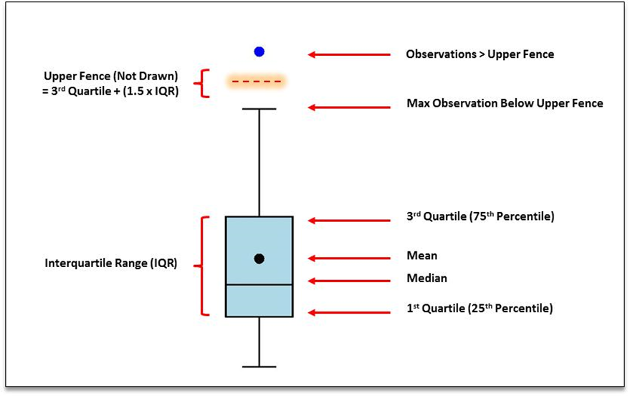
Figure 30 Box plot components showing mean, median, 1st and 3rd quartiles, outliers and the upper fence defined as the 3rd quartile plus 1.5 times the Inter Quartile Range (IQR)

Graphical presentation is used for some of the data presentations using box and whisker plots, which will be referred to simply as boxplots in this report. A brief description of the form of boxplots is provided using Figure 30 as a reference. Within upper and lower boundaries of the “box” are defined the 3rd and 1st quartiles of the data, respectively. Inside the “box” will be the median (horizontal line) and mean (X). The maximum value below the upper fence is depicted and computed as shown in Figure 30. Similarly, for the minimum value that is greater than the lower fence, that value is depicted as shown in the figure.

Because of the inverse relationship of the saturation concentration of DO to water temperature, DO concentrations in a water body are often correlated with season and water temperature. This inverse relationship of measured DO concentrations is driven by the inverse relationship of the saturation concentration of DO to water temperature, i.e., as water temperatures rise, the saturation concentration of DO becomes less. As examples, for freshwater, the saturation concentration of DO at 10°C (50°F) is 11.3 mg/L, and at 30°C (86°F) this concentration has decreased to 7.6 mg/L. This reasonable range of winter to summer water temperatures represents over a 3.5 mg/L change in the amount of oxygen water will hold at saturation conditions.
In order to reduce the impact of water temperature on the statistical and graphical analyses, the analyses were performed on the derived variable, percent DO saturation, which is defined as:
% DO saturation = DO observed concentration x 100 /DO saturation concentration.

The DO saturation concentration involved the correction for water temperature and elevation as provided in the North Carolina State University guidelines (projects.ncsu.edu/cals/course/zo419/oxygen.html). The larger the percent DO saturation, the greater the observed concentration is towards the saturation concentration. Percent DO saturation exceeding 100 occur whenever DO is above the saturation concentration. These excess DO saturation values will typically occur when the rate of photosynthetic oxygen production exceeds the rate of respiration and other oxygen-using processes.

Analysis of 24-hour DO data
Reliable evaluation of DO to the DO criteria is obtained using data collected with a multiprobe instrument that is deployed for 24-hour periods. Typically, the deployed multiprobe is programmed to collect DO and other field parameters (e.g., water temperature, pH, and specific conductance). The Kickapoo Creek data were all collected at 15-minute intervals resulting in 96 data points collected over the 24-hour period for three out of the nine water quality stations. The multiprobe data can then be post processed to provide 24-hour minimum and a 24-hour average DO concentrations that can be compared to the DO criteria. For Kickapoo Creek, the two relevant criteria are a 24-hour minimum DO ≥ 2 mg/L and a 24-hour average DO ≥ 3 mg/L. Further, the TCEQ considers that a water body is fully supporting if 10 percent or less of the sample sets are below the established criteria and not supporting if greater than 10 percent of the sample sets are below the established criteria. The TCEQ uses a binomial method to specify the number of exceedances required to determine non-attainment.

The 24-hour DO data are summarized in Table 17 by providing for each deployment the 24-hour DO minimum, average, and range. The DO range is the difference between the maximum DO reading and the minimum DO reading during the 24-hour deployment period.
Some interpretations can be made from the 24-hour DO data in Table 17. Except one sample in station 10517 (on March 2020 shown in red font) all the water quality samples collected show compliance to the minimum and average 24-hour DO categories.

When the 24-hour DO minimum criterion is met, the average DO criterion is also met. It likely indicates no possibility of eutrophication during the sampling period for the stream segments. The range of 24-hour DO values (column 6 of Table 17) also confirms assumption of no eutrophication.
Table 17 Summary of 24-hour deployment DO data for the Kickapoo Creek
Station | Assessment Unit | Date of sample | 24-hour Dissolved Oxygen Data (mg/L)
 |  |  | Minimum | Average | Range  [Max-Min]
22166  22166  22166  22166  22166  22166  22166  22166  22166  22166  22166  22166  22166  22166 | 0605A_02  0605A_02  0605A_02  0605A_02  0605A_02  0605A_02  0605A_02  0605A_02  0605A_02  0605A_02  0605A_02  0605A_02  0605A_02  0605A_02 | 11/13/2019  12/11/2019  01/08/2020  02/05/2020  03/03/2020  04/09/2020  05/07/2020  06/04/2020  07/10/2020  08/04/2020  09/03/2020  10/07/2020  11/05/2020  12/09/2020 | 9.8  8.9  10.4  8.8  8.8  7.0  6.8  6.6  6.5  6.9  5.6  7.1  9.3  10.5 | 10.3  9.4  10.9  9.1  8.9  7.2  7.1  6.8  6.7  6.9  6.2  7.7  9.6  10.7 | 0.9  1.3  1.2  0.7  0.3  0.6  0.7  0.6  0.3  0.1  1.3  1.2  0.5  0.6
22164  22164  22164  22164  22164  22164  22164  22164  22164  22164  22164  22164  22164  22164 | 0605A_02  0605A_02  0605A_02  0605A_02  0605A_02  0605A_02  0605A_02  0605A_02  0605A_02  0605A_02  0605A_02  0605A_02  0605A_02  0605A_02 | 11/13/2019  12/11/2019  01/08/2020  02/05/2020  03/03/2020  04/09/2020  05/07/2020  06/04/2020  07/09/2020  08/04/2020  09/03/2020  10/07/2020  11/05/2020  12/09/2020 | 8.3  8.6  8.7  9.2  8.5  6.2  5.6  4.53  4.5  6.4  4.9  6.1  8.7  9.6 | 8.8  8.7  9.8  9.3  8.8  6.7  6.1  5.0  4.9  6.5  5.3  6.2  8.9  9.8 | 0.7  0.3  1.8  0.3  0.7  0.8  1.2  1.1  0.8  0.2  1.3  0.4  0.5  0.6
10517  10517  10517  10517  10517  10517  10517  10517  10517  10517  10517  10517  10517  10517 | 0605A_01  0605A_01  0605A_01  0605A_01  0605A_01  0605A_01  0605A_01  0605A_01  0605A_01  0605A_01  0605A_01  0605A_01  0605A_01  0605A_01 | 11/13/2019  12/11/2019  01/08/2020  02/05/2020  03/03/2020  04/09/2020  05/07/2020  06/04/2020  07/09/2020  08/04/2020  09/03/2020  10/07/2020  11/05/2020  12/09/2020 | 8.4  6.9  9.6  7.3  5.7  4.5  2.5  3.64  3.7  6.7  1.8  4.9  7.9  9.3 | 9.0  7.2  9.8  7.9  6.7  5.0  3.6  4.1  4.3  6.8  2.7  6.9  8.7  9.6 | 1.0  0.6  0.6  1.6  2.4  1.2  2.3  1.0  1.3  0.2  2.1  3.2  1.5  0.8

In water bodies with a high amount of aquatic vegetation, such as sestonic algae, a strong diel pattern is present. This pattern is caused by photosynthesis dominating during daylight hours resulting in high DO concentrations, peaking in the late afternoon on days with good solar radiation, followed by low DO concentrations the next morning as respiration processes dominate in the absence of solar radiation, reaching minimums around the time of sun rise. The more aquatic vegetation present, the greater the diel variation as represented by the range in DO over a 24-hour deployment.

Additional analysis of the 24-hr DO data was performed with correlations of 24-hr DO range and 24-hr DO minimum with Chlorophyll-A and presented in Figures 31 and 32. The correlations of 24-hr DO range/DO minimum with Chlorophyll-A do not support Chlorophyll-A are the primary cause of depressed DO in the Kickapoo Creek. Similar relationships for each individual station also highlight the same. This indicates other factors are, most likely, influencing the occurrences of depressed DO.

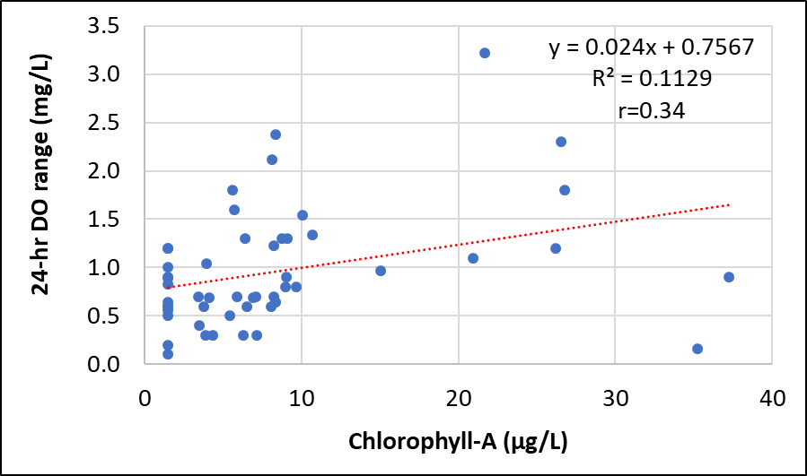
Figure 31 Scatter plot showing the relationship of 24-hour DO range to Chl-A for data collected in Kickapoo Creek (Data of three stations namely 22166, 22164, and 10517)

The common measure of aquatic vegetation for streams is Chlorophyll-A (Chl-A), which is the primary photosynthetic pigment found in algae. Consequentially, Chl-A is considered as a measure of the amount of sestonic algae in the water. The Chl-A data and DO range for the data pairs for all the three stations are provided in Figures 31 and 32. What is notable from the data in all the plots is that a linear regression of “weak” strength (r <0.59) can be fit through the data indicating no significant relationship of DO range or DO minimum with Chl-A. Also, only one out of 14 samples in station 22164 and three out of 14 in station 10517 exceed the TCEQ screening level of 21.0 µg/L.

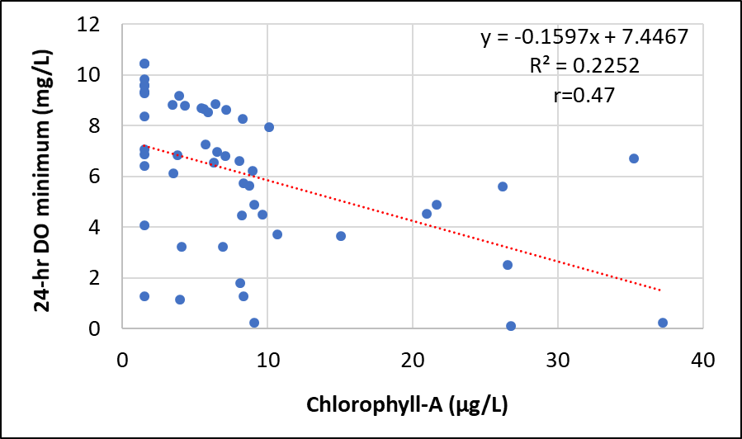
Figure 32 Scatter plot showing the relationship of 24-hour DO minimum to Chl-A for data collected in Kickapoo Creek (Data of three stations namely 22166, 22164, and 10517)

The Standard least squares linear regressions were performed with water quality parameters and 24-hour average DO, 24-hour minimum DO, and 24-hour DO range, the results of which are presented in Table 18. The strong correlation of water temperature with DO is obvious. However, no other relationships were noticeable from the analysis except the moderate correlation of tnh3 and DO (correlation coefficient of 0.75 with DO minimum and 0.76 with DO mean) and correlation of fopo4 and DO (correlation coefficient of 0.74 with DO minimum and 0.76 with DO mean) and correlation of ftp with DO mean (r=0.6) (Table 18). The 24-hr DO data suggests the depressed DO is most prevalent in the downstream portions of the Kickapoo Creek. There is a decreasing trend of DO mean from the upstream to downstream (Figure 33). The spatial patterns of Chlorophyll-A (indicative of eutrophication) (Figure 34) supports the DO mean trends which could possibly be due to the excess nutrients in the Kickapoo Creek. This argument is partially supported by the moderate correlation of DO with tnh3, fopo4, and ftp for the station 22164 (Table 18). The correlations of nutrients with DO is rather week for the other two stations (Table 18).

The attempt to find a strong correlation of 24-hr DO parameters to water quality parameters with possible causal connects was not conclusively discovered through these analyses. However, a spatial component of lower DO in the downstream direction of Kickapoo Creek appeared most notable from this analysis.
Table 18 Correlations of 24-hour deployment DO data and different water quality variables for the Kickapoo Creek
Station | Assessment Unit | Water quality variable | Correlation of WQ with 24-hour DO (r)
 |  |  | Minimum | Average | Range  [Max-Min]
22166  22166  22166  22166  22166  22166  22166  22166  22166 | 0605A_02  0605A_02  0605A_02  0605A_02  0605A_02  0605A_02  0605A_02  0605A_02  0605A_02 | tss  chla  tnh3  tno23  fopo4  bod5  ftkn  ftp  Wat Tmp | 0.32  0.41  0.24  0.04  0.42  0.25  0.40  0.42  0.82 | 0.30  0.41  0.26  0.08  0.41  0.22  0.42  0.41  0.84 | 0.25  0.07  0.29  0.33  0.15  0.32  0.31  0.11  0.38
22164  22164  22164  22164  22164  22164  22164  22164  22164 | 0605A_02  0605A_02  0605A_02  0605A_02  0605A_02  0605A_02  0605A_02  0605A_02  0605A_02 | tss  chla  tnh3  tno23  fopo4  bod5  ftkn  ftp  Wat Tmp | 0.06  0.13  0.75  0.30  0.74  0.39  0.47  0.56  0.78 | 0.07  0.13  0.76  0.32  0.76  0.38  0.51  0.60  0.81 | 0.30  0.45  0.07  0.07  0.13  0.40  0.18  0.04  0.03
10517  10517  10517  10517  10517  10517  10517  10517  10517 | 0605A_01  0605A_01  0605A_01  0605A_01  0605A_01  0605A_01  0605A_01  0605A_01  0605A_01 | tss  chla  tnh3  tno23  fopo4  bod5  ftkn  ftp  Wat Tmp | 0.53  0.55  0.47  0.54  0.46  0.56  0.50  0.48  0.77 | 0.49  0.54  0.49  0.56  0.48  0.58  0.53  0.51  0.78 | 0.44  0.10  0.10  0.05  0.12  0.13  0.13  0.11  0.05

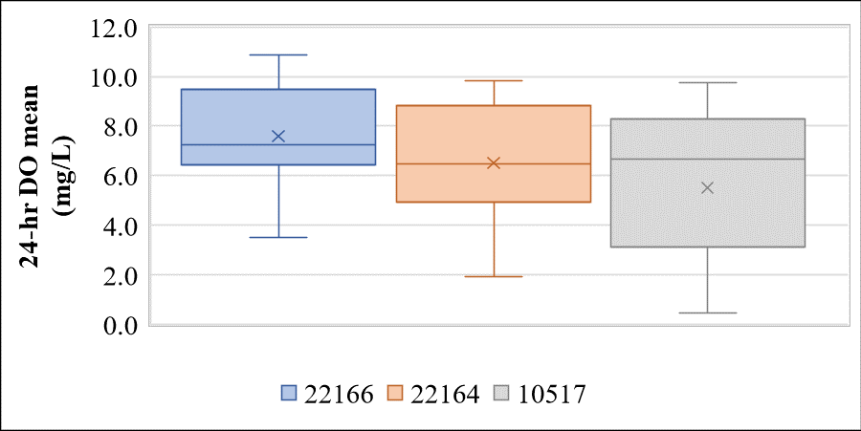
Figure 33 Spatial trends of 24-hr mean DO in the Kickapoo Creek

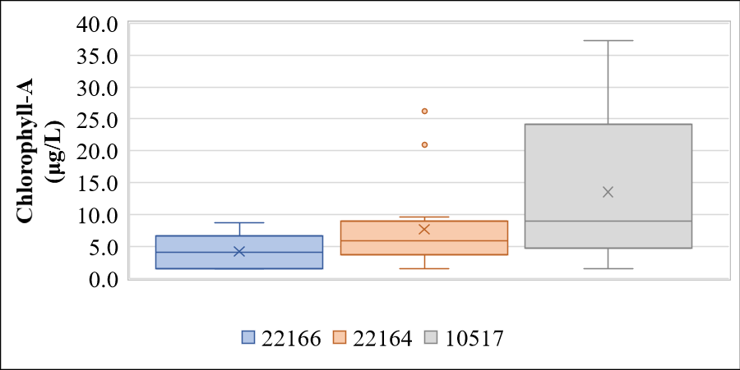
Figure 34 Spatial trends of Chlorophyll-A in the Kickapoo Creek

For Kickapoo Creek, there are many more grab DO data and associated water quality data (from nine stations) than what exists for the 24-hour DO dataset (three stations only). The dataset of DO and contemporaneously collected water quality data collected from August 2019 through December 2020 in nine monitoring stations comprise the dataset used in this analysis. The data were collected at the monitoring stations previously shown in Figure 7.

A downside of grab DO data is that it cannot be used to assess the 24-hour DO average criterion, because that assessment requires 24-hour multiprobe data. A single grab DO concentration below the 24-hour DO average criterion of 3 mg/L does not mean that the average over the 24-hour period would have been below the criterion, just as a grab concentration above the average criterion does not mean that the 24-hour average criterion would have been met. The grab DO data can be used, however, to assess the 24-hour DO minimum criterion, because a grab DO concentration below the minimum criterion of 2 mg/L is a definite indication that the minimum criterion was not met.

Temporal Analysis
As the first step in the analysis, an investigative plot of the water temperature collected with the water quality data were plotted on a monthly basis for the purpose of selecting an approximate temperature to separate the data into warm and cool seasons for some of the subsequent analyses (Figure 35). These data clearly depict the seasonal pattern in temperature and led to the selection of a temperature of 19.25 °C as the demarcation value between data from warm and cool seasons. The temperature of 19.25 °C roughly divided the number of data points in half, with the cool season temperature defined as ≤ 19.25 °C, and the warm season defined as temperature > 19.25 °C.

Next, the seasonality of the depressed DO was investigated graphically through the presentation of the DO (both DO saturation and DO grab) by month (Figures 36 and 37). The entire grab DO dataset of all the Kickapoo Creek stations are plotted by the month in which the data were collected. The season of each data point based on water temperature is differentiated through the color used to plot the data in both the figures 36 and 37. The DO saturation data shown in Figure 36 indicates a significant degree of seasonality with a higher likelihood of depressed DO from August through October. Further, figure 37 indicates that the depressed DO in the Kickapoo Creek below the 24-hour minimum criterion is likely to be in the months of August and October. A similar trend was observed with the historic grab DO data as well (illustration not shown). In summary, seasonality is strongly exhibited by the DO data monitored in the Kickapoo Creek.

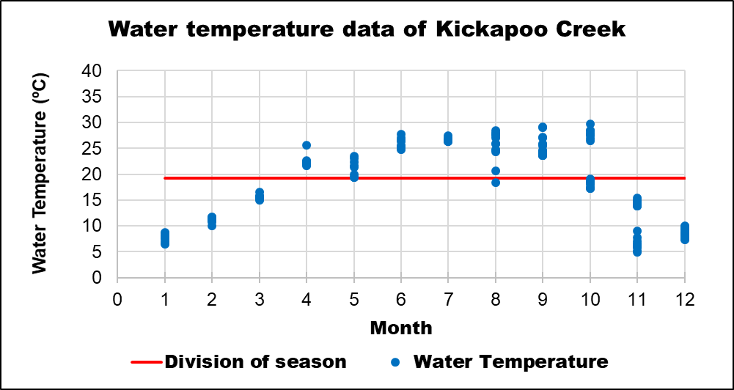
Figure 35 Grab water temperature data plotted by month for stations in Kickapoo Creek (Cool and warm seasons separation at 19.25 ºC)

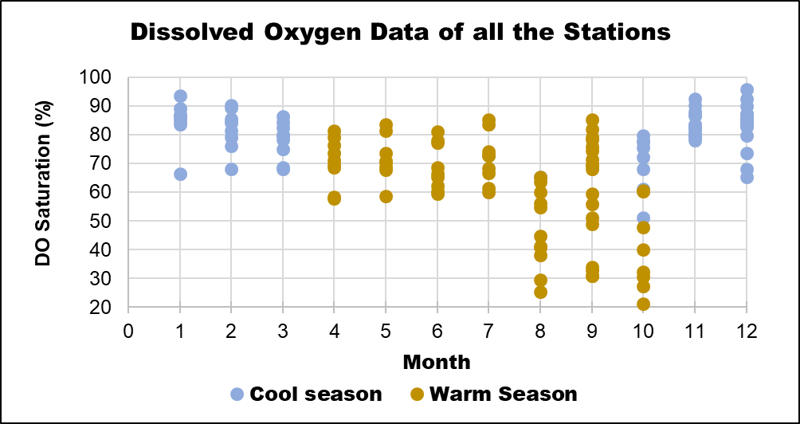
Figure 36 Percent DO saturation plotted by month for stations in Kickapoo Creek (Difference in seasons indicated)

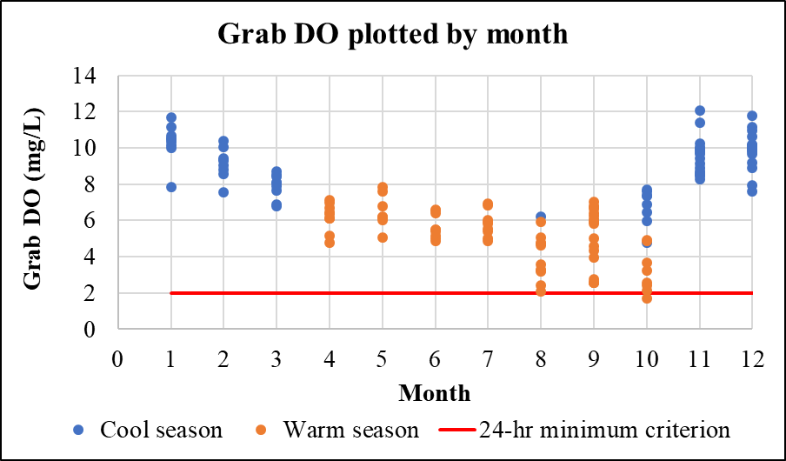
Figure 37 Grab DO data plotted by month for stations in Kickapoo Creek (24-hour DO minimum DO criterion indicated by the red line; DO data points shown by different color to indicate seasons)

To support the use of percent DO saturation as a variable to compensate for the typical relationship of DO to water temperature and the seasonality of water temperature, separate plots of grab DO data and water temperature data collected simultaneously and % DO saturation calculated from DO data and water temperature are provided in Figures 38 and 39. Because grab DO data are also capturing a single point in time within the diel cycle associated with photosynthesis and respiration in the stream, and this temporal variability can be large sometimes. Also, the relationship of grab DO to water temperature is strong (R² = 0.83 and r = 0.91) (Figure 38). But the % DO saturation to temperature relationship is moderate (R² = 0.46 and r = 0.68) (Figure 39). From this graphical and relational analysis, it was concluded that there is some benefit in using % DO saturation as a means of compensating partially for the influence of temperature on DO.

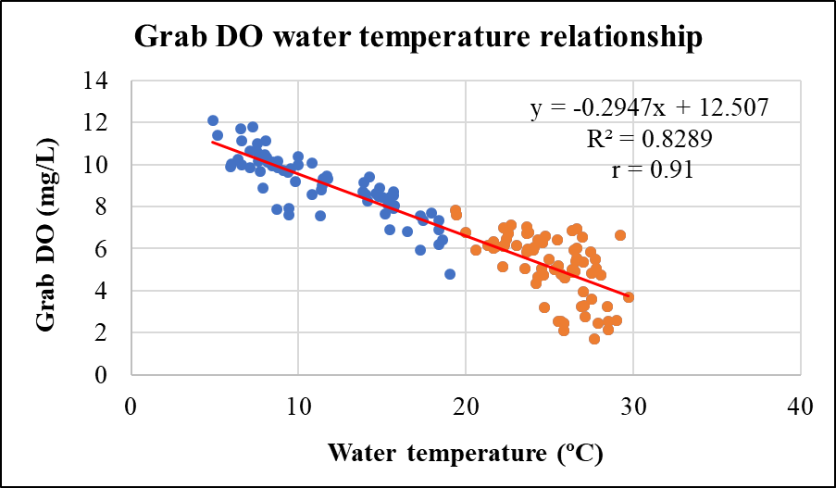
Figure 38 Grab DO data plotted with simultaneously collected water temperature for stations in Kickapoo Creek

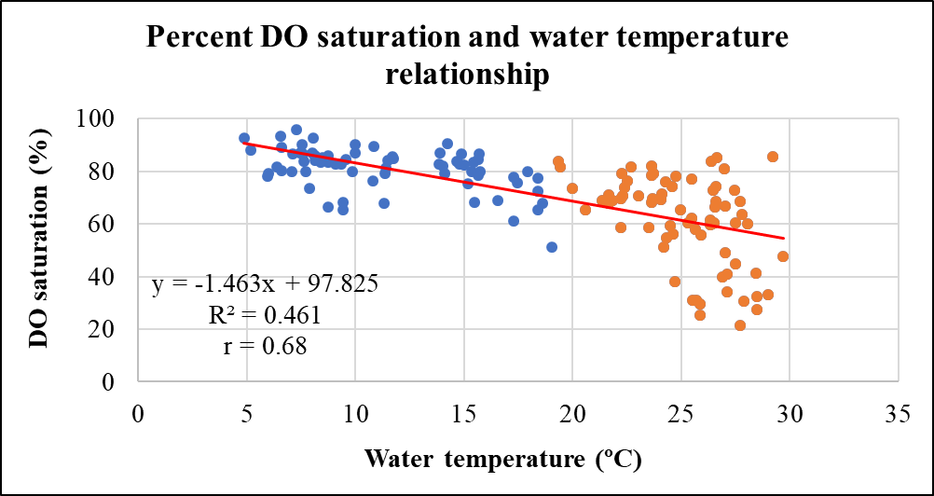
Figure 39 Percent DO saturation data plotted with water temperature for stations in Kickapoo Creek

Correlation Analysis

Nutrient parameters such as Chl-A, NH₃N, NO₂₃, PO₄, TKN and total phosphorus and oxygen demanding substances such as BOD₅, TSS and VSS were correlated with percent DO saturation and the results are presented in Table 19. Majority of the % DO saturation and water quality parameter correlations are weak for most of the stations. The strong correlations are shown only
Table 19 Correlation analysis for percent DO saturation to selected water quality parameters showing r values for stations of Kickapoo Creek in upstream to downstream order
Station | Chl-A | NH₃-N | NO₂₃-N | PO₄-P | BOD₅ | TKN | Total-P | TSS | VSS
22167 | 0.30 | 0.04 | 0.30 | 0.38 | 0.20 | 0.33 | 0.48 | 0.27 | 0.07
22166 | 0.09 | 0.03 | 0.21 | 0.12 | 0.05 | 0.16 | 0.16 | 0.04 | 0.001
22165 | 0.54 | 0.02 | 0.19 | 0.13 | 0.27 | 0.21 | 0.23 | 0.02 | 0.14
16797 | 0.64 | 0.53 | 0.27 | 0.67 | 0.37 | 0.49 | 0.43 | 0.23 | 0.07
22164 | 0.06 | 0.83 | 0.32 | 0.87 | 0.18 | 0.56 | 0.61 | 0.06 | 0.003
16796 | 0.75 | 0.20 | 0.001 | 0.08 | 0.71 | 0.66 | 0.48 | 0.08 | 0.43
22163 | 0.41 | 0.04 | 0.41 | 0.20 | 0.33 | 0.20 | 0.07 | 0.11 | 0.02
21618 | 0.60 | 0.44 | 0.52 | 0.51 | 0.59 | 0.69 | 0.40 | 0.55 | 0.24
10517 | 0.61 | 0.51 | 0.63 | 0.53 | 0.67 | 0.55 | 0.54 | 0.34 | 0.16

by NH₃ N and PO₄ P with % DO saturation for the station 22164. Moderate correlations are exhibited some parameters such as Chl-A, PO₄ in 16797 and total phosphorus in 22164, Chl-A, BOD₅, TKN in 16796, Chl-A and TKN in 21618, and Chl-A, NO₂₃ and BOD₅ in 10517. In summary, the correlational analysis point out that excess nutrients to be the likely cause of the depressed DO in most of the downstream stations of Kickapoo (except 22163). For the upstream stations (especially the first three out of the total nine stations) neither the nutrients nor the oxygen demanding substances show any meaningful correlation with percent DO saturation. With the exception of % DO saturation and TKN (moderate correlation) for station 16797, the correlation of historic water quality data (Table 20) with DO is weak. Any meaningful conclusion cannot be interpreted from the correlation analysis of historic DO and water quality data.
Table 20 Correlation analysis of historic data for percent DO saturation to selected water quality parameters showing r values for stations of Kickapoo Creek in upstream to downstream order
Station | Chl-A | pH | NO₂₃-N | PO₄-P | BOD₅ | TKN | Total-P | TSS | VSS
16797 |  | 0.06 | 0.12 | 0.19 |  | 0.60 | 0.47
16796 |  | 0.27 | 0.28 | 0.10 | 0.57 |  | 0.21
10517 | 0.46 | 0.36 | 0.02 |  |  | 0.47 | 0.52

Spatial Analysis
The final data analysis approach was to spatially present the water quality data using boxplots to see if any trends could be observed that would provide insights into the depressed DO occurring in the downstream portions of the Kickapoo Creek. The boxplots were developed with the stations plotted from left to right starting with station 22167 (AU 0605A_02), and then progressing from upstream to downstream in Kickapoo Creek: 22166 (AU 0605A_02), 22165 (AU 0605A_02), 16797 (AU 0605A_02), 22164 (AU 0605A_02), 16796 (AU 0605A_02), 22163 (AU 0605A_02), 21618 (AU 0605A_01), 10517 (AU 0605A_01). The boxplots were generated as sets of three plots: all data points regardless of water temperature, cool season (water temperature ≤ 19.25 °C), and warm season (water temperature > 19.25 °C).

These boxplots series were developed for the parameters of grab dissolved oxygen, Chlorophyll-A (Chl-A), biochemical oxygen demand (BOD), total phosphorus, orthophosphate, nitrite and nitrate nitrogen (NO₂₃-N), total suspended solids (TSS), and total Kjeldahl nitrogen (TKN). If there is an applicable TCEQ screening level, that concentration is shown as a dotted horizontal line in blue color on each diagram. There is a progressive decrease in DO from the upstream to downstream (Figure 40). The decrease in DO is more pronounced in station 22163 than others especially in the cool season (Figure 40). Chl-A concentrations rarely exceed the screening levels in cool season with the exception of station 22163. However, the warm-season concentrations exceed more often. The spatial pattern of progressive increase in Chl-A concentrations from upstream to downstream with a pronounced increase in station 22163 (Figure 41) support Chl-A as likely parameter affecting DO.
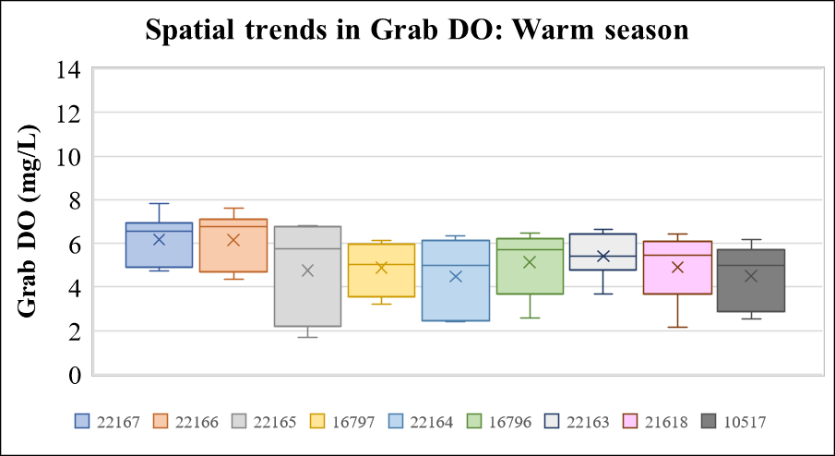
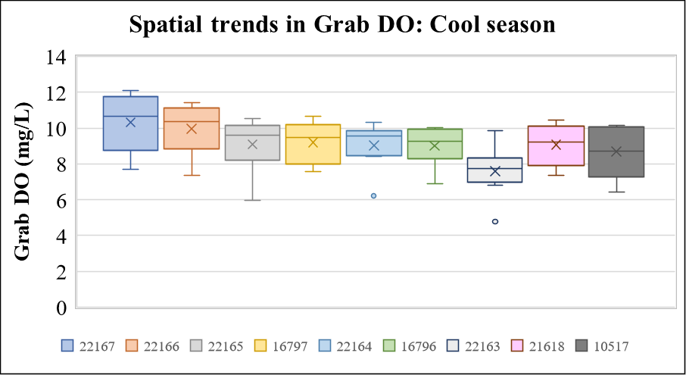
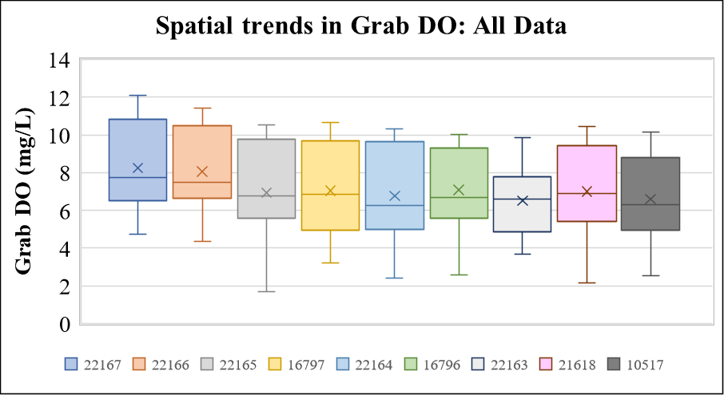

Figure 40 Box plots of grab dissolved oxygen concentration at stations on Kickapoo Creek

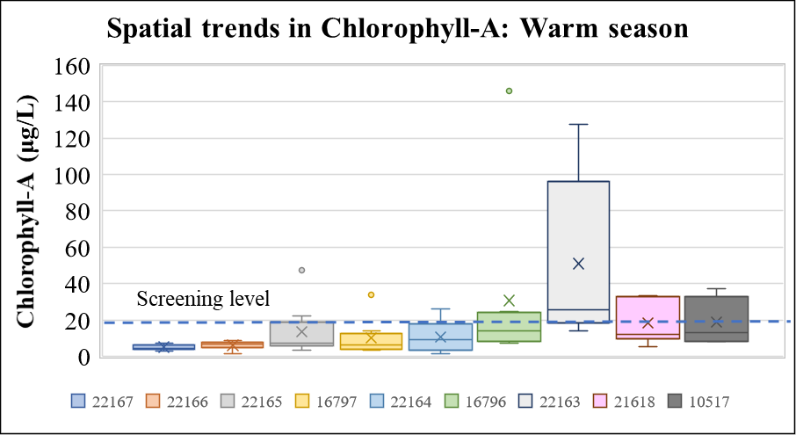
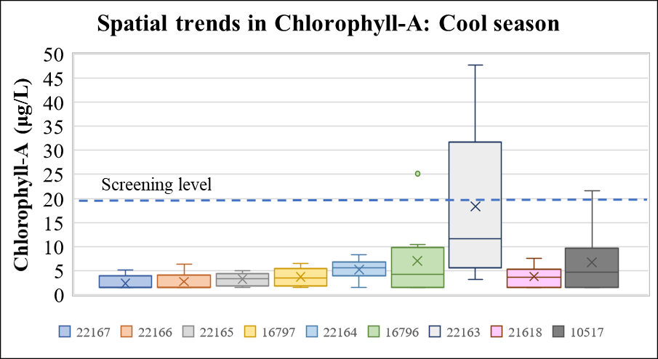
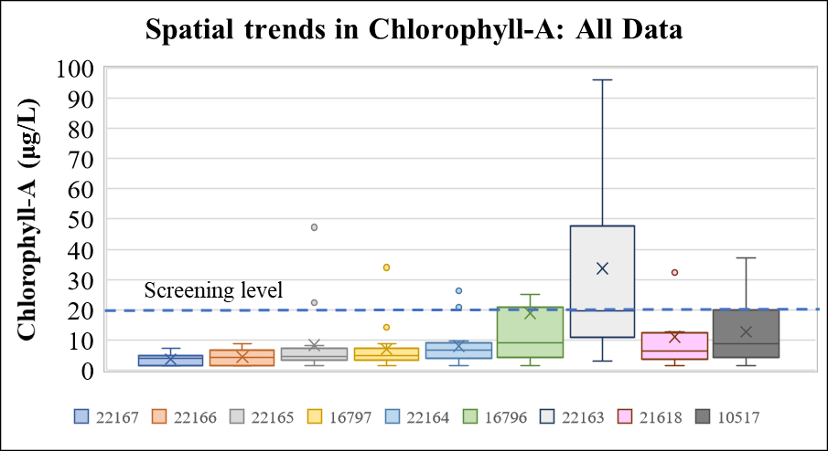

Figure 41 Box plots of chlorophyll-A concentration at stations on Kickapoo Creek (screening level is 20 μg/L; one outlier in 16796 (145.9 mg/L warm season data) and one outlier in 22163 (127.6 mg/L warm season data not shown)

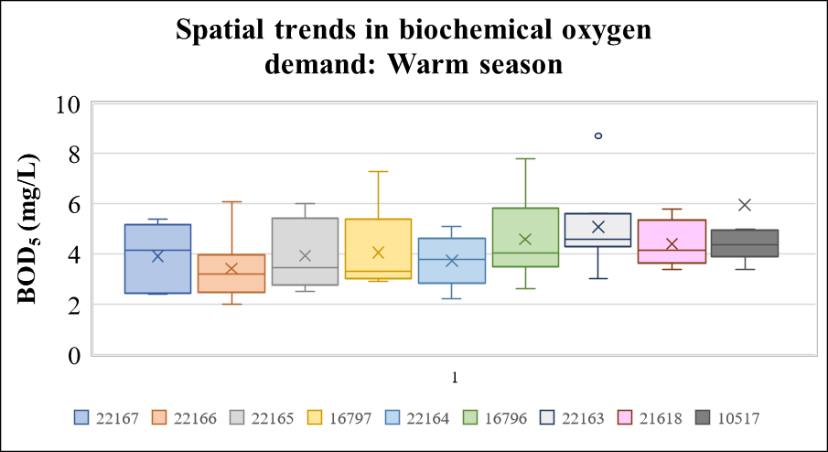
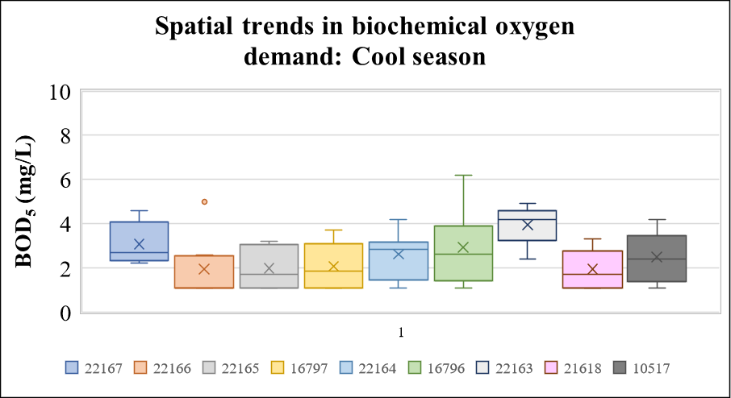
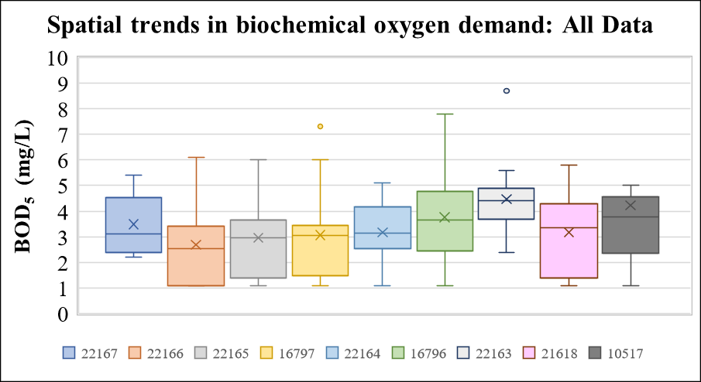

Figure 42 Box plots of BOD concentration at stations on Kickapoo Creek (one outlier in station 10517 (18 mg/L during warm season) not shown in the box plots)

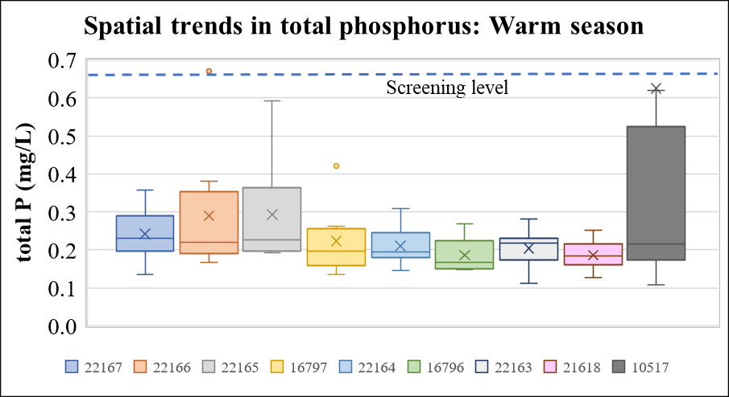
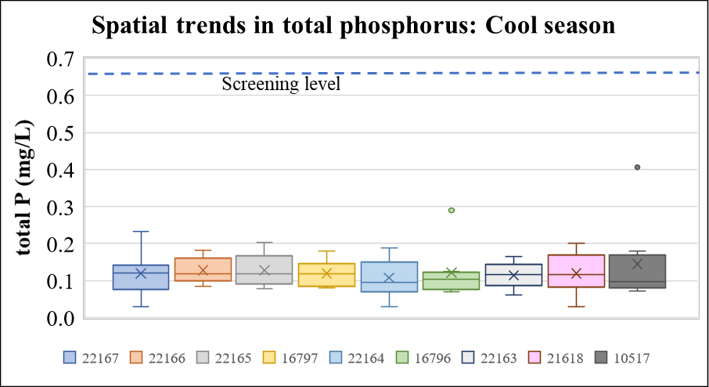
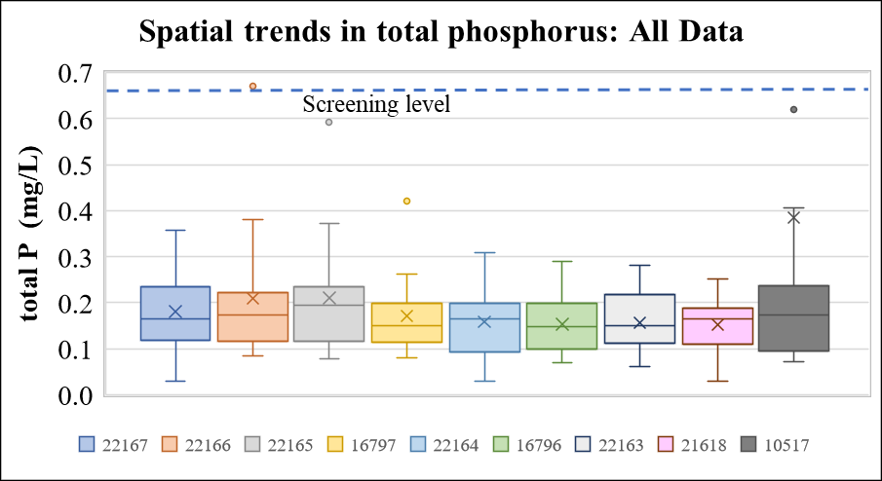

Figure 43 Box plots of total phosphorus concentration at stations on Kickapoo Creek (screening level is 0.66 mg/L; one outlier in station 10517 (3.24 mg/L during warm season not shown)

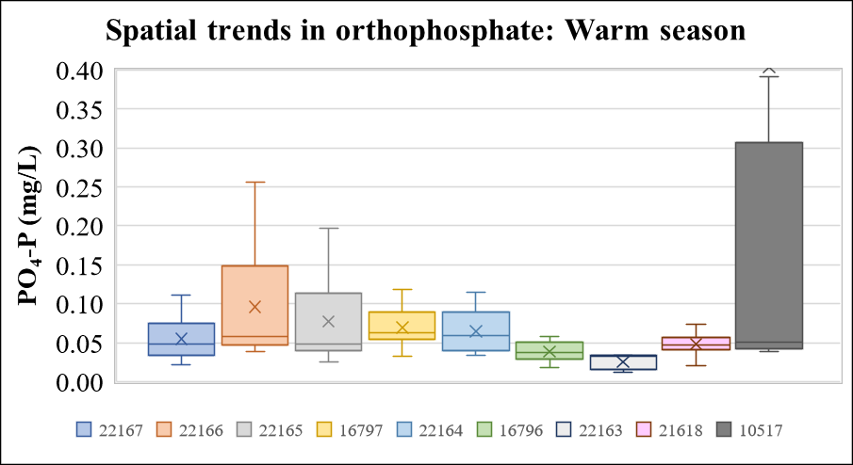
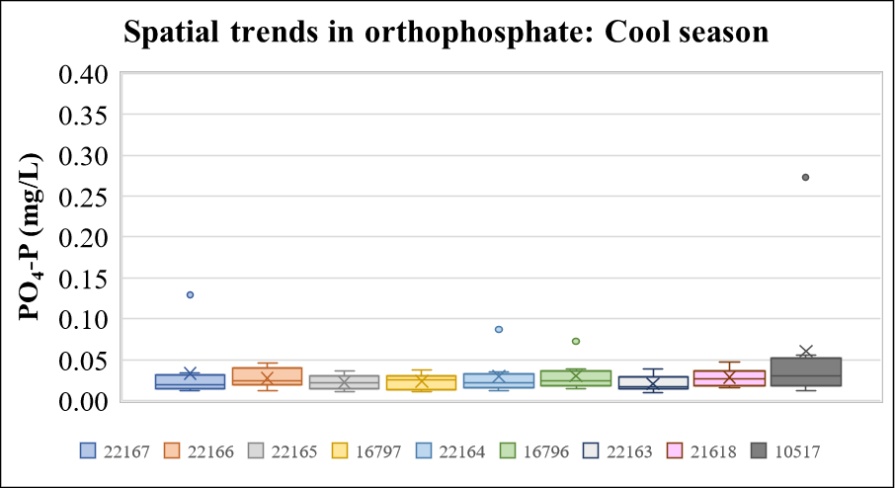
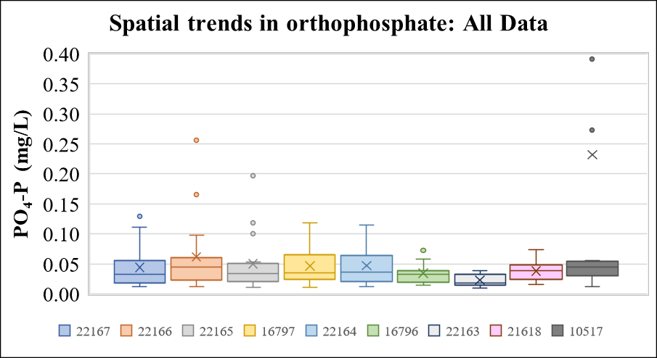

Figure 44 Box plots of orthophosphate concentration at stations on Kickapoo Creek (one outliner in station 10517 (2.55 mg/L during warm season) not shown)

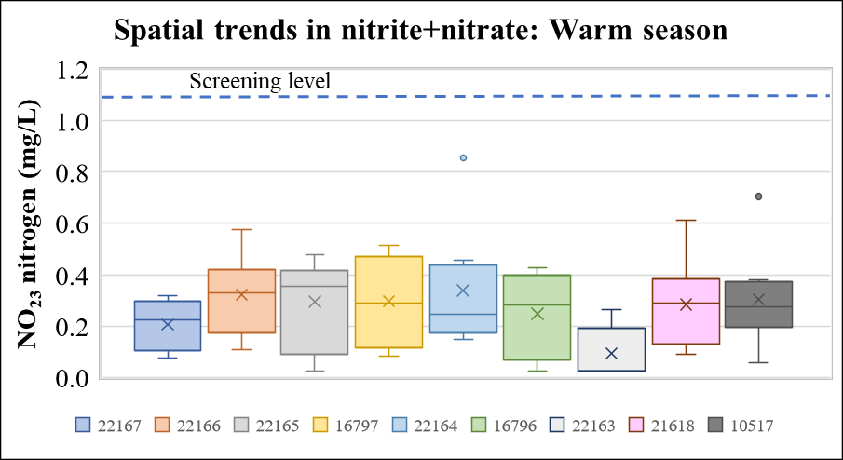
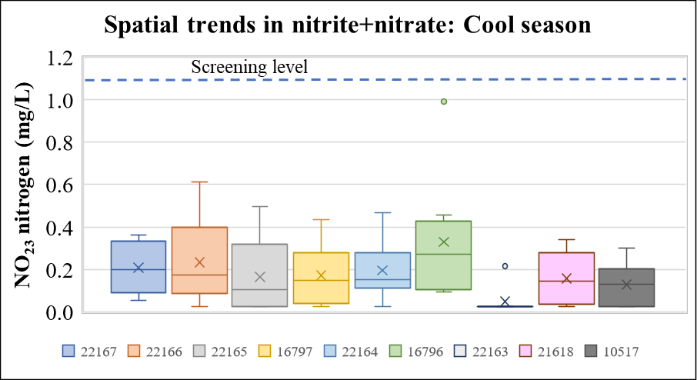
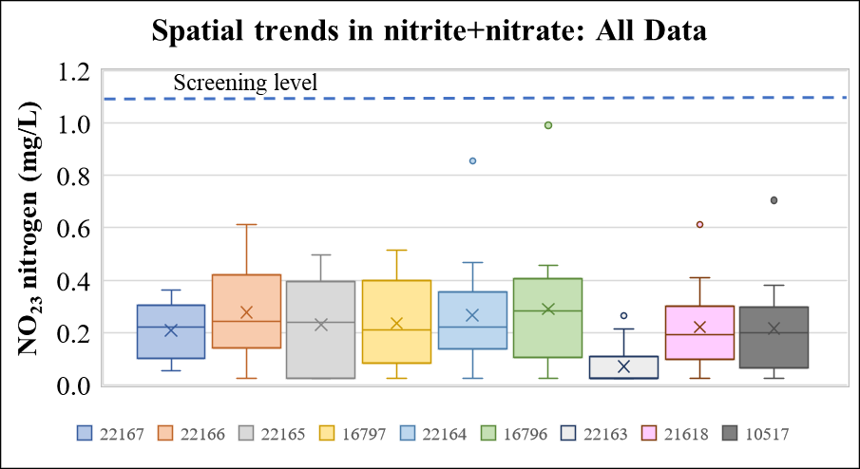

Figure 45 Box plots of nitrite and nitrate nitrogen at stations on Kickapoo Creek (screening level 1.1 mg/L)

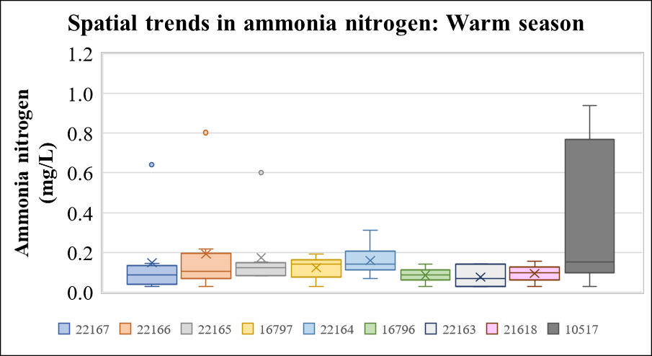
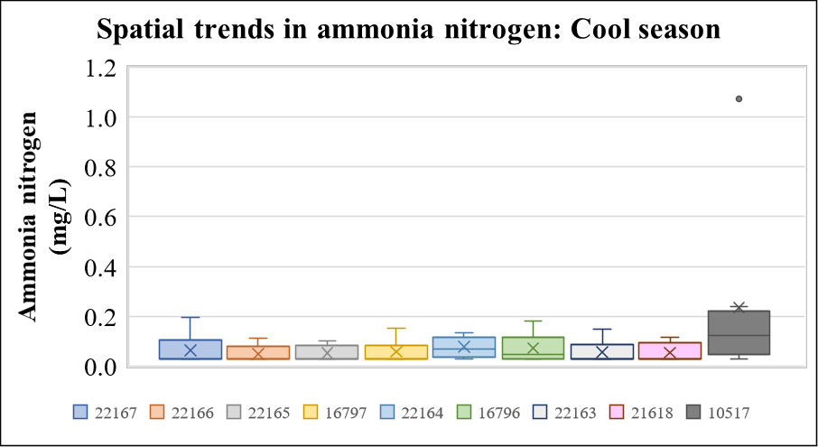
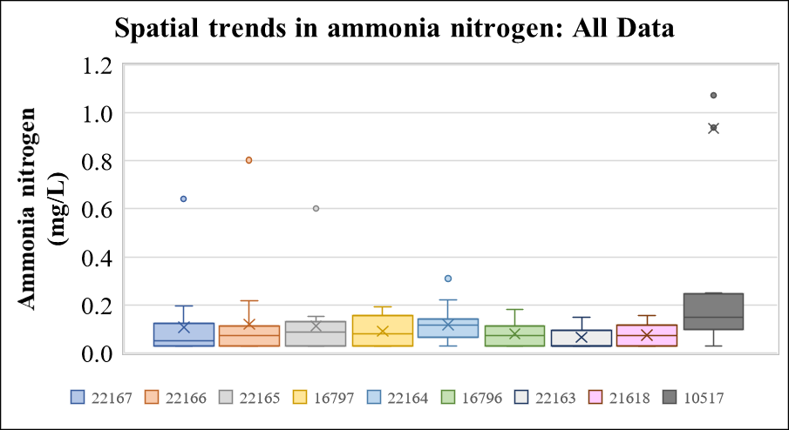

Figure 46 Box plots of ammonia nitrogen concentration at stations on Kickapoo Creek (one outliner in station 10517 (11.36 mg/L during warm season) not shown)

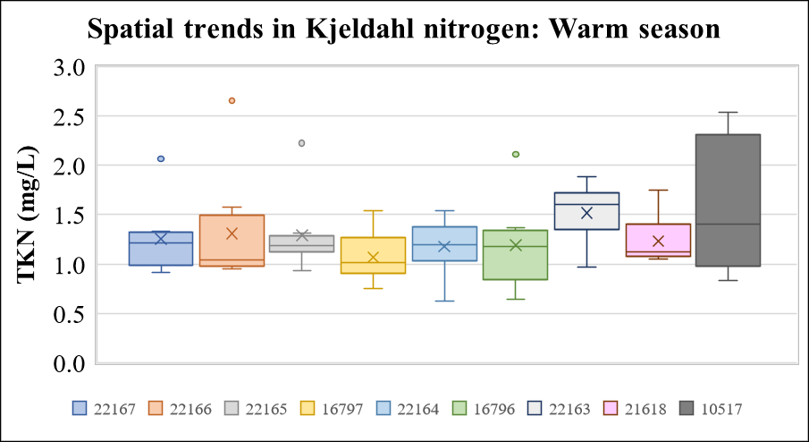
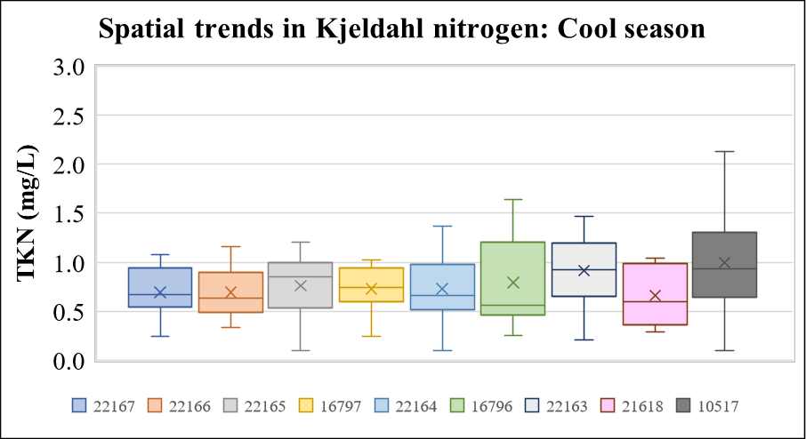
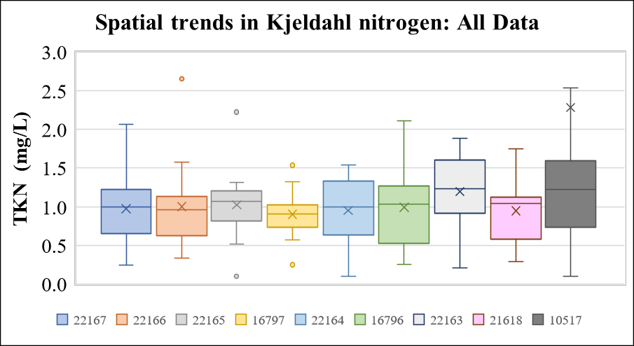

Figure 47 Box plots of total Kjeldahl nitrogen at stations on Kickapoo Creek (one outliner in station 10517 (18.68 mg/L during warm season) not shown causative of the depressed DO
This is further confirmed by the progressive increase in the BOD values from upstream (station 22166) to downstream (22163) (Figure 42) although a similar trend in not exhibited by the other oxygen demanding substances such as TSS or VSS (not shown). With the exception of one outlier in station 10517 the total phosphorus concentrations are well below the screening levels. However, the TP concentrations in 10517 are much higher than the other stations (Figure 43). A similar spatial trend can be seen for orthophosphate as well (Figure 44). Nitrite and nitrate concentrations are well below the screening levels (Figure 45) and therefore could not be the causative factor for depressed DO in the Kickapoo Creek. However, the ammonia (Figure 46) and TKN (Figure 47) concentrations for station 10517 are higher than other stations although a progressive increasing trend from upstream to downstream is absent for any form of nitrogen.

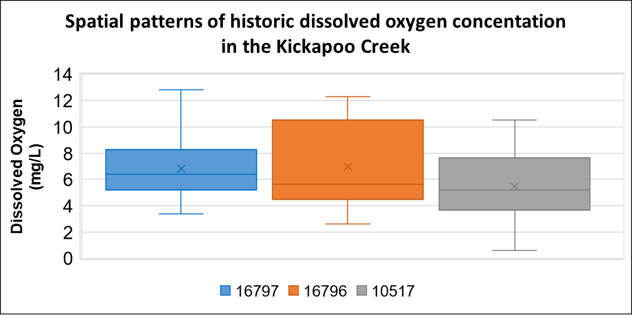 | 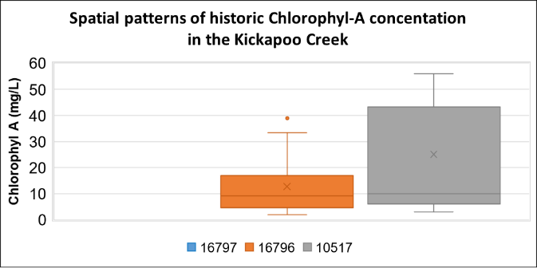
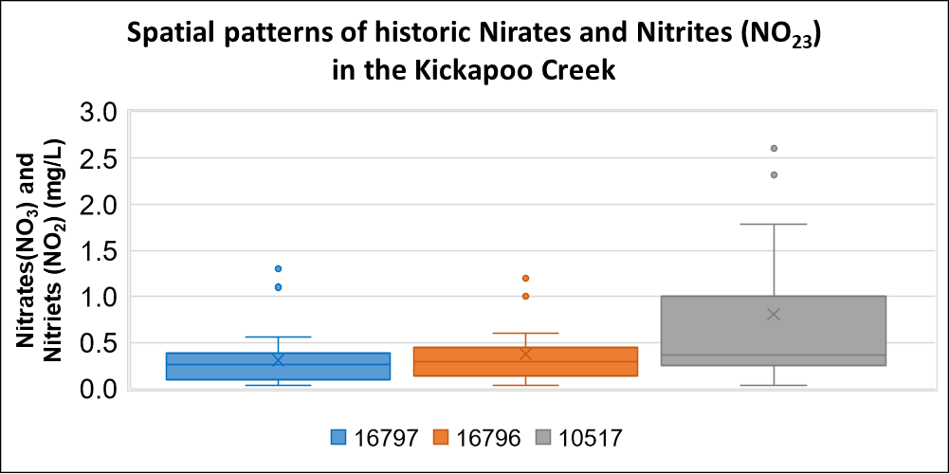 | 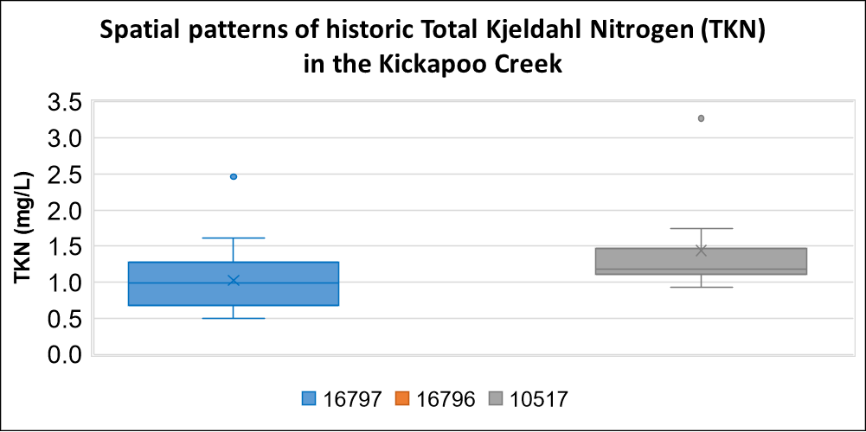
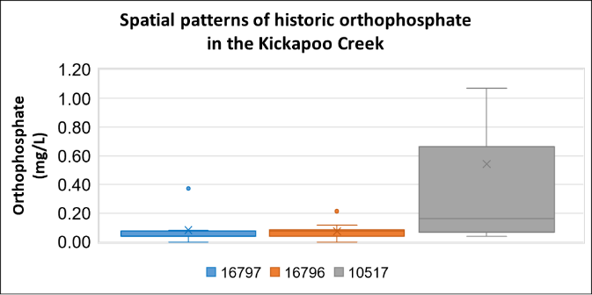 | 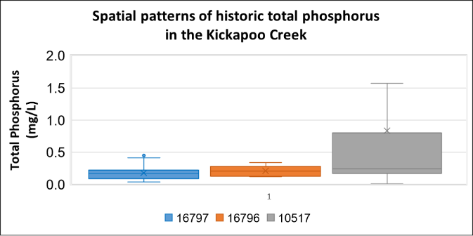
Figure 48 Spatial patterns in the historic water quality data of Kickapoo Creek

Historic water quality data are available from three stations namely 16797, 16796 and 10517. Spatial patterns in the historic water quality were analyzed and presented in Figure 48. The data points in the historic data were not enough to analyze any seasonality patterns clearly. Therefore, all the data were analyzed together. Similar to the water quality data of the current monitoring

effort (described above), the historic data showed progressively decreasing trend in DO from upstream to the downstream section of Kickapoo Creek and progressively increasing trend for nutrient and cholorophyl-A concentrations (Figure 48) from upstream to downstream. Chl-A and total phosphorus frequently exceeded the TCEQ screening levels (20 μg/L and 0.66 mg/L respectively) for the station 10517 that is the most downstream one. The nitrate and nitrite concentrations frequently exceeded the TCEQ screening levels (1.1 mg/L) in all three stations analyzed. Although the correlation analysis of historic data (Table 20) doesn’t clearly point out nutrients as the likely cause of depressed DO in the Kickapoo Creek, the spatial patterns and exceedance of TCEQ screening levels suggest a meaningful correlation between depressed DO and the nutrient concentrations.

Discussions and Conclusions from DO Data Analysis
The statistical and graphical analysis of available DO and water quality data in Kickapoo Creek indicated some association of depressed DO to nutrient forms that are indicators of eutrophication and oxygen-demanding substances, characterized by CBOD. Correlational analysis of 24-hour DO data with water quality variables revealed weak to moderate correlations. However, the spatial relationship of depressed DO from upstream to the downstream segment of Kickapoo corresponds to increasing trends (from upstream to downstream) of Chlorophyll-A concentrations. Temporal analysis of the grab DO data exhibited depressed DO during the months of August through October. Correlational analysis of grab DO with water quality variables indicated weak to moderate correlation for stations mostly on the downstream segments of Kickapoo Creek (Table 19). Spatial analysis of grab DO closely corresponded to similar patterns of BOD, Chlorophyll-A and some nutrient forms especially during summer months.

In spatial analysis of grab DO, the nutrient levels are predominately below the TCEQ screening levels. However, there were occasional exceedances especially in the downstream sections of the Kickapoo Creek. Nonetheless, Chl-A, as an indicator of algal abundance, are above screening levels in a sufficient number of measurements in some stations of Kickapoo Creek (Figure 41). The tendency toward elevated Chl-A in Kickapoo Creek can be an indication of sufficient levels of nutrients to allow excessive algal growth even if the nutrient levels do not routinely exceed screening levels. An important observation from the analyses of this study is that the depressed DO appears to have a spatial component wherein lower DO is more prevalent in the more downstream portions of the Kickapoo Creek especially after its confluence with the tributaries such as Slater creek (explained by elevated levels of Chl-A, BOD, and TP in station 22163) and Murchison Creek (explained by elevated levels of phosphorus, ammonia and TKN in station 10517).

While it is likely that human-derived influences, such as nutrients and organics within runoff, and effluent from permitted dischargers contribute to DO fluctuations; there is little understanding of natural background fluctuations. The analyses provided herein provides some explanation of the depressed DO. While conclusive/convincing findings of cause-and-effect for

the depressed DO issues are absent from the presented analyses, the likely positive influences on DO of reducing pollutant loads into Kickapoo Creek should not be dismissed. It is suggested, that from an adaptive management perspective, it is reasonable to initially rely on management measures identified for reducing bacteria loads to also reduce nutrient and organic-matter loading that can depress DO and to monitor the response DO in Kickapoo Creek to these management measures.

References
AVMA, American Veterinary Medical Association. 2012. U.S. Pet Ownership Statistics. Online at: https://www.avma.org/resources-tools/reports-statistics/us-pet-ownership-statistics (Accessed last on March 29, 2021)).
Cain, Alan. 2014. 2014 Hunting Report. The Cattleman. Available online at: http://www.thecattlemanmagazine.com/this-issue/ranching-natural-resources.html (link verified March 15, 2021).
Griffith, G., Bryce, S., Omernik, J., and A. Rogers. 2007. Ecoregions of Texas. U.S. Geological Survey. https://tpwd.texas.gov/publications/pwdpubs/pwd_pl_w7000_1187a/media/1.pdf (Accessed last on March 29, 2021).
Griffith, G., S. Bryce, J. Omernik, and A. Rogers. 2007. Ecoregions of Texas. Project report to the Texas Commission on Environmental Quality, Austin, Texas (AS-199, 12/07).
Hatherly, D.T., and M. D. Mays. 1979. Soil Survey of Henderson County, Texas. United States Department of Agriculture, Natural Resources Conservation Service, Washington, D.C.
Homer, Collin G., Dewitz, Jon A., Jin, Suming, Xian, George, Costello, C., Danielson, Patrick, Gass, L., Funk, M., Wickham, J., 353 Stehman, S., Auch, Roger F., Riitters, K. H. (2020). the Conterminous United States land cover change patterns 2001–2016 from 354 the 2016 National Land Cover Database: ISPRS Journal of Photogrammetry and Remote Sensing, v. 162, p. 184–199, at 355 https://doi.org/10.1016/j.isprsjprs.2020.02.019 (Accessed last on March 29, 2021).
https://www.911.gov/ (Accessed last on April 1, 2021).
https://tnris.org/ (Accessed last on April 1, 2021).https://www.timeanddate.com/ (Accessed last on March 29, 2021).
https://www.wcc.nrcs.usda.gov/ftpref/wntsc/H&H/training/runoff-curve-numbers1.pdf (Accessed last on March 29, 2021).
Jin, S., Homer, C.G., Yang, L., Danielson, P., Dewitz, J., Li, C., Zhu, Z., Xian, G., and Howard, D. (2019). Overall methodology 358 design for the United States National Land Cover Database 2016 products. Remote Sensing, 11(24); 359 https://doi.org/10.3390/rs11242971 (Accessed last on March 29, 2021).
National Land Cover Database 2016 (NLCD, 2016). Multi-resolution Land Characteristics Consortium (MRLC). https://www.mrlc.gov/data/nlcd-2016-land-cover-conus (Accessed last on March 29, 2021).
National Oceanic and Atmospheric Administration (NOAA). 2021. Climate Data Online. National Climatic Data Center. http://www.ncdc.noaa.gov/cdo-web/ (Accessed last on March 29, 2021).
Stringer, B.R. 1998. Soil Survey of Van Zandt County, Texas. United States Department of Agriculture, Natural Resources Conservation Service, Washington, D.C.
TCEQ, Texas Commission on Environmental Quality. 2016. 2016 Texas Integrated Report of Surface Water Quality for Clean Water Act Sections 305(b) and 303(d), approved August 6, 2019. Available at: https://wayback.archive-it.org/414/20190906170449/https://www.tceq.texas.gov/assets/public/waterquality/swqm/assess/16txir/2016_303d.pdf (link verified March 10, 2020).
Texas Commission on Environmental Quality (TCEQ) 2020. Texas Integrated Report of Surface Water Quality for the Clean Water Act Sections 305(b) and 303(d). https://www.tceq.texas.gov/waterquality/assessment/20twqi (Accessed last on March 29, 2021).
Texas Demographic Center (TDC), 2021. https://demographics.texas.gov/ (Accessed last on March 29, 2021).
TxDOT 2021. Cit Boundaries Dataset http://gis-txdot.opendata.arcgis.com/datasets/txdot-city-boundaries (Accessed last on April 1, 2021)
United States Environmental Protection Agency (USEPA) 2021. https://echo.epa.gov/ (Accessed last on March 29, 2021).
United States Geological Survey (USGS) 2021. National Elevation Database (NED). http://nationalmap.gov/viewer.html (Accessed last on March 29, 2021).
USCB, United States Census Bureau. 2019. Census 2019 Data, Washington D.C. Census Block Data available at: https://www.census.gov/quickfacts/tylercitytexas (Accessed last on March 29, 2021).
USDA National Agricultural Statistics Service 2019, 2017 Census of Agriculture. Complete data available at 365 www.nass.usda.gov/AgCensus (Accessed last on March 29, 2021).
USDA National Agricultural Statistics Service, 2017 Census of Agriculture. Complete data available at: www.nass.usda.gov/AgCensus (Accessed last on March 29, 2021).
Yang, Limin, Jin, Suming, Danielson, Patrick, Homer, Collin G., Gass, L., Bender, S.M., Case, Adam, Costello, C., Dewitz, Jon A., 369 Fry, Joyce A., Funk, M., Granneman, Brian J., Liknes, G.C., Rigge, Matthew B., Xian, George. (2018). A new generation of the 370 United States National Land Cover Database—Requirements, research priorities, design, and implementation strategies.

